ICAR-SUMMA PNW Modeling Application Technical Report
Ethan Gutmann, Naoki Mizukami, Andrew Wood, Bart Nijssen, Bert Kruyt, Abigail Smith

1 Background
The modeling application outlined in this report was developed to improve the representation of regional climate and hydrological variability for planning purposes, with an initial emphasis on extreme precipitation and flooding in the Pacific Northwest (PNW). Throughout this project, ensemble-based datasets and tools were developed to provide a comprehensive representation of current and future climate and hydrological variability using state of the art numerical meteorological and hydrological models. The modeling framework included four major components to derive meteorological and hydrological datasets that will be used by USACE to support long term planning studies in the PNW. The framework is comprised of (1) Global Climate Models (GCMs); (2) the Intermediate Complexity Atmospheric Research (ICAR) quasi-dynamical atmospheric model; (3) the Structure for Unifying Multiple Modeling Alternatives (SUMMA) hydrologic model coupled with the streamflow routing model Mizuroute; and (4) the bmorph streamflow bias-correction tool. This effort included many enhancements to the existing model parameterizations and workflows to optimize their utility in the evaluation of extreme events.

2 Numerical Weather Modeling

2.1 Downscaled Climate Projections
A major component of this work was the downscaling of Global Climate Model (GCM) output using the Intermediate Complexity Atmospheric Research (ICAR) model. ICAR is a quasi-dynamical downscaling method designed to represent 90% of the physical processes in the atmosphere for one percent of the computational cost of a traditional atmospheric model used for regional climate downscaling (Gutmann et al., 2016). While ICAR downscales the entire atmosphere, storage constraints prevented save the 3-dimensional fields, ultimately, 3-hourly fields for near surface air temperature, pressure, humidity, wind speed and direction, longwave and shortwave radiation, and precipitation (rain and snow) were saved. Only daily precipitation and daily minimum and maximum temperature have sufficient observational data to enable a high-fidelity final bias correction, as such only those variables were used for hydrologic modeling.
Many sensitivity tests were performed for the PNW domain to configure ICAR with the best possible grid, vertical level structure, and internal physics parameterization. Although the hydrologic modeling domain is restricted to the PNW, the domain used for meteorological downscaling simulations (Figure 1) was ultimately expanded to cover the entire western United States (US) to better represent surrounding topographic barriers in simulations over the Columbia River Basin, and to enable the use of this downscaled dataset for a larger range of future applications. During sensitivity testing, it was determined that the convective parameterization within ICAR was not sufficient to reproduce warm season precipitation, so multiple additional convective parameterizations were added to ICAR and tested. We selected the BMJ (Betts & Miller, 1993) parameterization for use in this work because its patterns of precipitation best matched observed precipitation totals. Similarly, recent work has shown that the Noah-MP land surface model provides a better representation of land atmosphere feedbacks, and so to improve the air temperature simulations in ICAR, we added Noah-MP (Niu et al., 2011) to ICAR in place of the original Noah model (Chen & Dudhia, 2001). To represent water vapor fluxes off of lakes in a changing climate, a multi-layer lake model was coupled within ICAR using the latest lake model from the Weather Research and Forecasting (WRF) model (Skamarock & Klemp, 2008). Finally, because changes in future long wave radiation and feedbacks due to greenhouse gases are important for climate projections, we added the Rapid Radiative Transfer Model for GCMs (RRTMG) radiation parameterization (Iacono et al., 2008) to ICAR. The additions of Noah-MP and RRTMG were found to improve ICAR temperature biases in the historical period.
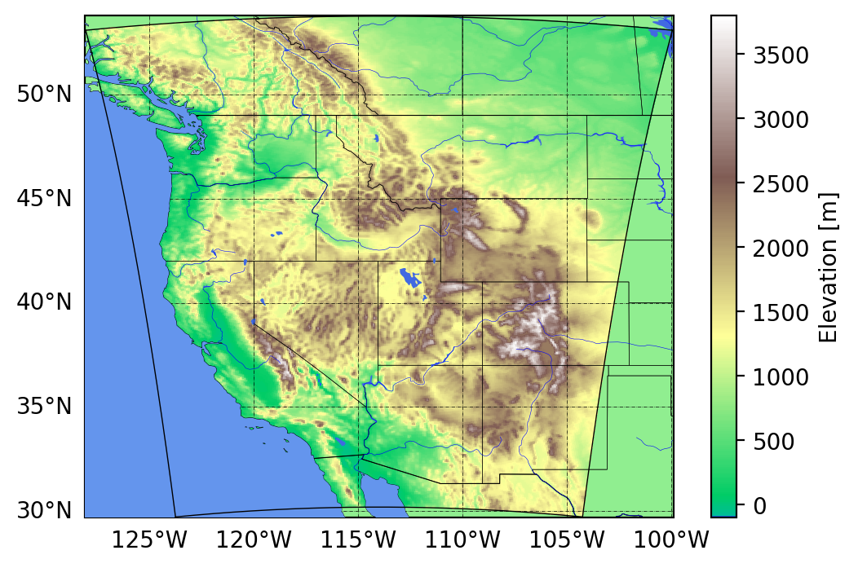
Figure 1. Map of domain used in ICAR downscaling simulations (inset black outline).

Over the course of testing ICAR with GCM data, it was determined that raw GCM outputs had too many biases to realistically reproduce the regional hydroclimate of the Columbia River Basin using a physically based atmospheric model, and thus were not suitable as direct inputs to ICAR. To correct this, prior to using the raw GCM data in ICAR, a statistical bias correction method was developed and implemented as part of this project to correct the 6-hourly, 3-dimensional atmospheric boundary conditions (temperature, humidity, and winds). The source code for this bias correction technique is now available on GitHub. The complete workflow is shown in figure 2.

2.2 Global Climate Model Ensembles
ICAR was used to downscale spatially coarse output from 14 GCMs to a 6 km grid. This included eight GCMs from the Coupled Model Intercomparison Project phase 5 (CMIP5) for each of two Representative Concentration Pathways (RCP) scenarios, RCP 4.5 and RCP 8.5. This also included six models from CMIP phase 6 (CMIP6) for three Shared Socio-economic Pathways (SSP) scenarios, SSP2-4.5, SSP3-7.0, and SSP5-8.5 (Table 1). All downscaled simulations included the period 1950-2099. An additional CMIP6 model, CESM2, was added for SSP3-7.0 because it included 10 different ensemble members that each simulated the time period 1850-2099 in a Large Ensemble (CESM2-LE). Large ensembles such as the CESM2-LE are useful to distinguish a forced climate change response from natural (random) variability. Each of the ensemble members represents a different, plausible, natural variation in projected future climate. In addition, the large historical simulation period enables a more complete evaluation of the natural variability that could have occurred over the past 150 years. The CESM2-LE was selected for this because there are relatively few such Large Ensembles at present that saved the necessary 6-hourly 3D atmospheric data to run ICAR. In total, this represented 39 model simulations and 6,850 simulation years, two of the CMIP5 RCP-4.5 simulations had problems in the data (Table 1).

2.3 GCM and ICAR Model Evaluation

2.3.1 Global Climate Model Skill
To assess the viability of the use of GCMs to understand variability in extreme precipitation, it is necessary to evaluate their representation of the global circulation that matters most for this, atmospheric rivers (Gershunov et al., 2019; Ralph et al., 2011; Rutz et al., 2014; Warner et al., 2012). While Atmospheric Rivers (ARs) can be identified by a large array of tracking methods (Shields et al., 2023), these primarily based Integrated Vapor Transport (IVT), a measure of the total (integrated from the land surface to the top of the atmosphere) amount of water vapor being transported (mass times wind speed). We compared both the mean and extreme IVT in GCMs along the west coast relative to the IVT computed from wind and specific humidity from the
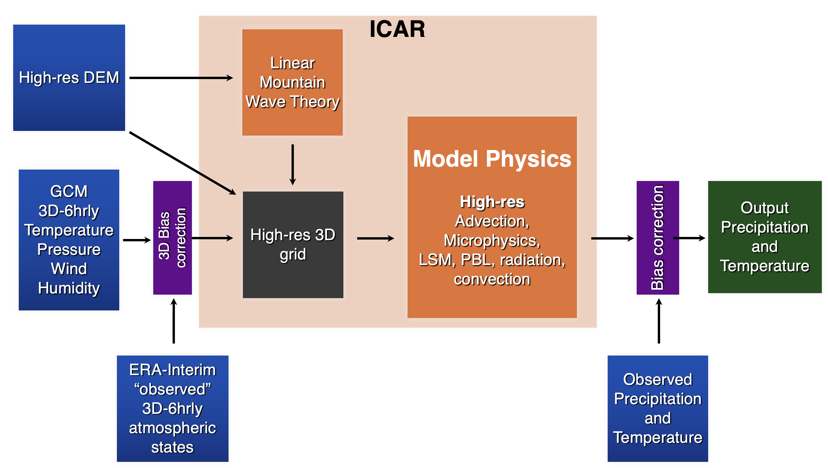
Figure 2. ICAR workflow from input datasets (blue), bias correction steps (purple), ICAR physics (orange), to output data (green).
Table 1. CMIP GCMs, SSP, and RCP scenarios included in this application are indicated by an “x.” Blue shading represents ensemble members that have been carried through the streamflow modeling framework described in Sections 3 and 4.
CMIP6 GCMs | SSP2-4.5 | SSP3-7.0 | SSP5-8.5
CanESM5 | x | x | x
CMCC-CM2-SR5 | x | x | x
MIROC-ES2L | x | x | x
MPI-M.MPI-ESM1-2 | x | x | x
NorESM2-MM | x | x | x
CESM2-LE |  | x
CMIP5 GCMs | RCP 4.5 |  | RCP 8.5
CanESM2 | x |  | x
CCSM4 |  |  | x
CMCC-CM | x |  | x
CNRM-CM5 | x |  | x
GFDL-CM3 | x |  | x
HadGEM2-ES |  |  | x
MIROC5 | x |  | x
MRI-CGCM3 | x |  | x

European Centre for Medium-Range Weather Forecasts (ECMWF) interim ReAnalysis (ERA-interim) dataset (Dee et al., 2011). We found that while the mean IVT in various GCMs exhibited a realistic spatial pattern, individual GCMs could be biased high or low (Figure 3, left). Evaluating the frequency of extreme IVT events, most GCMs had a reasonably consistent spatial pattern and magnitude when compared to ERA5-based observations, but with larger variations between GCMs (Figure 3, right) than is present in the mean IVT. This suggests that the GCMs are realistically representative of the weather patterns that control extreme precipitation events across the PNW, but that persistent biases would limit their suitability for use in direct downscaling without correcting those biases. Prior GCM bias correction methods (Bruyère et al., 2014) have corrected only the mean state for each variable, here we show that for some

GCMs biases in the extremes do not have the same spatial pattern or magnitude as the biases in the mean state. Because the biases identified were more pronounced in the extreme statistics, we implemented a more complex bias correction algorithm than has been used previously. The quantile mapping bias correction algorithm systematically corrects the statistical distribution of magnitudes each variable including the extremes. Performing ICAR simulations with inadequately bias corrected GCM data would result in a worse representation of extreme precipitation in this domain.
After bias correction of temperature, humidity, and winds independently, the models have minimal bias in the aggregate IVT mean spatial patterns, or frequency distributions (Figure 4), despite the fact that IVT itself is not corrected directly. This suggests that the models themselves have a realistic covariance between large scale fields such that this independent bias correction is sufficient.
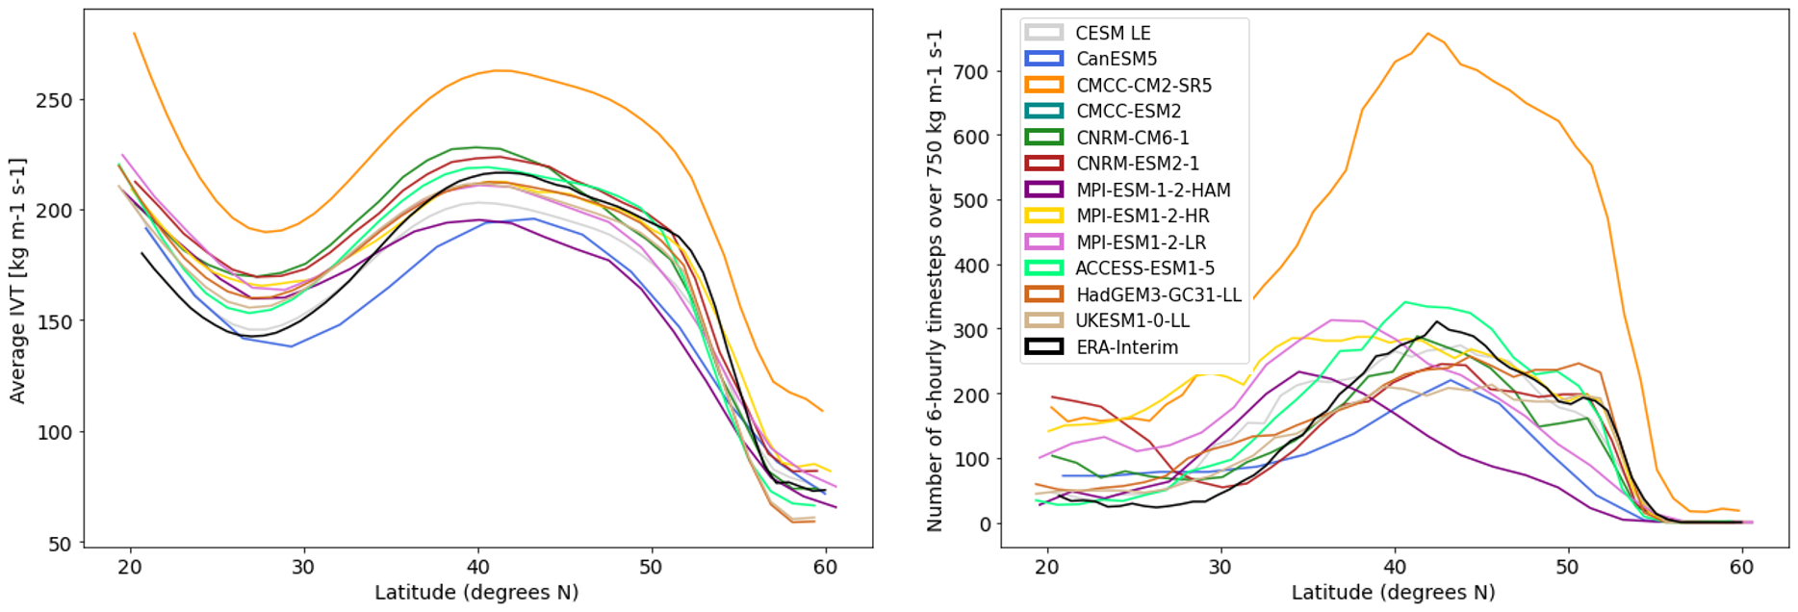
Figure 3. Latitudinal transects of mean IVT (left) and the frequency of extreme (>750 kg/m/s) IVT events (right) in 12 CMIP6 GCMs and the ERA-interim reanalysis.
The climate models selected for the initial dataset production in this study all have a reasonable performance in the Pacific Northwest. They span a range of relative skill scores for the domain (Figure 5) based on the analysis of (Lybarger et al., 2024). Model selection was limited partially due to the availability of 3D 6-hourly data needed to run ICAR and partially due to complications that arose when processing some of the better models, e.g. missing or erroneous data in one variable or errors in associated metadata. Some of these complications may be impossible to overcome because they are the result of errors in the source CMIP6 data as archived by the global modeling centers, others can be overcome with individual discussions with the relevant modeling center. The models with available 3-D 6-hourly data available are highlighted in figure 5. Models we have run ICAR for are outlined in purple, models deemed higher priority to run are outlined in orange, and lower priority but feasible models are in grey. Higher priority models are defined as those with better performance scores and not duplicative of another model already in the list (e.g. EC-EARTH3 and EC-EARTH3-Veg). Some models with ICAR runs “available now” score lower in this analysis, and were included because they represent IVT reasonably well, they had data available for use earlier, and this more complete evaluation was not available at the time. More work is planned to add additional CMIP6 models.
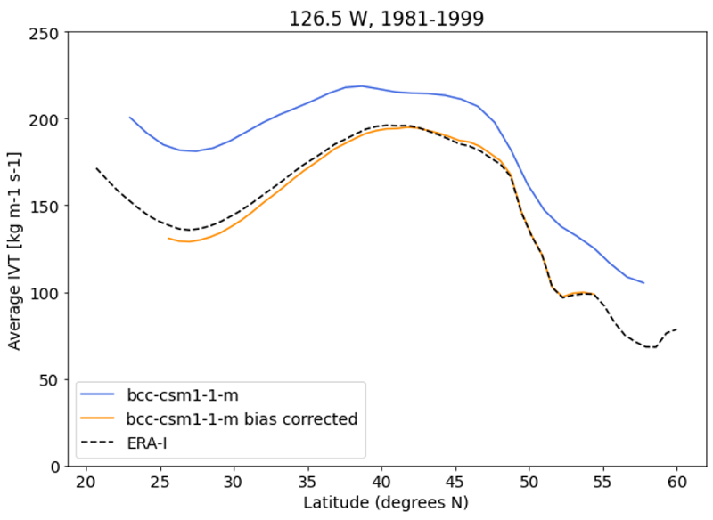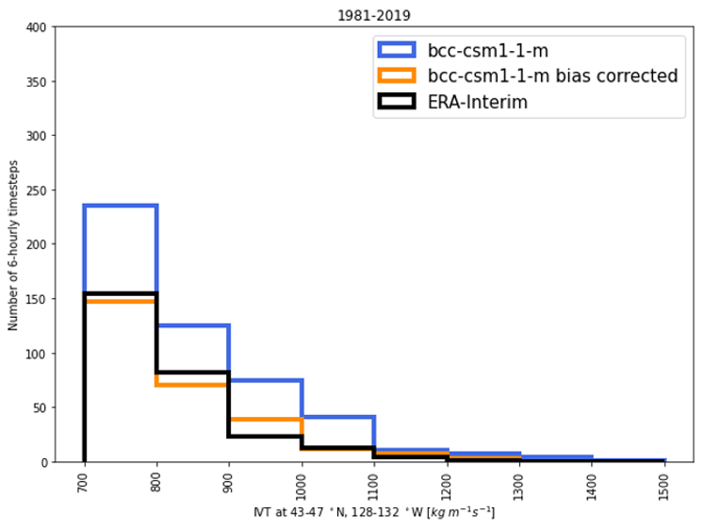
Figure 4. Comparison of IVT from the original bcc-csm1-1-m GCM (blue), and after bias correction (orange) in comparison to ERA-Interim (black). Left: latitudinal transect of mean IVT, Right: histogram of IVT magnitudes for only the most extreme magnitudes (750 kg/m/s)
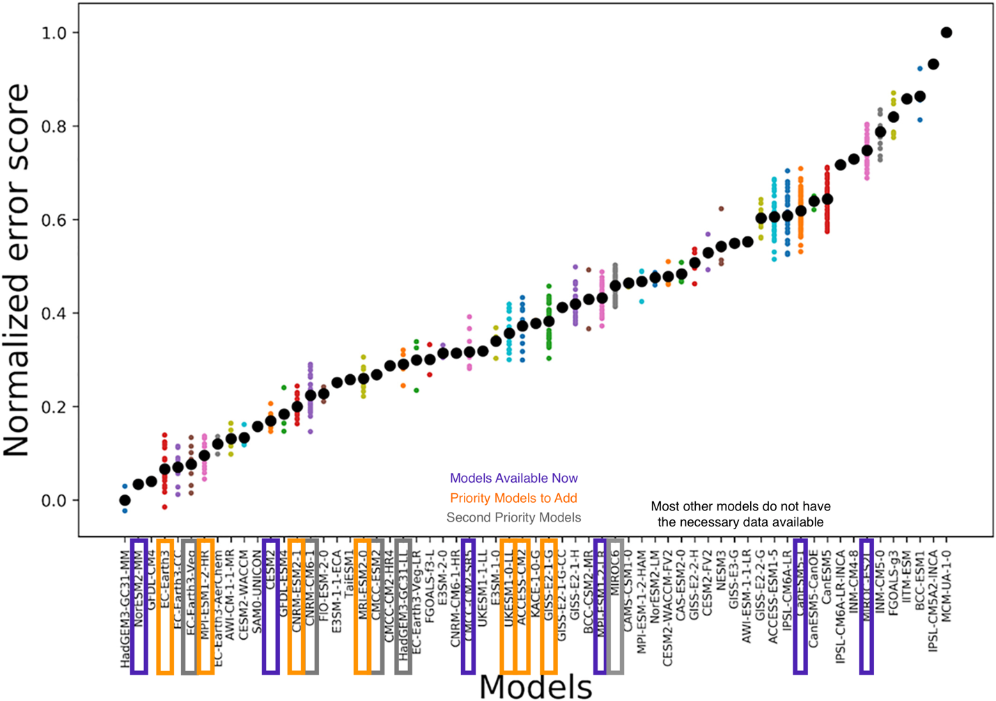
Figure 5: Collection of CMIP6 global climate models ranked by a large scale evaluation (Lybarger et al;, 2023). Climate models downscaled in this study are outlined in purple, models deemed high priority to add next are in orange, and lower priority models in grey.

2.3.2 ICAR Evaluation for the Western US
When ICAR is used to simulate the historical period (1980-2019) using the ERA-interim atmospheric reanalysis (Dee et al., 2011) for boundary conditions, ICAR simulates realistic patterns of precipitation across the domain with a high correlation coefficient between monthly modeled and observed (Livneh et al., 2013) precipitation (Figure 6). However, ICAR exhibits a dry bias across the domain that warrants future investigation to improve the internal representation of atmospheric processes. This is likely due to a tendency to underestimate turbulent variability in the atmospheric winds, resulting in a weaker enhancement of precipitation than is actually caused by embedded convective processes. New work is developing methods to increase that variability in the wind field; however, for the purposes of this effort, we have bias corrected the final output of ICAR daily precipitation and temperature to enable its use for forcing hydrologic models.
The high degree of month-to-month correlation between ICAR and the observational dataset (Figure 6) indicates that it can be used to project monthly variations in weather, and provides some confidence in the ability of ICAR to simulate the response of the atmosphere to future changes in weather and climate. The monthly correlation coefficient in ICAR varies around 0.5 to 1 across the domain, with a mean value of 0.74. For comparison, the more complex, Weather Research and Forecasting (WRF) model has similar, though slightly higher, correlation coefficients, with a mean value across the domain of 0.78.
In addition to an evaluation of the mean patterns, the response of ICAR to IVT events was compared with the Weather Research and Forecasting (WRF) model (Figure 6). While ICAR was found to underestimate the magnitude of extreme precipitation events, the response of ICAR to IVT was similar to that of WRF, but at a small fraction of the computational cost of WRF (100x faster). Multiple atmospheric river events were simulated with ICAR, and the correlation between IVT and precipitation in ICAR was between 0.76 and 0.83. For comparison, the correlation between IVT and precipitation in WRF for these events varied between 0.80 and 0.86. This shows that ICAR is able to respond to extreme IVT events in a similar fashion as a much more complex atmospheric model, although the simulation of the most extreme precipitation events needs more evaluation.
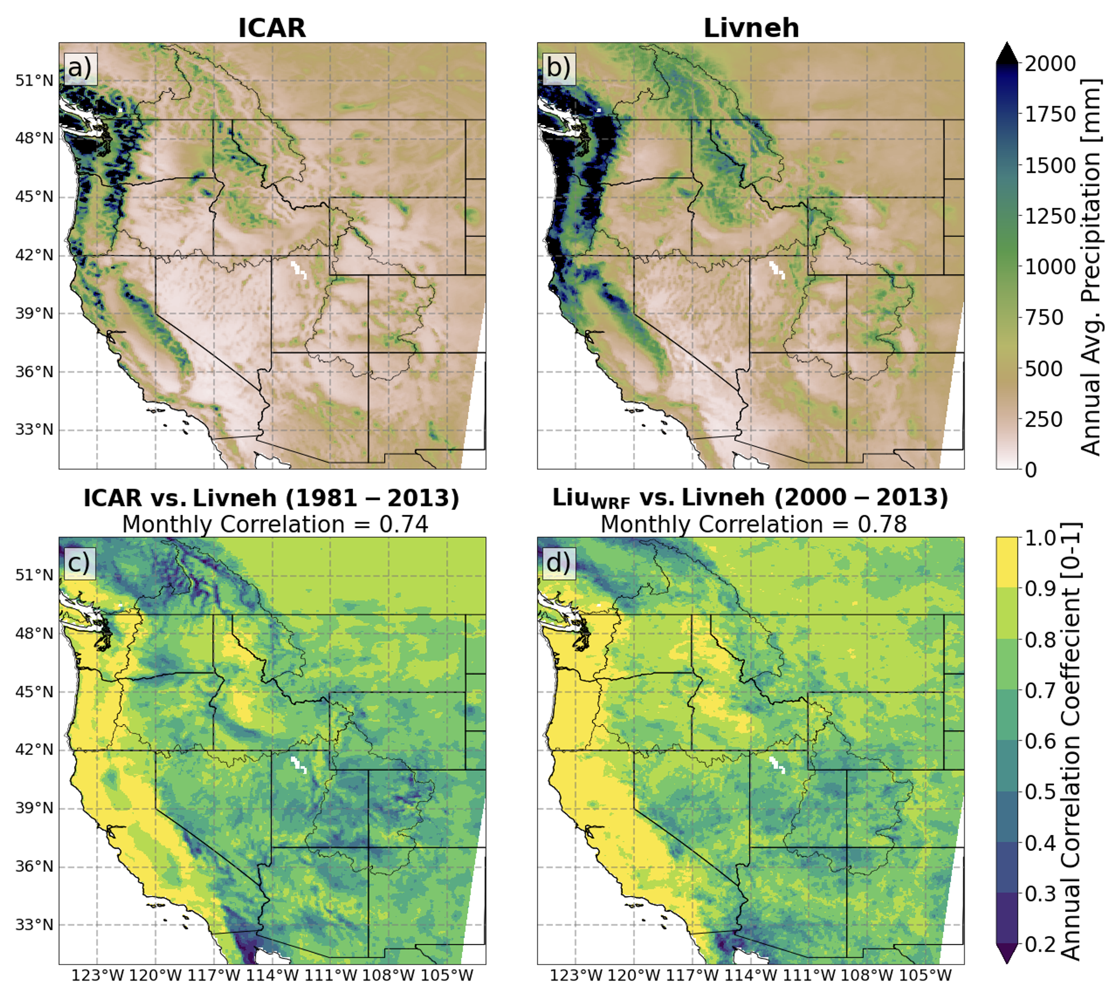
Figure 5. Comparison if ICAR with the Livneh observational dataset mean annual precipitation (top) and the WRF atmospheric model skill at predicting month to month variations (bottom)
Spatial patterns of extreme precipitation events in ICAR also correspond with the patterns of extreme precipitation observed across the Western US (Figure 7). The 50-year historical period (1950-2000) maximum daily precipitation event modeled by ICAR from nine different ensemble members of the CESM2-LE are shown below. The variability between these ensemble members is representative of the expected chaotic, natural variability in the real climate system. All members exhibit the same large-scale features with similar magnitudes as observed; however, none of the members capture the more extreme events observed in the interior Rocky Mountains in Idaho and Montana (Figure 7).
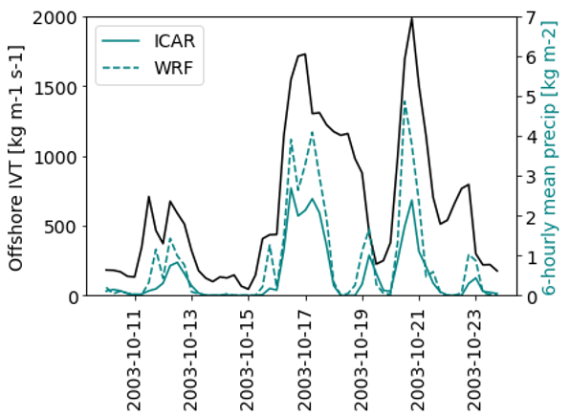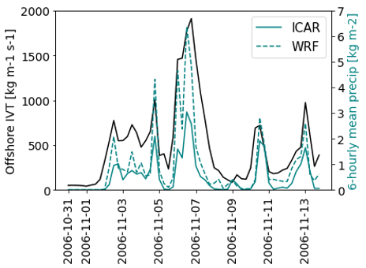
Figure 6. ICAR (solid) and WRF (dashed) modeled 6-hourly precipitation (right axis) during a two strong atmospheric river events, with ERA-interim IVT (black, left axis).

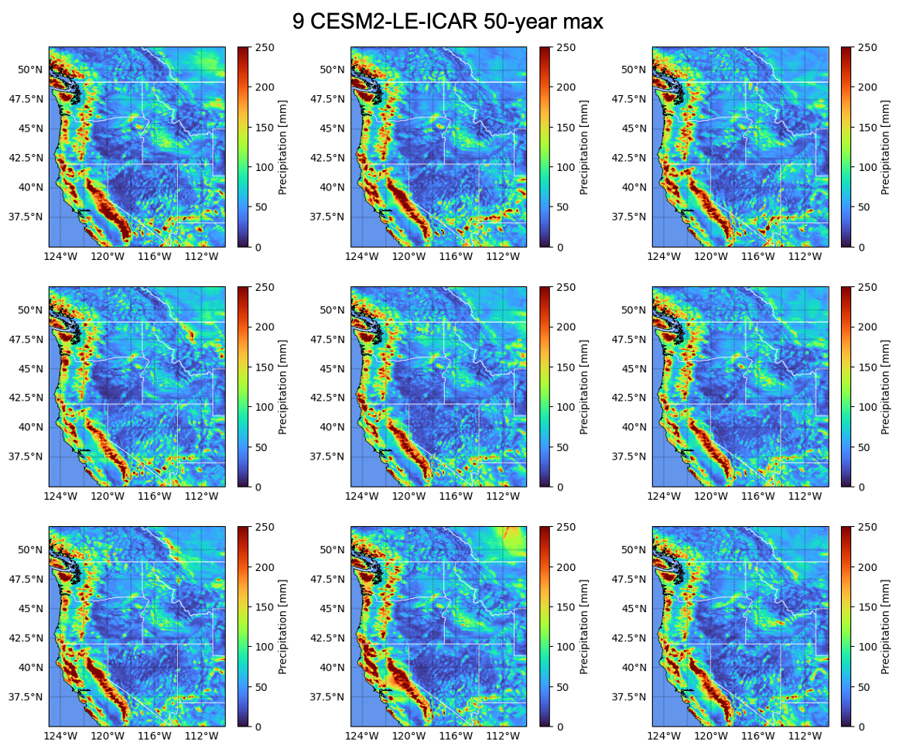
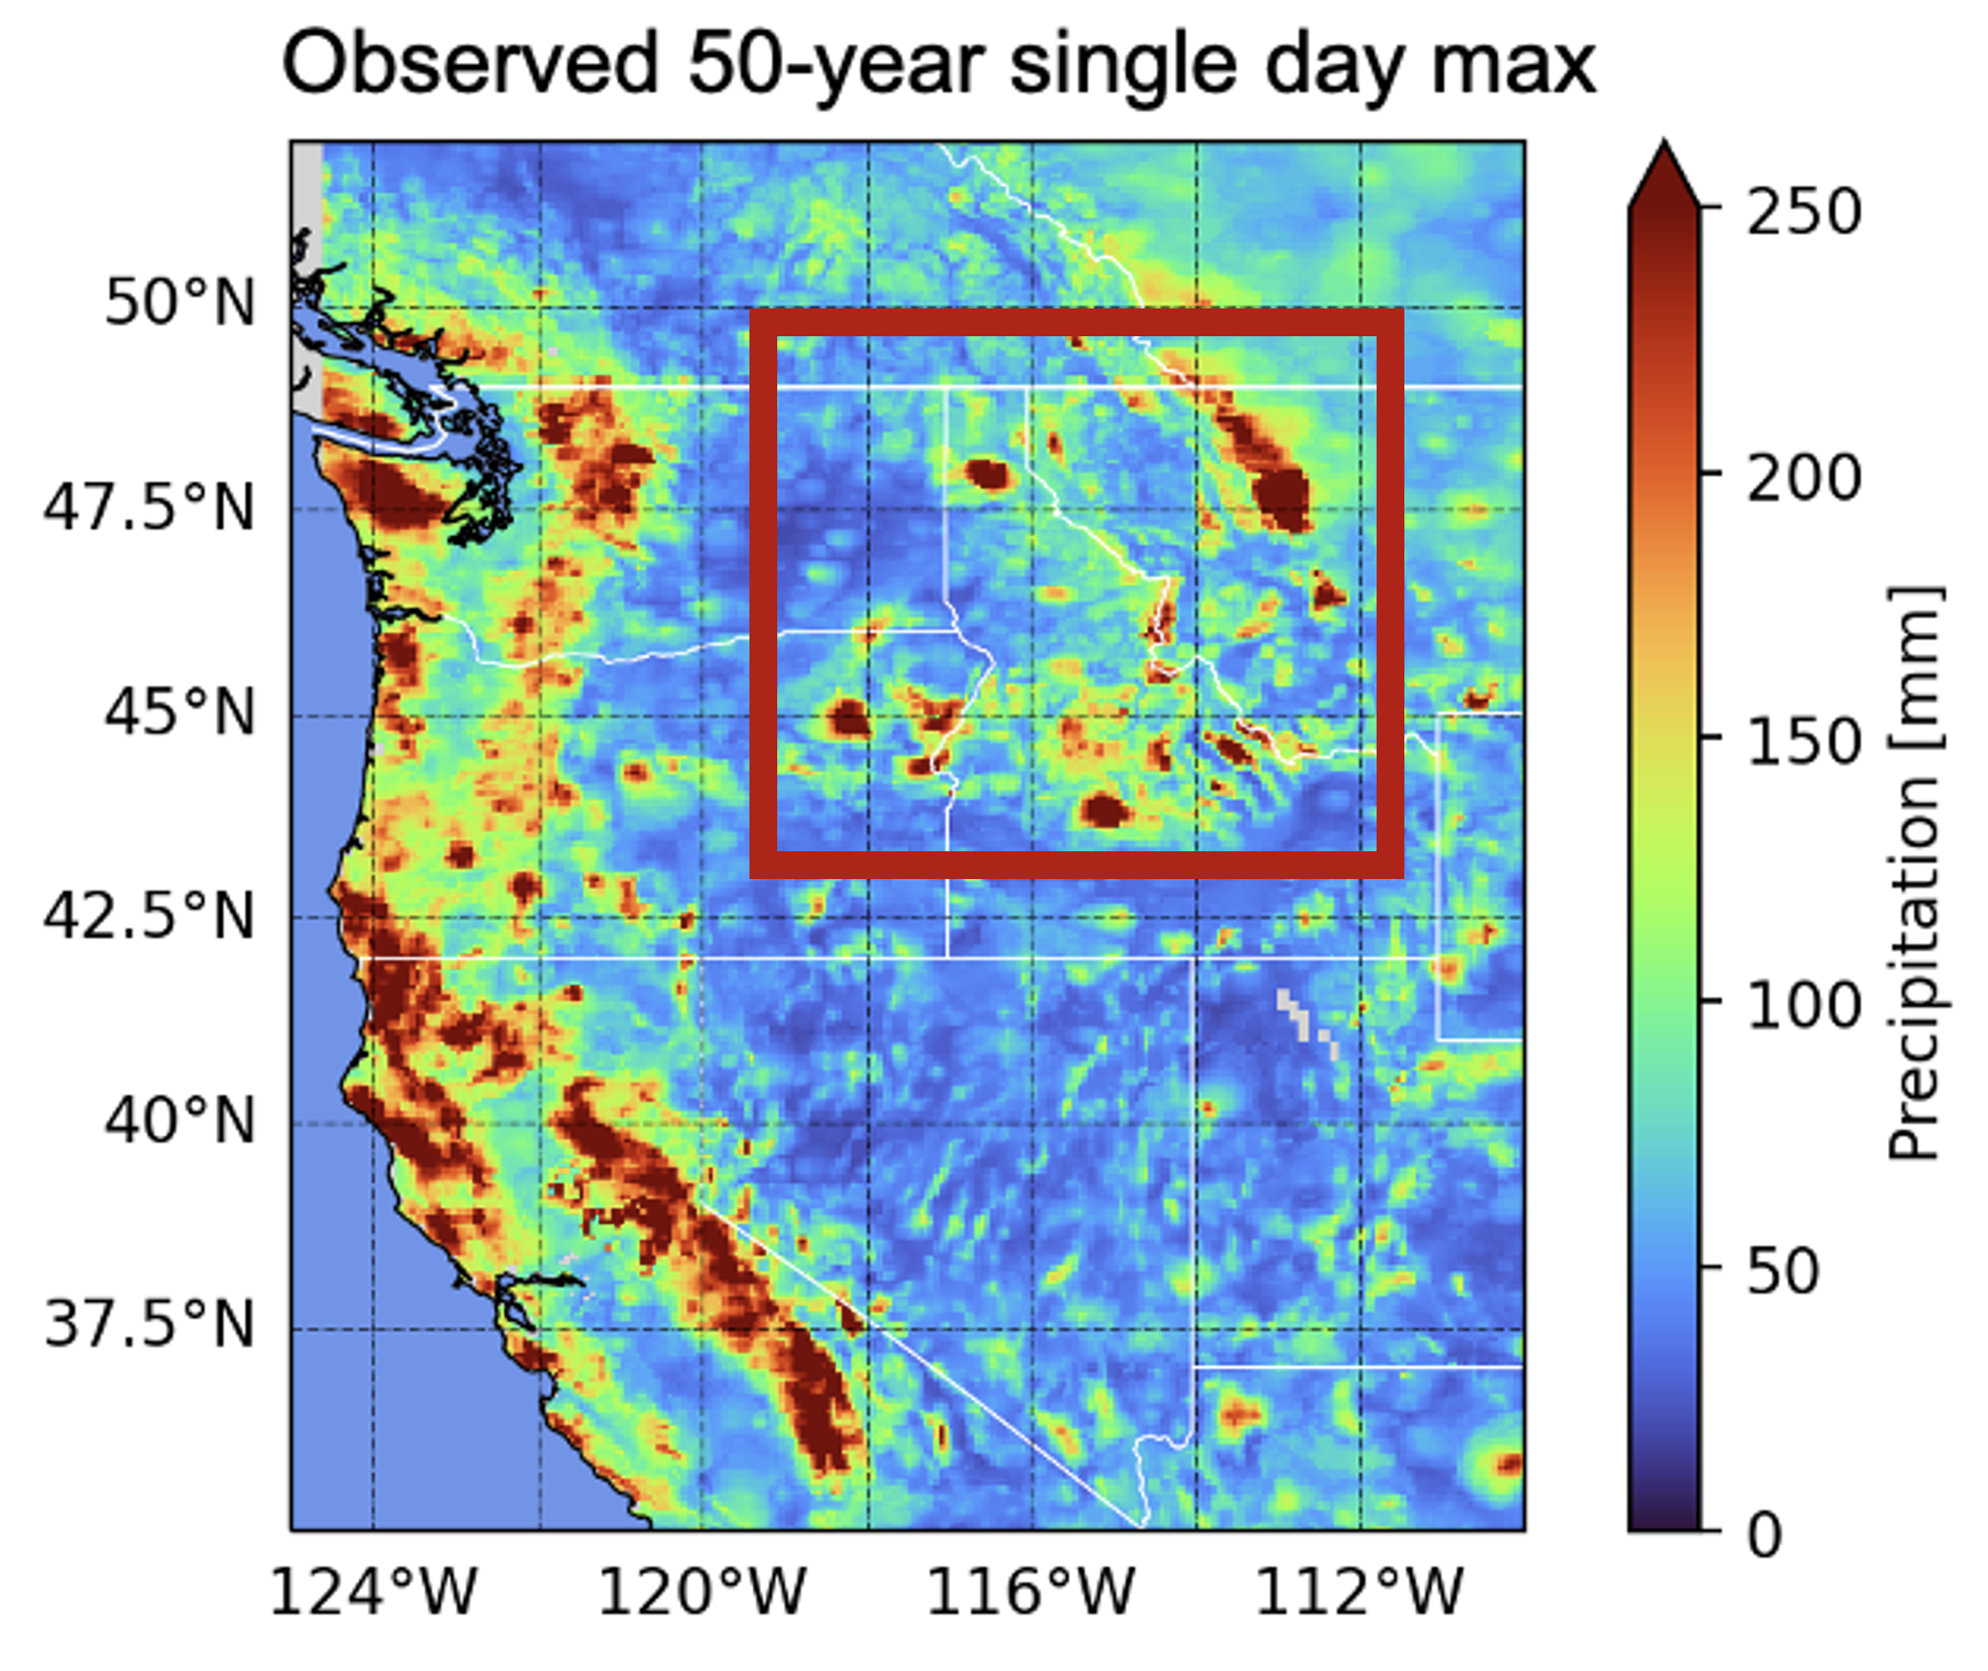
Figure 7. 50-year historical period (1950-2000) maximum daily precipitation event modeled by ICAR from nine different ensemble members of the CESM2-LE (top) in comparison to the observed maximum over this period (bottom). The interior Idaho and Montana regions with extreme events that are not well characterized in the ICAR simulations are outlined in red box on the observations, these descrepancies are removed by bias correction.
As with precipitation, ICAR is able to simulate a very similar spatial distribution of temperature when compared to observations; however, while precipitation is biased too low in ICAR, temperature is typically biased too high at low elevations, and too low at high elevations (Figure 8). In particular, coastal and lower elevation northern regions are too warm in the simulations. This is believed to stem primarily from near surface representation of land atmosphere coupling, and more work is needed to improve the representation of the land surface in ICAR. To minimize the impact of these biases on further hydrologic simulations, the output air temperature from ICAR is bias corrected before being used as input to the SUMMA hydrology model.

3 Hydrologic Modeling
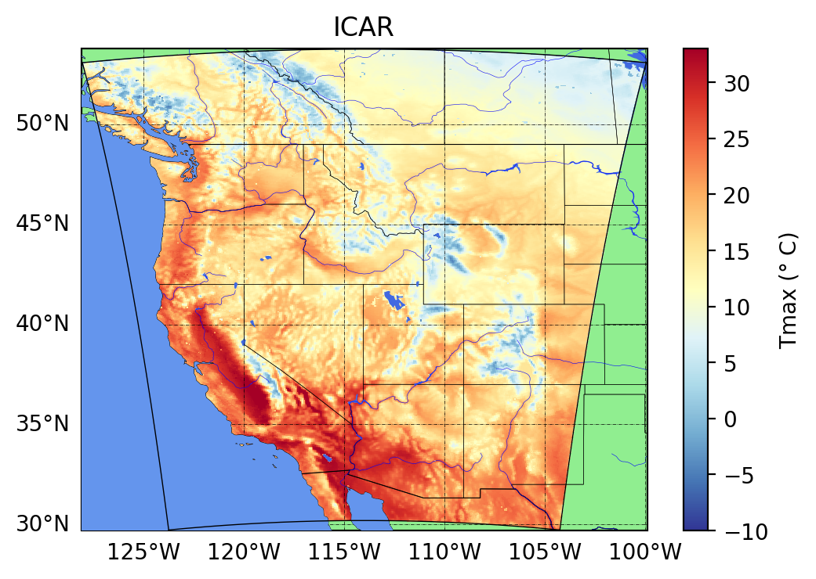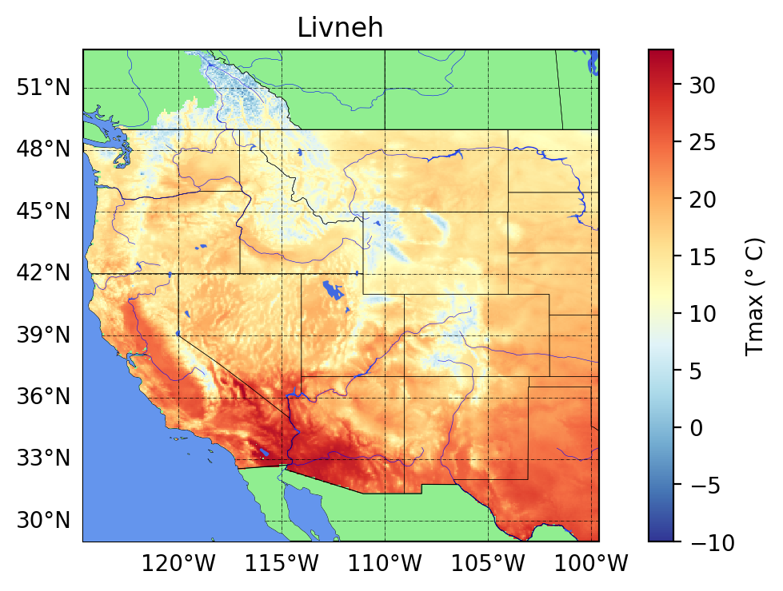
Figure 8. Comparison of mean annual daily maximum air temperature in an ICAR CESM2-LE simulation (left) and in the Livneh observational dataset (right)

3.1 SUMMA-mizuRoute
This project used hydrology and river routing models that were run sequentially to produce routed streamflow across the PNW domain. The Structure for Unifying Multiple Modeling Alternatives (SUMMA; Clark et al., 2015) was used to simulate applied to land-surface water and energy fluxes. MizuRoute (Mizukami et al., 2016) was used to simulate routed runoff in rivers. In this modeling framework, SUMMA is run first and its runoff outputs are then used as input to mizuRoute. Hereafter, the modeling framework is called SUMMA-mizuRoute.
The initial SUMMA-mizuRoute implementation for the project was developed in a series of prior projects (led by NCAR Co-PI Andy Wood) that were sponsored primarily by USACE, Reclamation and NASA. SUMMA was configured for the entire western US domain using a spatial resolution defined by catchments, rather than grids. For the western US, the catchment boundaries are from the USGS Hydrologic Unit Code Level 12 (HUC12) dataset, and these are extended to cover the remaining connected drainage areas (i.e., in Canada and Mexico) using similarly sized (slightly smaller) catchments defined in the MERIT-Hydro dataset (REF). Within the configuration of SUMMA applied, water-energy states and fluxes are computed independently for each 12-digit HUC watershed or Hydrologic Response Unit (HRU) with a single HRU used in each SUMMA Grouped Response Unit (GRU). The configuration used a 3-hour time step to resolve diurnal weather patterns, with unique meteorological forcings and physiographic characteristics including slope, elevation, soil layer thickness, vegetation and soil types defined for every catchment (HRU). More details covering the SUMMA model setup are provided in several Reclamation project reports, available online at (Broman & Wood, 2019; Wood et al., 2021). For the current project, a PNW-subset of the Western US SUMMA model was extracted, comprising approximately 10,000 catchments.
SUMMA offers several options for water and energy balance flux parameterizations (i.e., physical process algorithms). For this project, we used the flux parameterization choices that were selected in the existing well tested SUMMA modeling work. These include a Ball-Berry parameterization (Ball et al., 1987) for simulating stomatal resistance, one of the main vegetation physiological factors controlling transpiration, to represent the impacts of variation in temperature, humidity, sunlight, and CO2 on ET. To estimate the effect of vegetation on wind speed internally, a logarithmic wind profile below the vegetation canopy is used, described in Mahat et al. (2013). To translate wind speeds above the canopy to the canopy top, the Raupach (1994) parameterization was adopted for vegetation roughness length and displacement height effects on wind speed. To represent radiation transmission through vegetation the configuration used Beer’s law(Mahat & Tarboton, 2012). For vertical moisture movement within the soil column, the configuration used the mixed form of the Richards equation (Celia et al., 1990) with a vertically constant saturated hydraulic conductivity parameter. For snow albedo, a constant time decay rate was used to represent snow aging, and the snow thermal conductivity was parameterized using the Jordan (1991) approach. Further, each HRU incorporates an unconfined aquifer at the bottom of the soil column, which contributes to baseflow generation, using an exponential baseflow curve that is a function of aquifer storage. No lateral water movement occurs between HRUs in SUMMA. However, SUMMA computes “delayed runoff” (often termed hillslope routing) by accounting for overland and subsurface travel time of runoff movement to the river channel through the use of a gamma distribution-based unit hydrograph. Daily mean water flux variables (baseflow, evapotranspiration) are output, while overland routed runoff is output at a 3-hour time step. This 3-hour runoff is input into mizuRoute for the river routing. MizuRoute also uses a 3-hour simulation step.
MizuRoute (Mizukami et al., 2016) uses a “vector-based” river network” defined based on the MERIT-basin(Lin et al., 2019). The PNW-subset of the western US modeling framework includes 17,957 river reaches (blue lines in Figure 9) and their associated contributing catchments (HRUs) within the Pacific Northwest. Since SUMMA’s HRUs and mizuRoute’s MERIT basin HRUs differ in size, runoff re-mapping is performed within mizuRoute using a mass conserving average approach in which exactly the same amount of mass is added when summed across all mizuRoute river segments as is contributed from all SUMMA HRUs. Among several reach routing schemes offered by mizuRoute, we use the quickest routing method, which is the Impulse Response Function (IRF) or Unit Hydrograph based routing. This scheme mimics Lohmann’s IRF routing (Lohmann et al., 1996), which was used in the hydrologic modeling configurations for past climate change studies in the US (Glabau et al., 2020).

3.2 Hydrologic Model Calibration

3.2.1 Retrospective Forcing Dataset
We use an observation based 6-km climate dataset generated using the Gridded Meteorological Ensemble Tool (GMET; Bunn et al., 2022; Newman et al., 2015) as the retrospective forcing dataset for SUMMA. The GMET data are available from 1970 through 2023. GMET uses multiple logistic and linear regression with static geophysical attributes to predict precipitation and temperature across a grid (Clark & Slater, 2006; Newman et al., 2015). The core algorithm is a spatial regression approach for interpolating between in situ, point meteorological observations, by using spatially distributed terrain variables as predictor fields in an ordinary least squares (OLS) linear regression to explain the spatial distribution of weather reflected in the observational records. The spatial predictors are static geophysical attributes (south-north and east-west slopes, elevation, latitude, and longitude). The regression is applied to predict daily, accumulated precipitation, mean temperature, and diurnal temperature range (DTR) for each target grid cell, on each day. Regression model inputs are based on the current observed values of those variables within a sample from the 30 nearest meteorological stations, taking into consideration their relationship to the local terrain features at the station locations. This strategy generates dynamic (time-varying) mean and uncertainty estimates of the daily meteorological fields that are driven by daily observed meteorological conditions. These uncertainty estimates are used in a stochastic sampling process to generate realistic space-time variability in the estimates and can be used to generate an ensemble of equally likely meteorological conditions.
GMET was applied for the period 1970 to present at both 1/8th and 1/16th degree resolutions, yielding daily, accumulated precipitation and temperature minima and maxima. The resulting outputs were spatially remapped to the SUMMA HUC12 modeling fabric and then disaggregated to a 3-hourly time resolution and to a full set of meteorological fields (including radiation, pressure, humidity, wind variables) using MetSim (Bennett et al., 2020). MetSim is based on the MtClim program (Hungerford et al., 1989). This approach was applied to the entire western US, and the model forcing inputs for the PNW domain were extracted from the larger domain forcing dataset.
This project undertook multiple refinements of the SUMMA model calibration forcings dataset. Early analysis led to a revision of several predictor fields (related to slope in particular) that were optimized to improve precipitation estimates. An intensive comparison of the GMET forcings were made with other sources of meteorological forcings: NLDAS (Cosgrove et al., 2003), WRF (Rasmussen et al., 2023), and PRISM (Daly et al., 2008). A notable result of this analysis was that GMET annual total precipitation appeared to be biased approximately 15-20% low in some areas as compared to PRISM. To remove the impact of this bias, we scaled GMET to match the PRISM precipitation and temperature climatology for forcings within the US, with a linearly damped scaling extrapolated 1 degree latitude to the north of the US border, where the PRISM dataset ends. As a result, precipitation in the Canadian portion of the basin is largely unmodified. This modified GMET dataset was used in the calibration of the SUMMA model and was used as the reference dataset for the bias correction of ICAR datasets.

3.2.2 Calibration Workflow
SUMMA was calibrated to the 2020-Level No Regulation-No Irrigation (NRNI) streamflow dataset (BPA, 2020). NRNI flows represent hydrologic conditions unaffected by human activities, adjusted to correct for river regulation, reservoir evaporation and irrigation diversions (Pytlak et al., 2018). The 2020-Level NRNI dataset was derived from the 2020 Modified Flows Streamflow dataset (BPA, 2020) and contains daily streamflow for the period 1928 to 2018 for 221 sites across the PNW domain.
The SUMMA calibration strategy adopted the core methods and workflows from the prior SUMMA-mizuRoute modeling work, as described in Wood et al. (2021), with some modification. The primary parameter optimization method from that work is the Dynamical Dimensional Search algorithm (DDS; Tolson & Shoemaker, 2007), which had been tested and refined in dozens of smaller western US basins (e.g., the Shoshone R, the Flathead R, the Clearwater R, among others). DDS is incorporated into the workflow through a software package called Ostrich (Matott, 2017). Prior work focused mostly on individual basins. An example of a larger implementation, more analogous to the PNW domain being analyzed as part of this effort, was an application for the upper Rio Grande R basin. For the upper Rio Grande River basin a strategy was developed using DDS in a nested, headwaters-to-outlet sequence in which upstream areas (and headwaters) are calibrated before downstream areas.
Due to the size of the PNW spatial domain, calibration was conducted in two stages: first, a regional combined calibration, in which the PNW domain is split into four regions that are more hydro-climatically similar than the PNW domain as a whole — Cascade, Western Cascade, Snake, and Upper Columbia (Figure 9). This phase was not expected to obtain optimal parameters at each location, but to provide improved parameters that could serve as prior estimates for a second phase. The second phase of calibration is focused on individual and nested basin calibration, using the core approach from the Rio Grande project. For both individual and multi-basin calibration, parameter multipliers are calibrated to optimize objective functions comparing simulated to observed streamflow. This strategy results in a mixture of spatially varying and spatially uniform parameters, depending on the prior/uncalibrated parameters being scaled. While the spatially varying parameters derived from physical attributes are desirable, they result in worse calibrated performance when calibration points are available, as such the spatially uniform, within a sub-basin, parameters were used when direct calibration was possible. The SUMMA parameters that were calibrated are shown in Table 2. Most of the selected parameters were used in the prior studies(e.g. Wood et al., 2021), with a few calibration parameter additions to the list (critSoilTranspire, fieldCapacity, the van Genuchten parameters, windReductionParam, and wettingFrontSuction). Calibrated regional parameter multipliers are applied to all the HUC12 HRUs to update the parameters inside each region. The streamflow channel routing parameters of mizuRoute were not calibrated.
After initial, coarser regional calibration, we performed individual-basin (HRUs) calibrations at the flow sites, using the nested basin strategy from Wood et al. (2021). For this step, we first calibrated the headwater HUC12 HRUs, upstream of 65 selected naturalized flow sites, denoted by the red circles in Figure 8, then subsequently continued calibrating the areas between each immediate upstream site and the next downstream site while fixing the parameters already calibrated in the upstream areas. Calibration was done progressively, working downstream to the sites near the mouth of Columbia River. We used 33 of these downstream naturalized flow sites for calibration; these sites are denoted by the orange triangles in Figure 8. Thus, a total of 98 flow sites are used for individual basin calibration, resulting in the areas with adjusted parameters covering most of the PNW domain. Areas upstream of each reference flow site are made up of multiple HUC12 HRUs and parameters at each HUC12 HRU are adjusted by applying parameter multipliers determined using DDS with a minimum of 100 and up to 300 iterations to all the HUC12 HRUs upstream of a given flow site. We used normalized Kling-Gupta efficiency (Eq.1), nKGE’, as an objective function for the calibration. nKGE’ ranges from 0 to 1.
$nKGE'=\frac{1}{2-KGE'}$ $KGE'=1-\sqrt{{\left(1-\frac{μ_{obs}}{μ_{sim}}\right)}^{2}+{\left(1-\frac{{CV}_{obs}}{{CV}_{sim}}\right)}^{2}+{\left(1-r\right)}^{2}}$ (1)
where 𝜇_{obs} and 𝜇_{sim} are mean reference and simulated flows, respectively; CV_{obs} and CV_{sim} are the coefficients of variation of the reference and simulated flows, respectively; and r is the correlation coefficient between reference and simulated flows.
Model calibration uses the period between 1991 and 2001 which includes the driest and wettest years within the 1980-2014 periods. In general, each calibration used 300 iterations across the parameter space, which is relatively limited given the dimensionality of the calibration parameter space.

Table 2. List of the SUMMA parameters included in the calibration.
Parameter names | Process | Descriptions | min-max
Fcapil | snow | capillary retention as a fraction of the total pore volume (-) | 0.009-0.110
tempCritRain | climate | critical temperature where precipitation is rain (K) | 269-275
frozenPrecipMultip | climate | frozen precipitation multiplier (-) | 0.5-1.5
routingGammaScale | Hillslope routing | scale parameter in Gamma distribution used for sub-grid routing (s)
routingGammaShape | Hillslope routing | shape parameter in Gamma distribution used for sub-grid routing (-)
k_soil | soil | saturated hydraulic conductivity (m s-1) | 10⁻⁷, 10⁻⁴
theta_sat | soil | porosity (-) | 0.3, 0.6
critSoilTranspire | soil | critical vol. liq. water content when transpiration is limited (-) | 0.1, 1.0
fieldCapacity | soil | field capacity (-) | 0, 1
k_macropore | soil | saturated hydraulic conductivity for macropores (m s-1) | 10⁻⁷, 10⁻¹
qSurfScale | soil | scaling factor in the surface runoff parameterization (-) | 1, 100
aquiferBaseflowExp | soil | baseflow exponent (-) | 1, 10
aquiferBaseflowRate | soil | baseflow rate when aquifer storage is equal to aquiferScaleFactor (m s-1) | 10⁻⁷, 0.1
vGn_alpha | soil | van Genuchten "alpha" parameter (m-1) | -1.0, -0.01
vGn_n | soil | van Genuchten "n" parameter (-) | 1.0, 3.0
wettingFrontSuction | soil | Green-Ampt wetting front suction (m) | 0.1, 1.5
summerLAI | vegetation | maximum leaf area index at peak of growing season (m2 m-2) | 0.01, 10.0
heightCanopyTop | vegetation | height of top of the vegetation canopy above ground surface (m) | 0.05, 100
windReductionParam | vegetation | canopy wind reduction parameter (-) | 0.0, 1.0

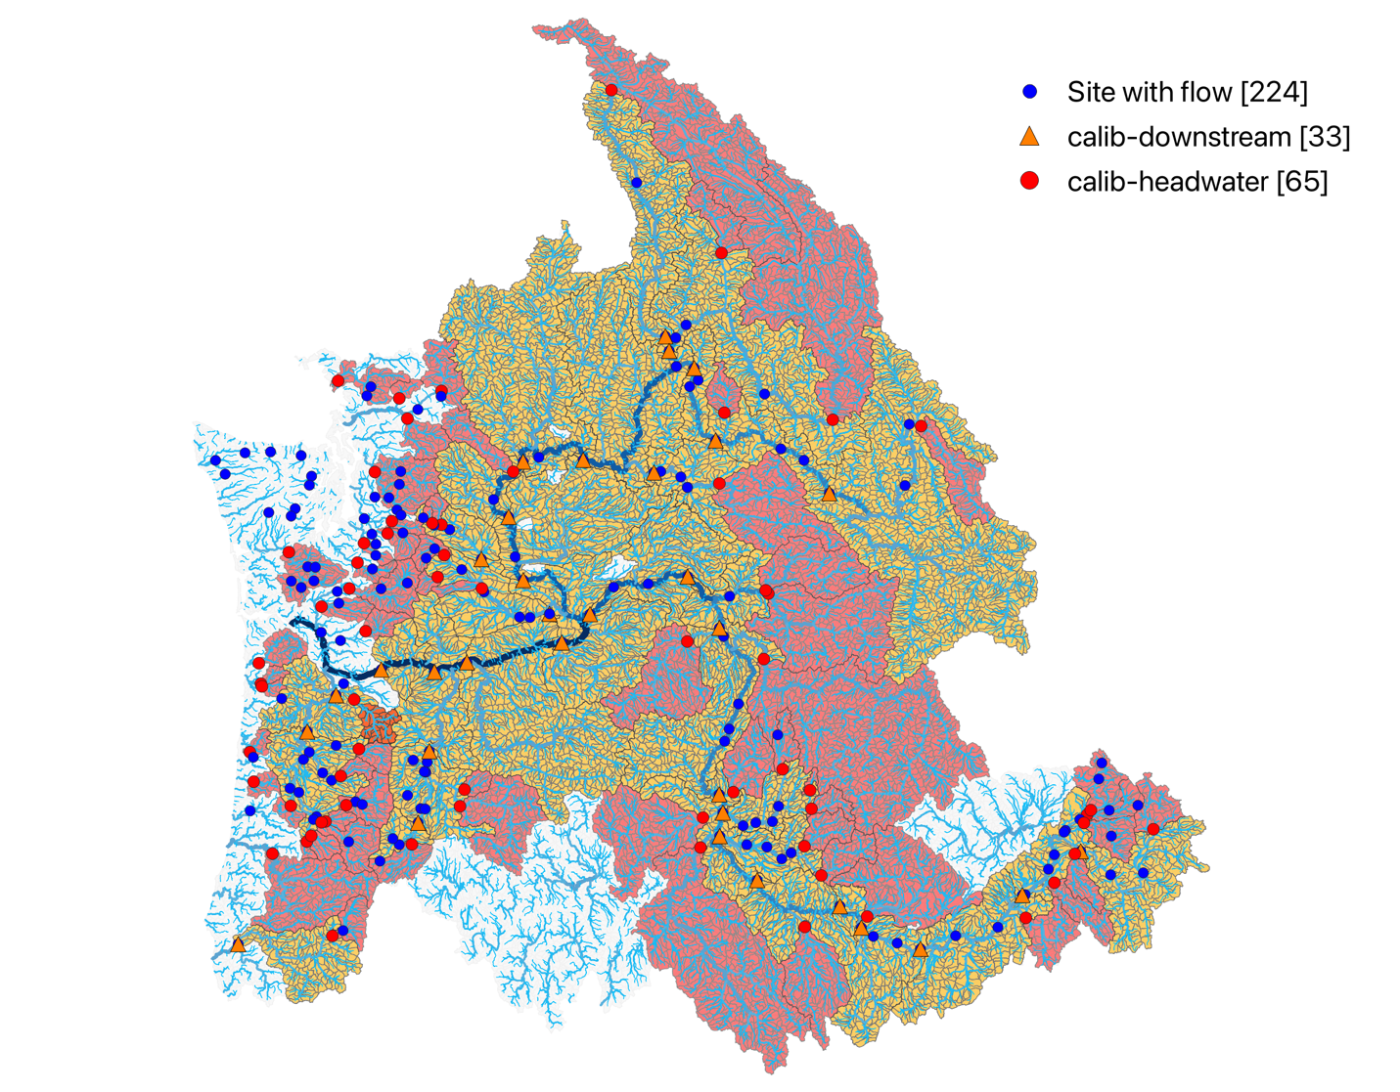Figure 8. Modeled river network in the Pacific Northwest with 221 naturalized flow sites. Red areas are headwater catchments calibrated using the flow data at the sites denoted by red circle first, and then their downstream areas in orange are subsequently calibrated using the flow data at orange triangle sites with calibrated parameters of their upstream areas fixed.
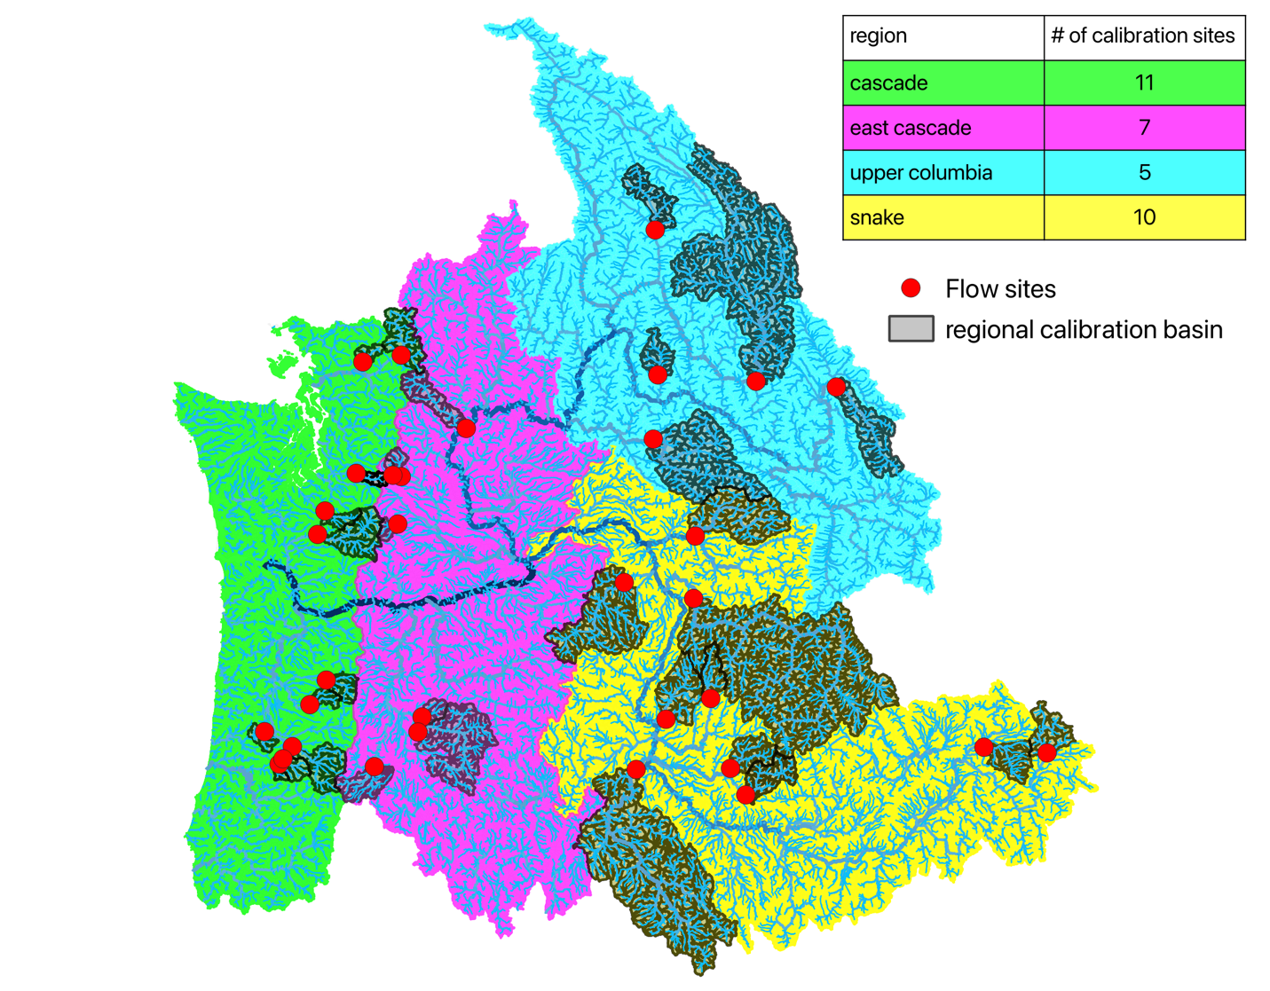Figure 9. 4 subregions and basins used for regional multi-basin calibrations.

3.3 Hydrologic Model Evaluation
In general, KGE in the mainstem Columbia is the highest, and the lowest performance is seen in headwaters of the Upper Snake (indicated by a circle), Deschutes (indicated by a rectangle). This pattern is similar to RMJOC-II (VIC) results which were attributed to “land use and geological characteristics” that are difficult to capture by models developed for a large spatial domain. i.e., irrigation withdrawals and groundwater effects not well-captured by hydrologic models.

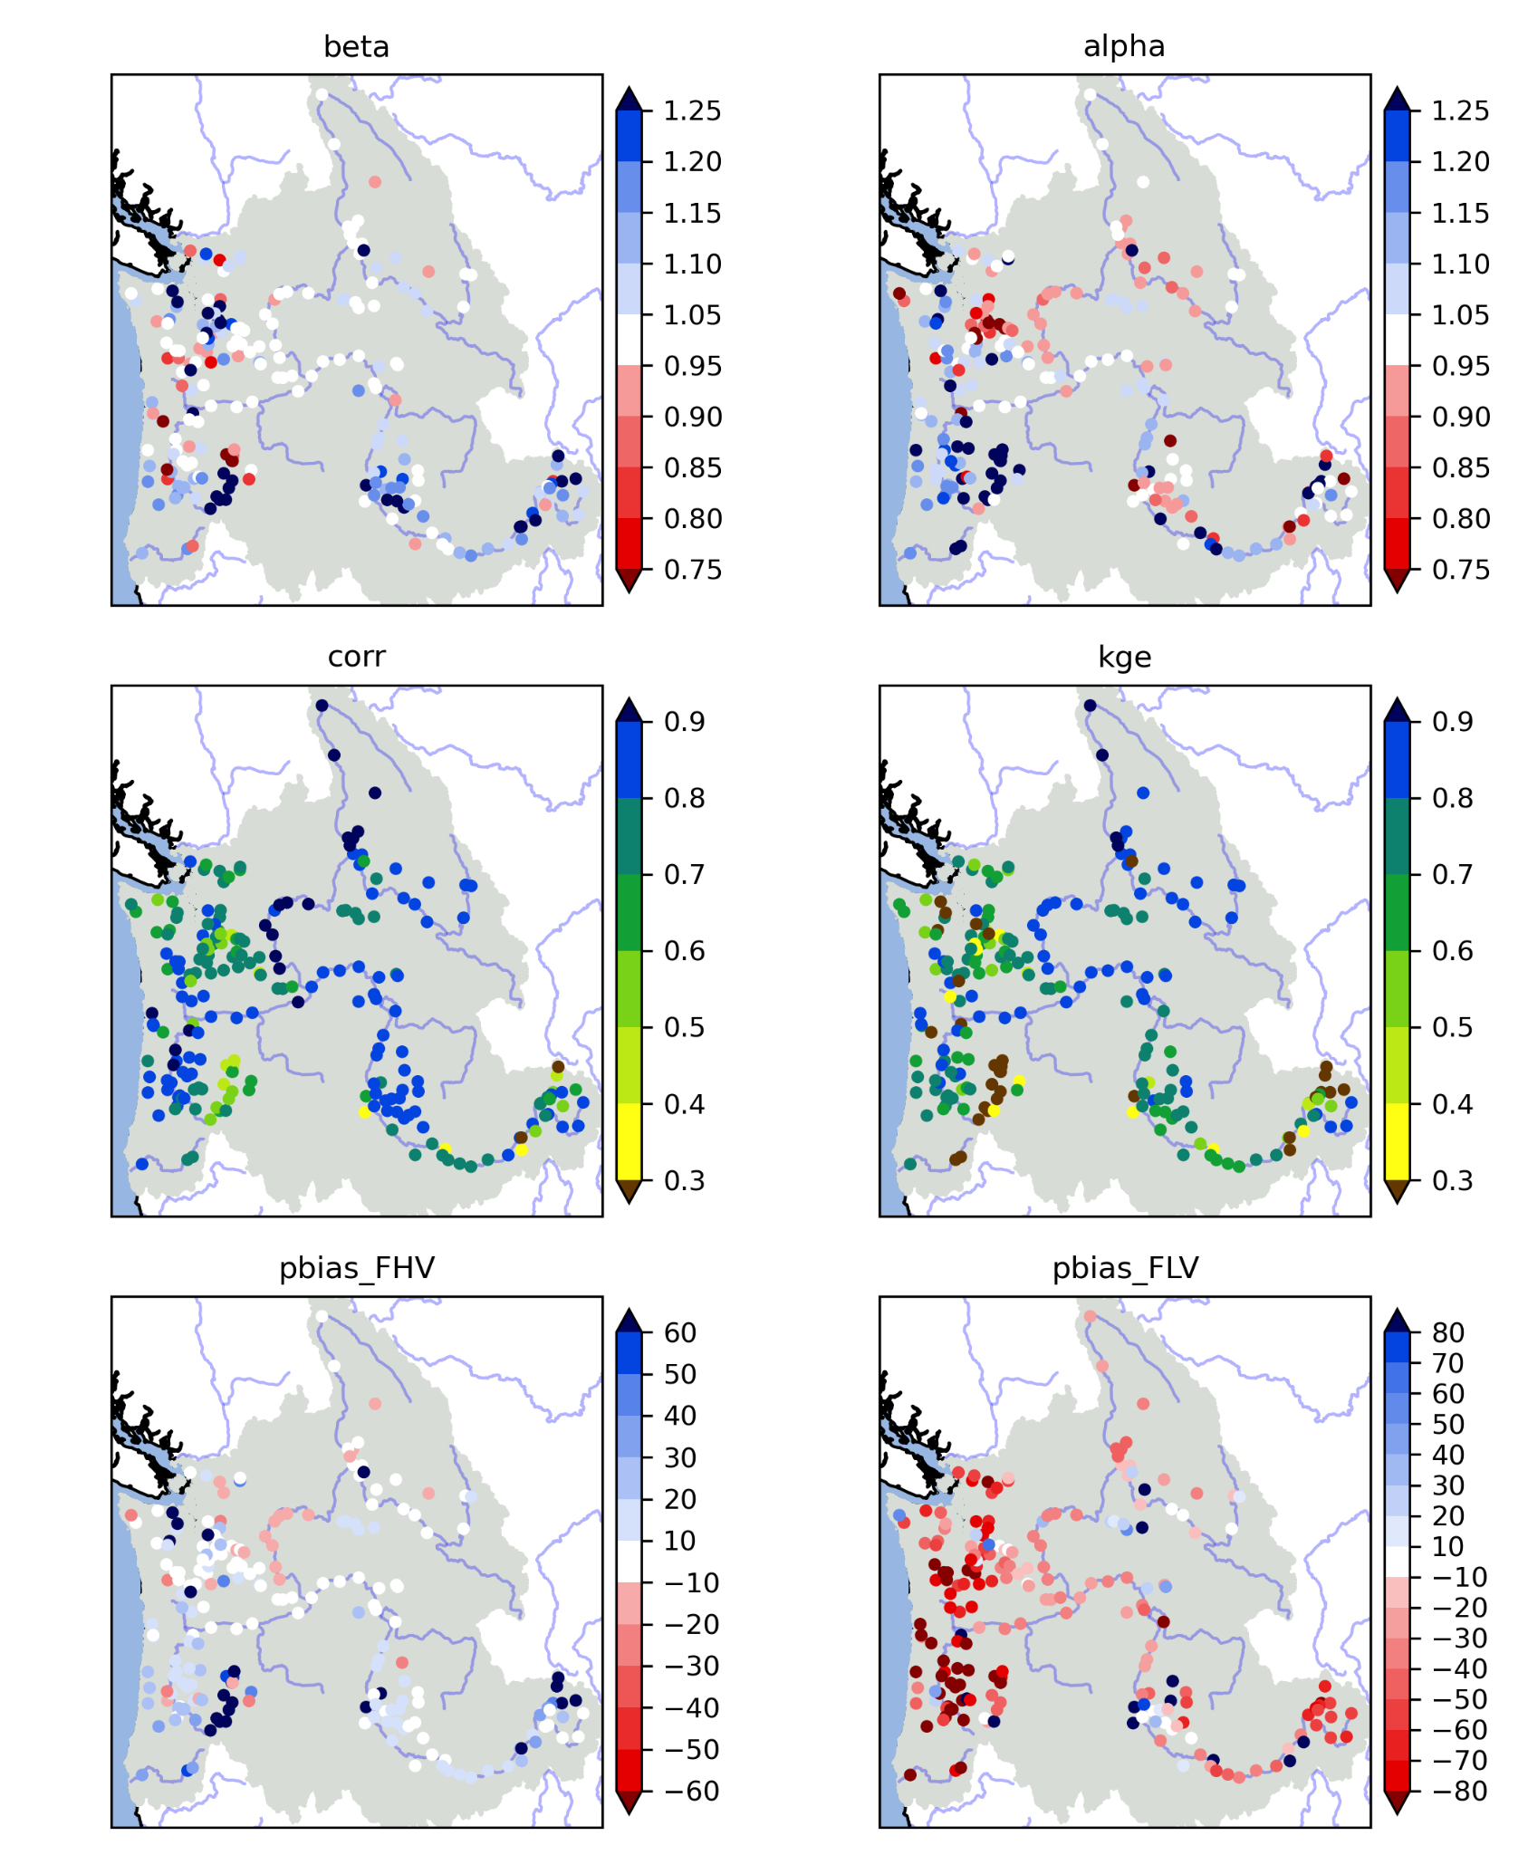
Figure 10. Maps of 219 flow sites with KGE and its three components (variability ratio, mean flow ratio, and correlation) and percent bias of high flow (>90% in FDC: FHV) and low flow (<10% in FDC: FLV). The error metrics are computed using 2001-2014 daily streamflow aggregated from 3hr simulations.
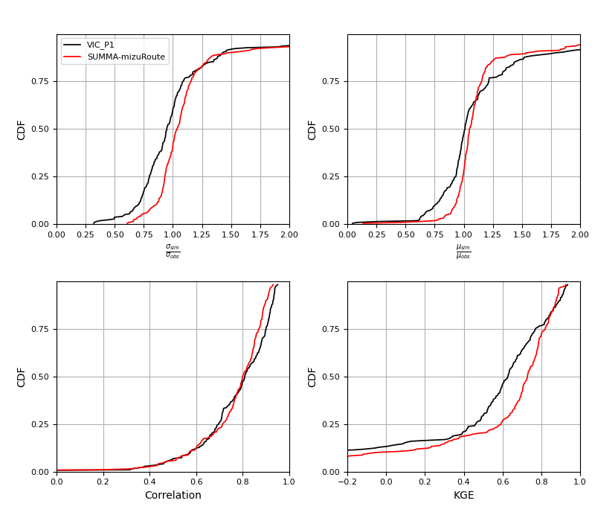
Figure 11. Comparison of cumulative distributions of KGE and its components at 219 naturalized flow sites between SUMMA and VIC (Chegwidden et al.,2019). The error metrics are computed using 2001-2014 daily streamflow aggregated from 3hr simulations.
High flow simulations are evaluated based on >90 percentile (high flow) and >99 percentile (extreme high flow) of flow duration curves (Figure 12). Histograms below show that the extreme high flow tends to be underestimated.

4 Streamflow bias correction
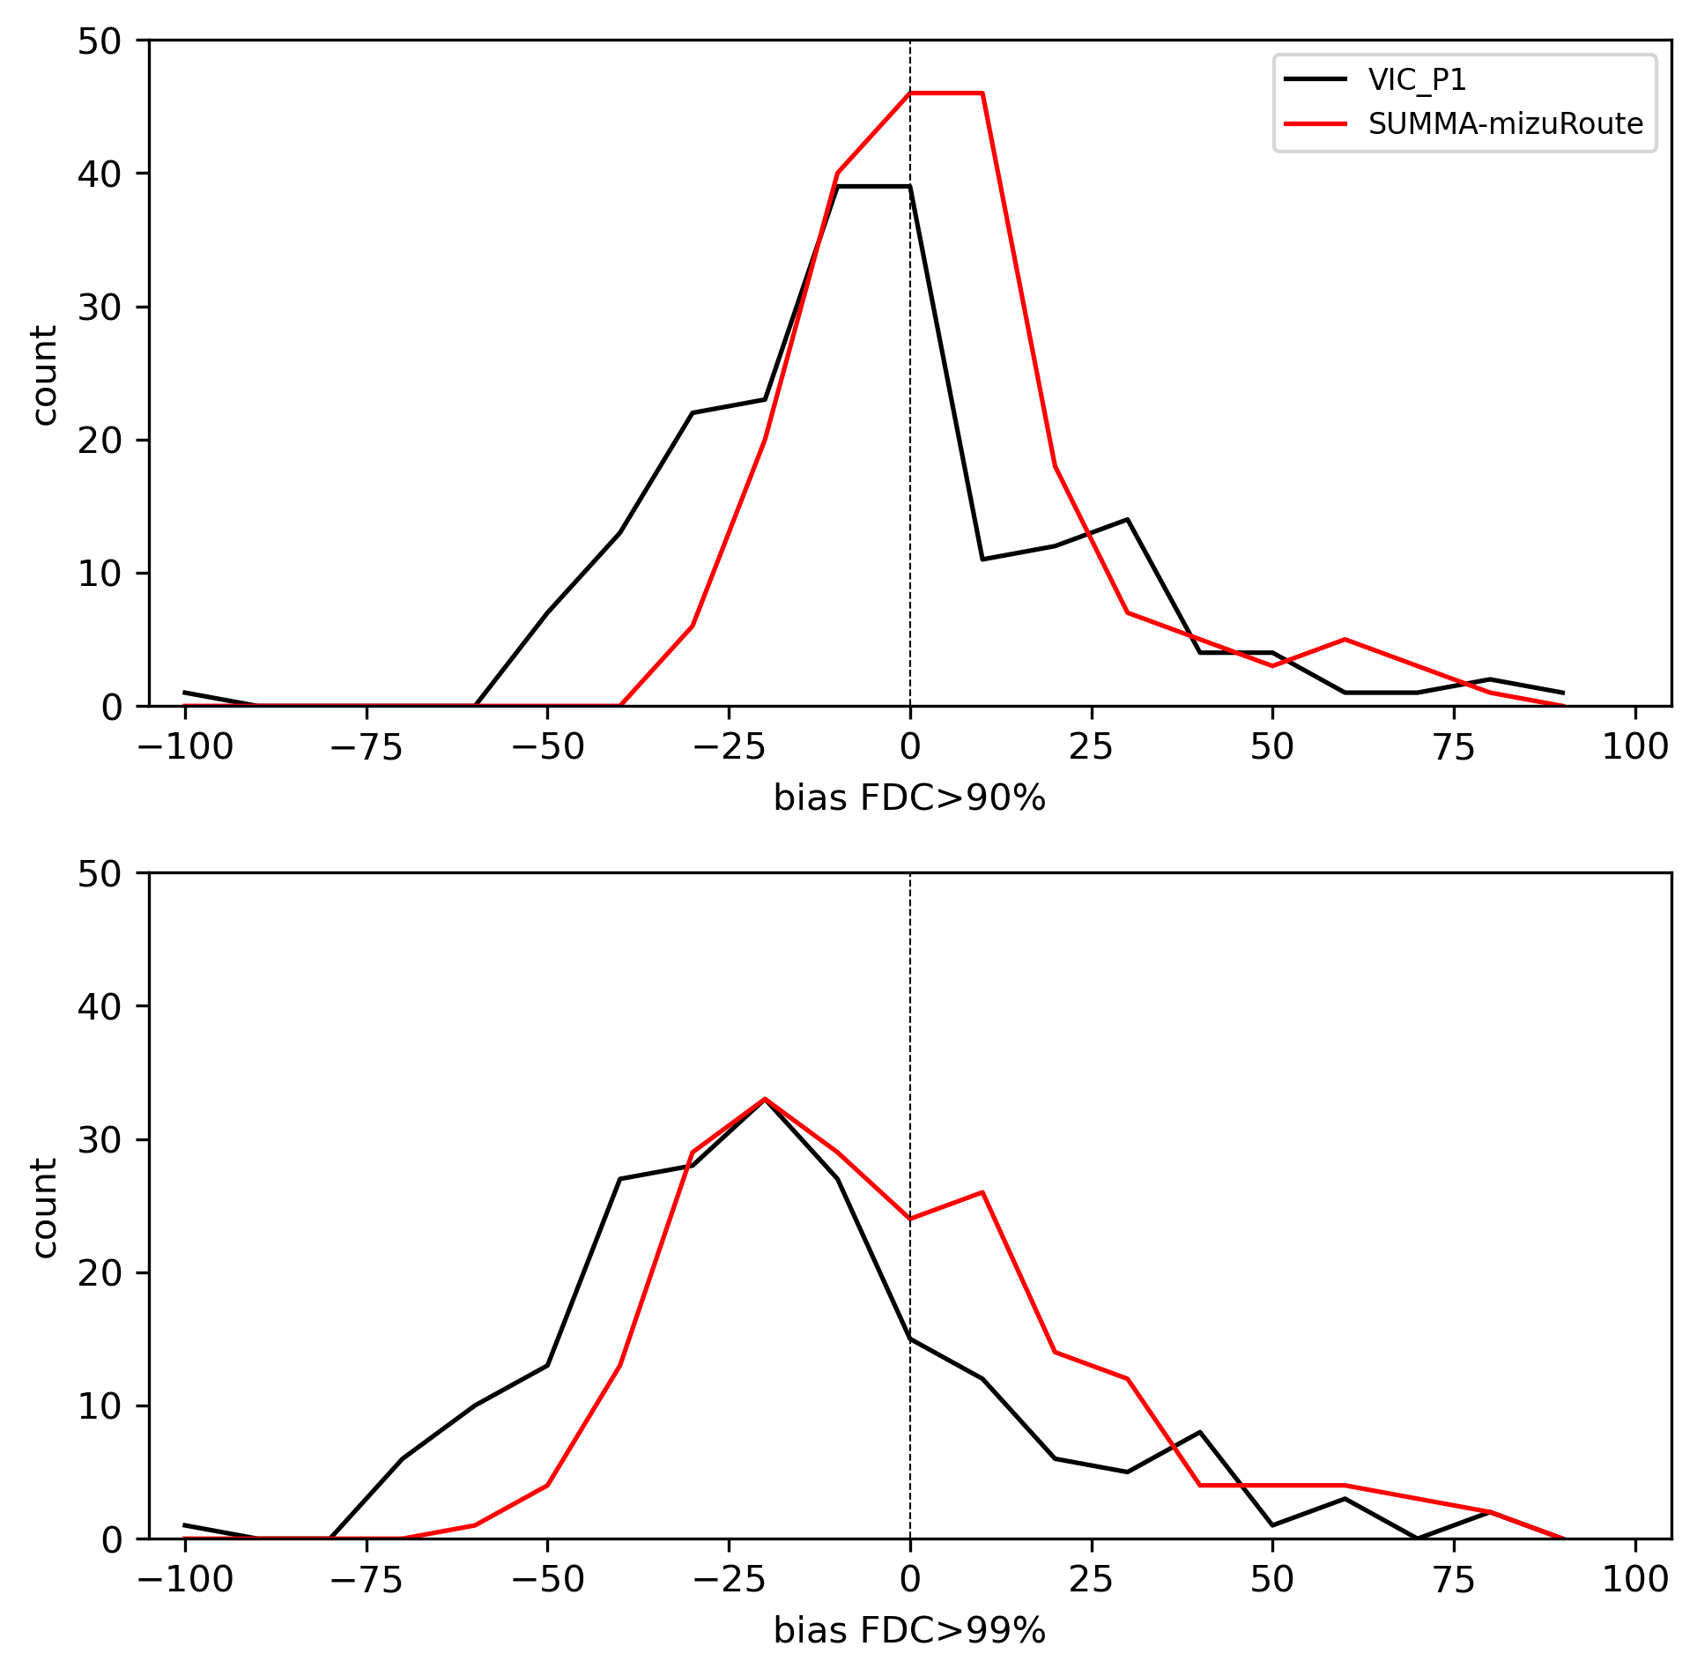
Figure 12. Histograms of biases in the top 10% of flow magnitudes (top) and in the top 1% of flows (bottom) for the new SUMMA implementation (red), and previous VIC implementation (black).

4.1 bmorph
The calibration of SUMMA parameters reduces the bias in historical streamflow simulations, which use the GMET meteorological forcings as model inputs. However, the calibrated SUMMA-mizuRoute simulations still show errors because of shortcomings in the model conceptualizations and parameter settings. Additional errors in simulated streamflow result when the calibrated SUMMA-mizuRoute models are forced with the downscaled GCM outputs. One source of errors stems from accumulated differences between GMET and GCM-derived forcing sequences that lead to different hydrologic states such as snow water equivalent and soil moisture.
To reduce the streamflow bias in SUMMA-mizuRoute simulations forced by the downscaled GCMs, we used bmorph (Bennett et al., 2022), an open-source software package to reduce systematic biases in modeled streamflow. Bmorph was originally developed and used in an early form as part of the RMJOC-II study (Pytlak et al., 2018). This study produced daily streamflow sequences for locations in the Columbia River basin and coastal drainages in the PNW based on CMIP5 climate model output. The method was further developed in collaboration with Reclamation as documented in Bennett et al (2022) to address two shortcomings of traditional streamflow bias correction methods. First, previous bias correction methods corrected all locations independently and therefore failed to maintain the spatiotemporal consistency of the streamflow simulations at multiple sites across a river network. This can result in inconsistent and nonsensical incremental flows between gauge locations. Second, previous bias correction techniques typically relied on time-invariant mappings (quantile based or simpler ratios) between reference and simulated streamflow without accounting for the processes that may give rise to systematic errors. For example, if streamflow errors result from a poor representation of snow processes, then corrections inferred from historic data may no longer be appropriate when snow becomes less prevalent. Bmorph was expanded with improved bias correction techniques that account for the river network topology (spatially-consistent) and that account for other processes (conditional).
As described in Bennett et al (2022), bmorph allows the user to select whether to apply these techniques separately or in conjunction, resulting in four bmorph configurations: independent bias correction, unconditional (IBC-U), spatially consistent bias correction, unconditional (SCBC-U), independent bias correction, conditional (IBC-C), and spatially consistent bias correction, conditional (SCBC-C). All four methods were evaluated in Bennett et al (2022), where daily minimum temperature was used as a proxy for snow processes to condition the bias correction.
For the project described in this report, we used the unconditional bias correction methods and tested both independent (IBC-U) and spatially-consistent (SCBC-U) methods. The IBC-U method provides good results for the historic period for which the mapping between simulated and reference flows is developed but has two shortcomings. It only provides bias-corrected flow sequences at sites with historic reference flows, and it often results in incremental flows that are negative and vary a lot from day to day. As a result, the SCBC-U method was used for all production runs in this project. The SCBC method bias corrects all reaches within the stream network and results in incremental flows that are consistent with flows at upstream and downstream locations. We did not test different conditioning approaches for bmorph and unless stated otherwise, IBC and SCBC in this report refer to the IBC-U and SCBC-U methods, respectively.
The bmorph workflow is described in detail in Bennett et al (2022) and consists of two steps, a preprocessing step and the bias correction step. The preprocessing step depends on whether spatial consistency is enforced and whether the bias correction is conditioned on an additional variable. In all cases, reference flows are required at a number of locations in the flow network that can be used to develop a mapping between the reference and simulated flows. This mapping is then used in the bias-correction step. For this project, reference flows were taken from the 2020-Level No Regulation-No Irrigation (NRNI) streamflow dataset mentioned in the calibration section.
If spatial consistency is not enforced, then bias correction (independent bias correction, IBC) is only performed for each of the locations for which reference flows (NRNI) are available. At each of these locations a mapping is developed between raw and reference flows and this mapping is then used to modify the raw flows.
If spatial consistency is enforced, bias corrected flows are generated for each reach in the channel network. In that case, the reference gauges must be mapped onto the river network topology and upstream and downstream gauges are identified for each river reach, along with an interpolation factor that is used to provide regionalized bias corrections at each river reach. For details on the regionalizations of the bias corrections, see Bennett et al (2022). After bias-correcting the local flows to each reach, we reroute these bias-corrected local flows through the channel network using mizuRoute to produce spatially consistent bias-corrected flows for every reach in the channel network. The flows are spatially consistent, because, unlike in the case of independent bias correction, upstream corrections affect downstream flows.

4.2 bmorph evaluation
The performance of bmorph was evaluated by calculating the goodness-of-fit of the bias-corrected and raw or uncorrected streamflow series compared to the NRNI reference flows. Goodness-of-fit was determined by the individual KGE components — bias ratio (mean), variability ratio (or prediction error), and correlation. For this evaluation, we used an evaluation period of 2001-2020. Reference and simulated flows from this period were not used for SUMMA calibration nor used as the period to develop the mapping between the reference and simulated flows used by bmorph.
Figure 13 shows the cumulative distributions of KGE and each of its components for the evaluation period for the uncorrected streamflow simulations and the SCBC-U corrected streamflows across the 200 flow sites with NRNI flows that were used in this study. The same information is shown in Figure 14, which shows spatial maps of the error metrics for uncorrected and SCBC-U corrected streamflows. SCBC-U improves long-term bias, particularly in the Northern Cascades. Improvements in the variability error are seen in the Willamette River and Snake River basins, but some deterioration is seen east of the northern Cascade areas. The correlation values are largely similar for the uncorrected and SCBC-U streamflow values. The overall KGE is generally improved as a result of the bias correction process, although the highest KGE values remain largely unchanged.
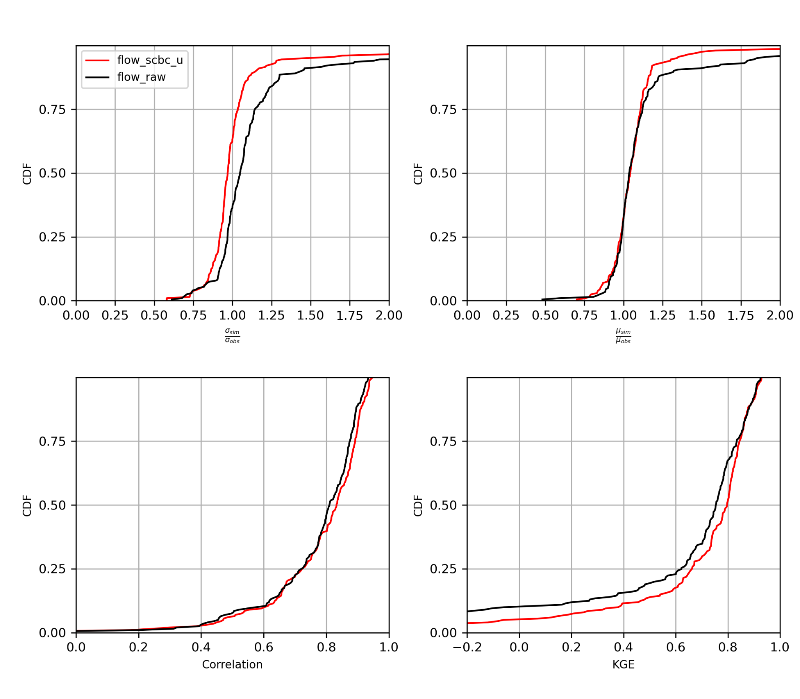
Figure 13. Comparison of cumulative distributions of KGE and its components between raw streamflow simulations and SCBC bias corrected streamflows. The error metrics are computed using 2001-2020.
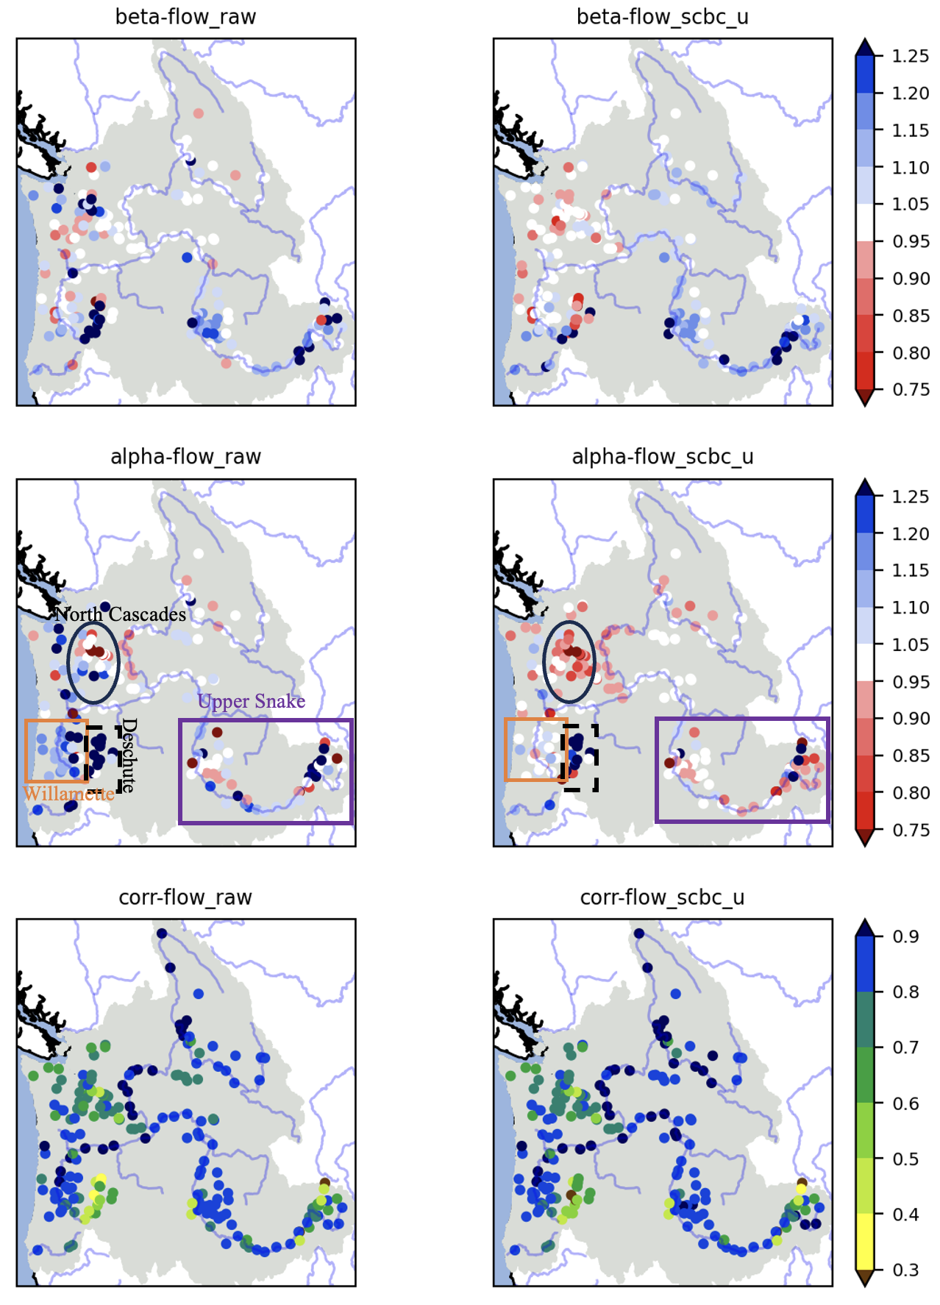
Preceding page: Figure 14. Spatial distributions of KGE components for raw or uncorrected streamflow simulations (left column) and SCBC-U bias corrected streamflows (right column). The error metrics are computed using 2001-2020. Top: Beta, the ratio between the modeled and observed mean flow, i.e. the bias ratio, Middle: Alpha, the ratio between modeled and observed variance in the flows, i.e. the variability ratio, Bottom: corr, the pearson correlation coefficient between modeled and observed daily flows. Regions referred to in the text are highlighted in the middle panel: the North Cascades are in the black oval, the Willamette Valley is in the orange box, and the upper Snake River is in the purple box, and the Deschutes is in the black dashed box.
Flow summary plots (Figures 15 and 16) include comparisons of the magnitude of annual maximum and minimum flow based on 7-day flow (top left 4 panels), timing (top right 3 panels), long-term mean seasonal cycle (bottom left), 30-day flow probability density (bottom middle), and daily Flow Duration Curve (FDC; bottom right). These flow summary plots are constructed to compare bmorph bias corrected GMET flow and raw GMET flow during each 20-year period–control (WY1980-2004) at all the sites.
Figures 15 and 16 show example flow summary plots for two NRNI locations on the Columbia River, Arrow Lakes (ARD; upper Columbia) and The Dalles (TDA; lower Columbia). Extreme high flows (FDC > 95th percentile) are underestimated at the ARD site, though the simulated 20-year mean seasonality (seasonal peak) captures observations well. High flow events are also underestimated at other sites in the upper Columbia River. This underestimation of high flow events decreases for sites further downstream along the Columbia mainstem (e.g., TDA).
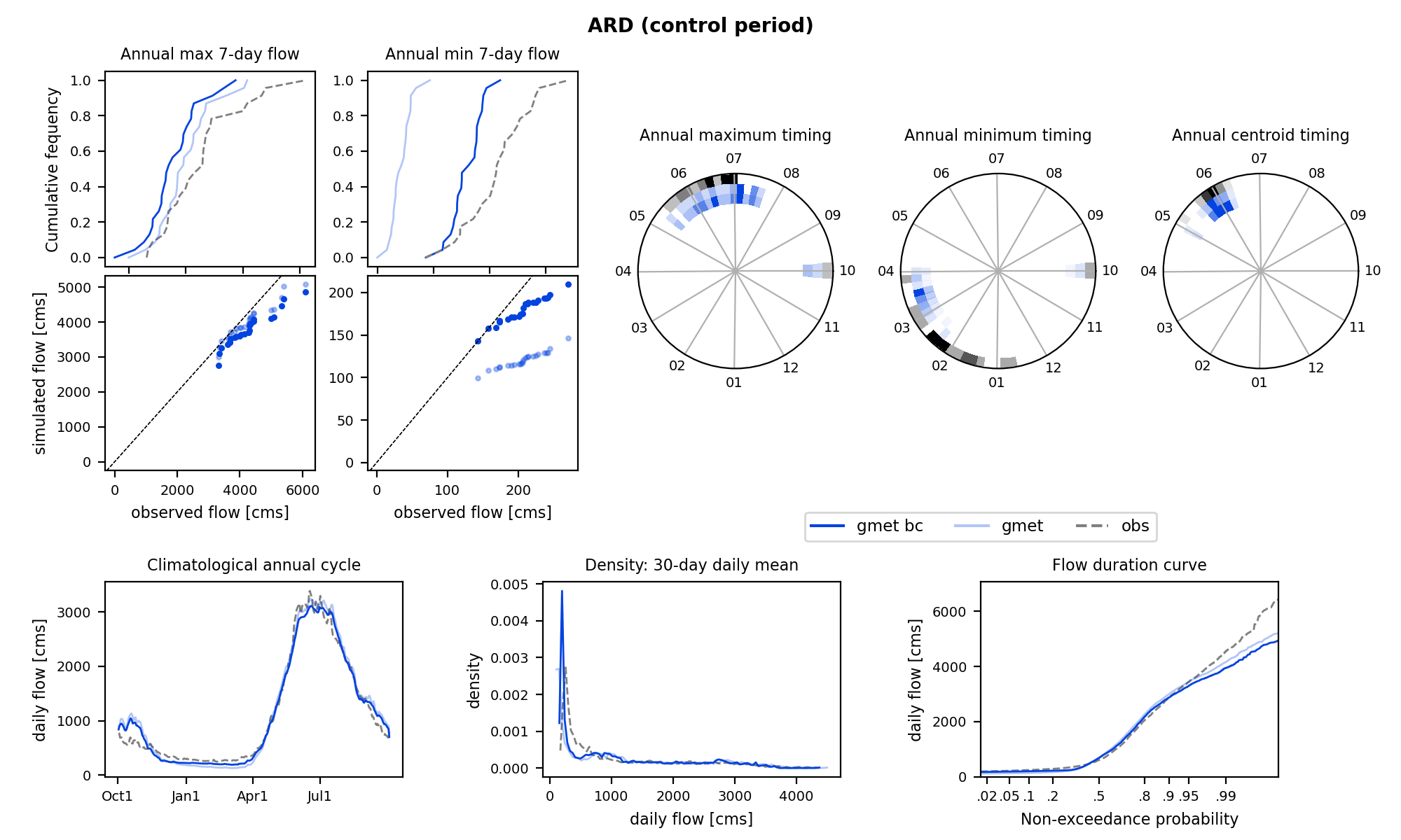
Figure 15. Flow summary plots at ARD (upstream Columbia River) during the control period (WY1980-2004). Light blue line: raw simulation using GMET forcing. Blue line: bmorph SCBC bias corrected flow.
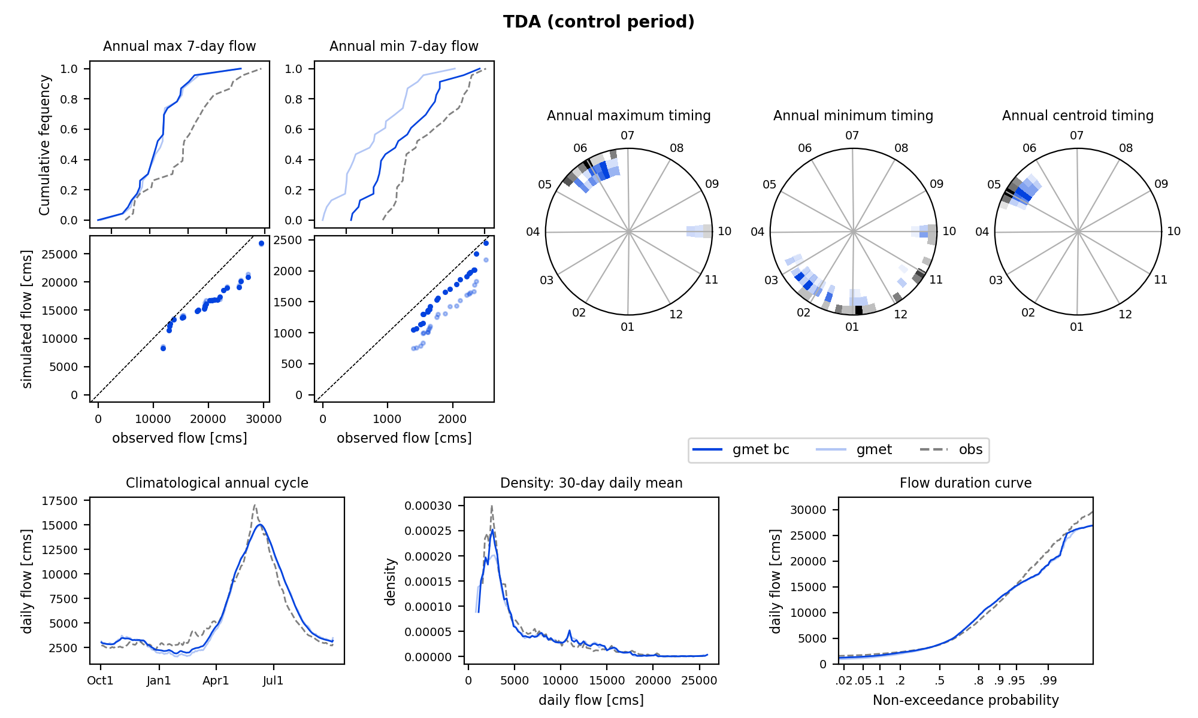
Figure 16. Flow summary plots at TDA (downstream Columbia River) during the control period (WY1980-2004). Light blue line: raw simulation using GMET forcing. Blue line: bmorph SCBC bias corrected flow.
4.3 Temporal disaggregation from daily to sub-daily

Bmorph produces daily bias-corrected flows. Temporal disaggregation from daily to 3hr is performed for several sites by using the sub-daily patterns in the uncorrected simulations. On each day, fractions of 3hr flow to daily flow (8 fraction value per day) are computed using the uncorrected 3hr simulation, and the bias-corrected flows are then multiplied by these 3-hourly fractions to obtain 3-hourly bias-corrected flows. This method conserves the daily bias-corrected flow volumes as illustrated by Figure 17, while using the temporal signal from the uncorrected simulations.

5 Model Application Results
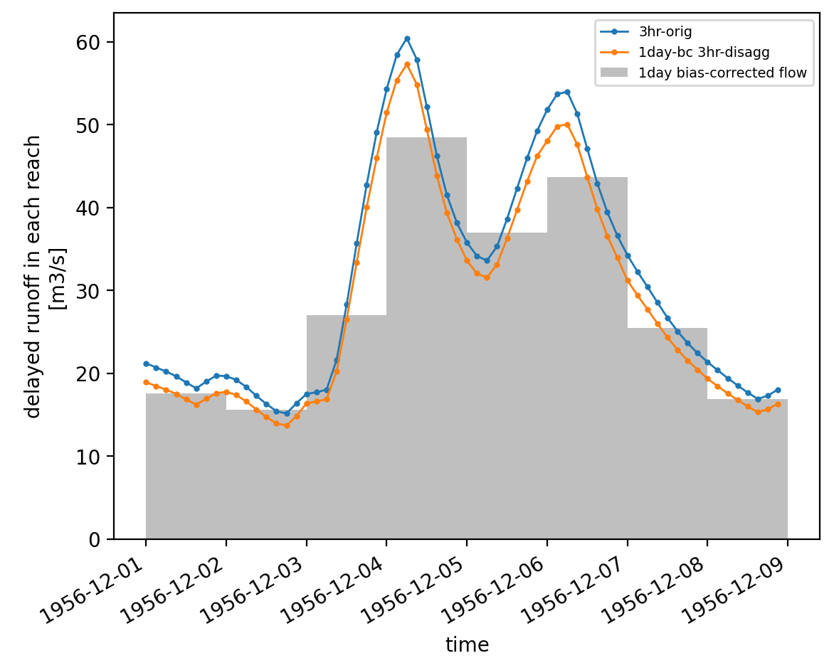
Figure 17. Example 10-day period with the original 3-hourly modeled streamflow (blue), the daily values after bias correction (grey), and the bias corrected daily flows disaggregated back to 3-hourly flows (orange).

5.1 Downscaled Temperature and Precipitation Projections

5.1.1 CMIP6 Annual Change Signal
When averaged across ICAR downscaled global climate model results (excluding CESM2-LE for consistency across SSPs), the models project increases in mean annual precipitation across most of the western U.S. (Figure 20). Although the annual pattern is one of increasing precipitation, seasonally there are often decreases as discussed later. Even annually, there are small decreases along the mountains of the west coast, particularly on the leeward (east) side of those mountain ranges. This includes the coast ranges from California north through the Olympics, as well as the larger mountain ranges from the Sierras through the North Cascades. The increases are larger in SSP585 than in SSP370 or SSP245. The variation in changes between climate models is greatest in the central latitudes of the western U.S. (37° to 45° N) and inland from the first major mountain range, most notably in the lee of the Sierras in California, but also east of the southern Cascades. Both the mean and standard deviation are amplified when a higher emission scenario is assumed (larger in SSP585 relative to SSP370 or SSP245). This implies greater uncertainty in the changes in basins like the Snake River and more confidence in output within the upper Columbia River basin and along the coast and windward (west) side of the Cascades (Figure 21). Figure 22 shows this variation across GCMs with each GCM and scenario pair plotted independently. Finally, the changes in more extreme precipitation amounts, defined by the mean of the annual maxima, are shown in figures 23 (west wide) and 24 (Columbia River Basin subset).
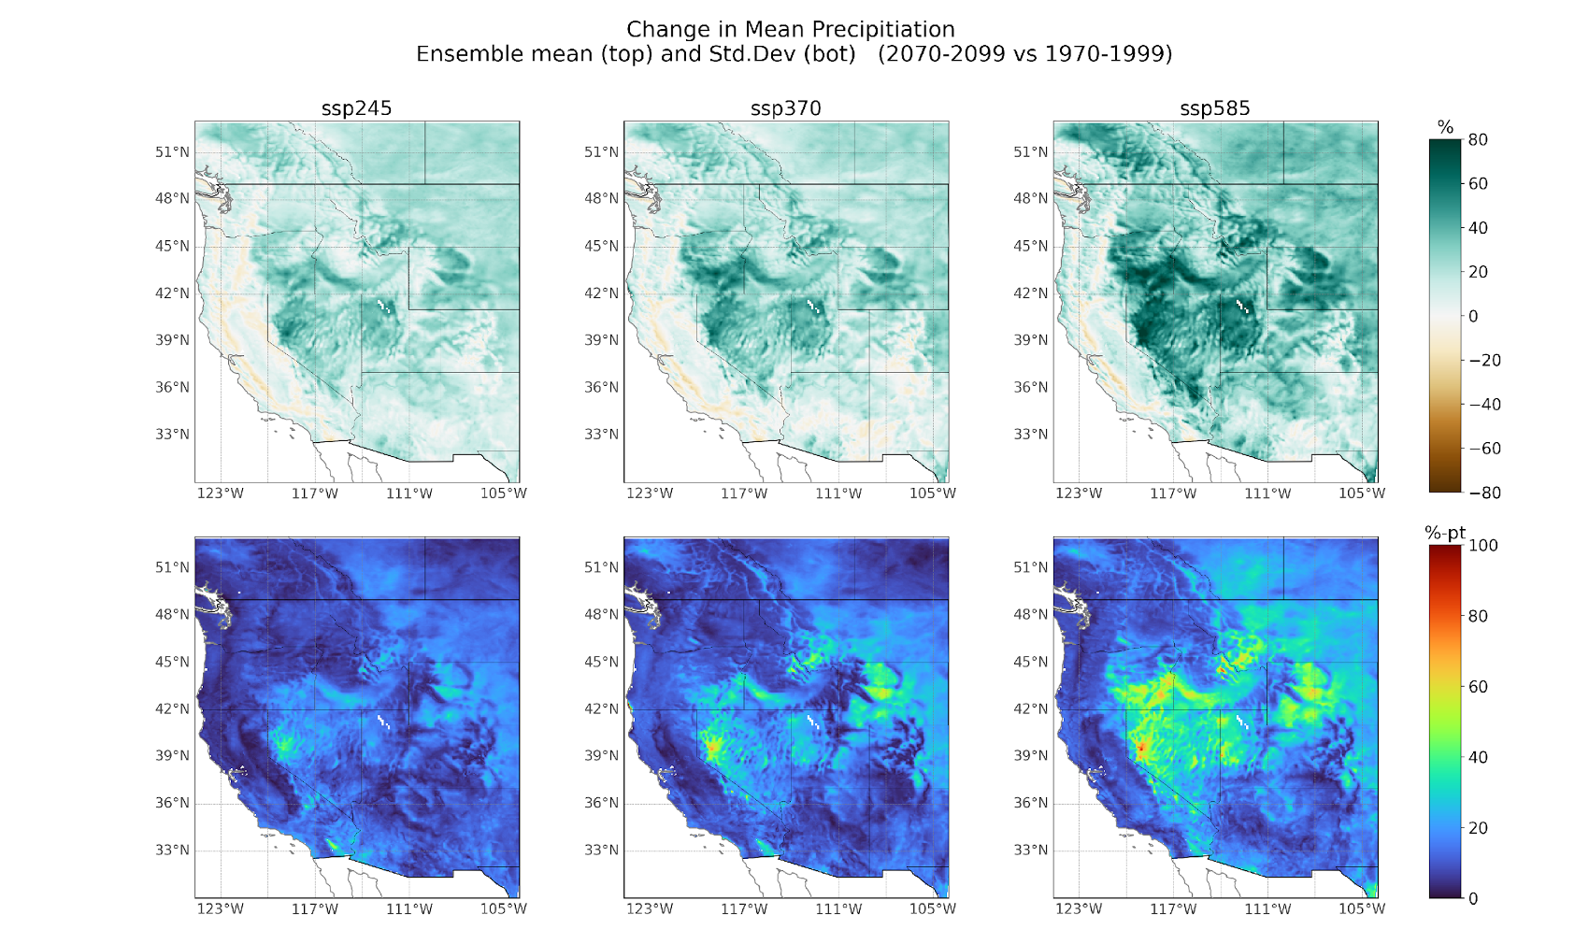
Figure 20. Percent changes in mean annual precipitation (top) and standard deviation of the change across the climate model ensemble (bottom).
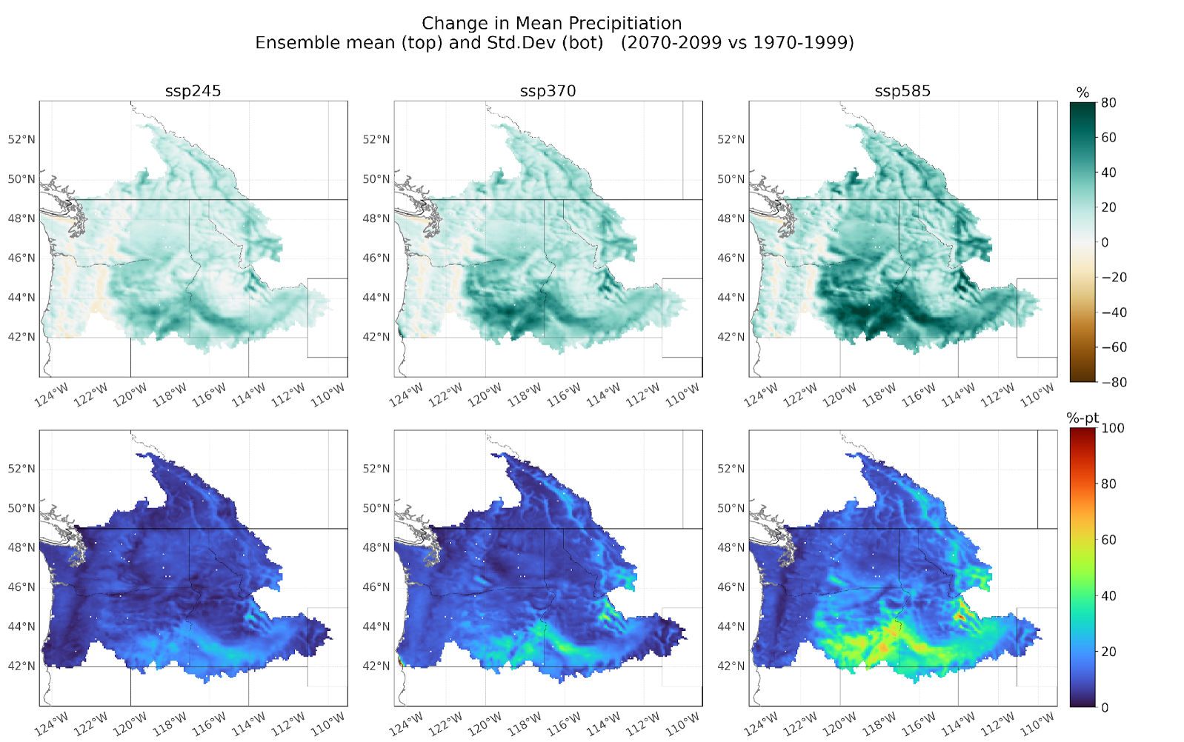
Figure 21. As in figure 20, subset over the Columbia River Basin.
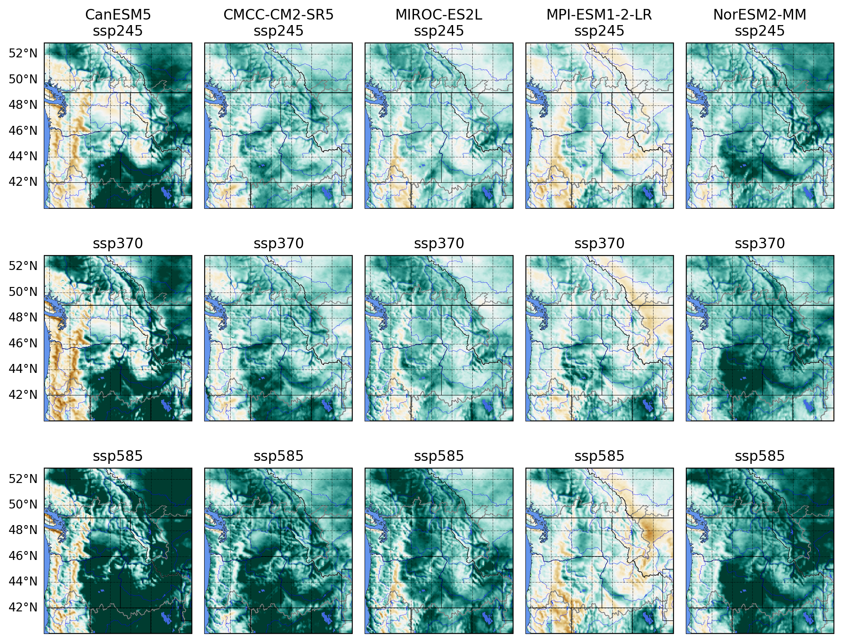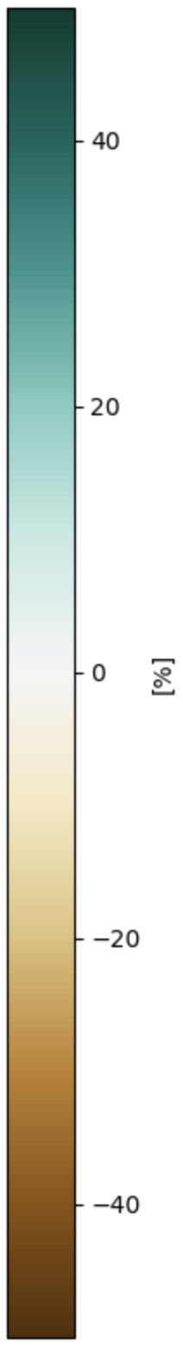
Figure 22. Percent changes in precipitation across the PNW for each GCM (columns) and SSP (rows).
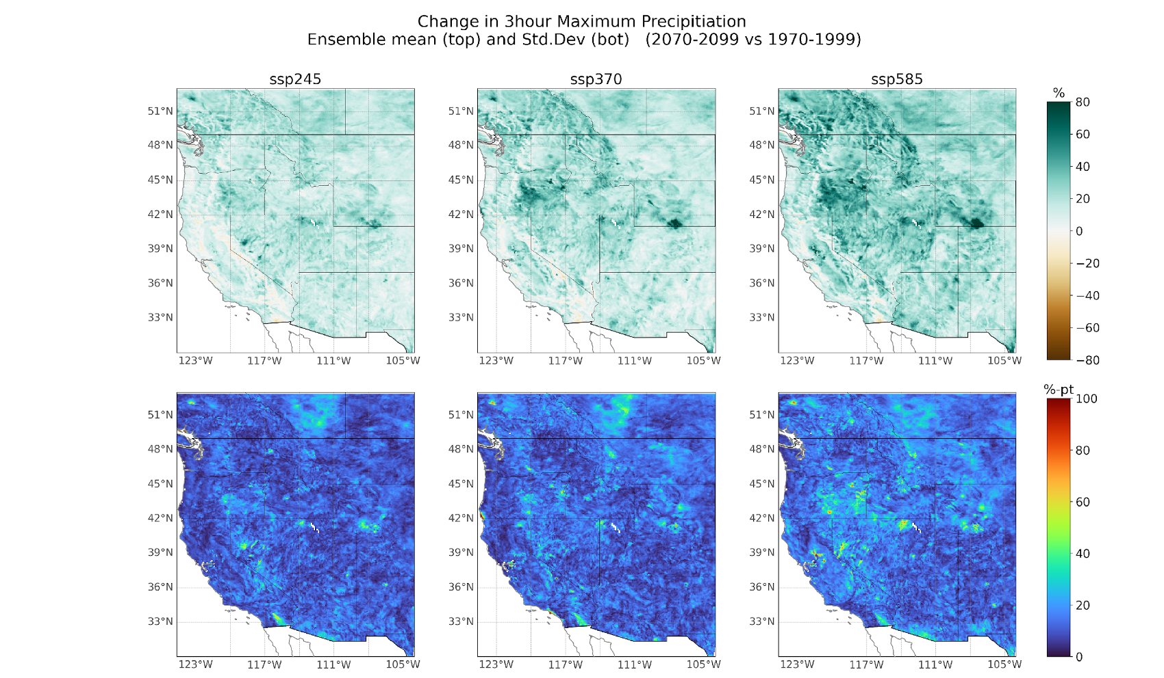
Figure 23. Percent changes in mean annual maximum precipitation (top) and standard deviation of the change across the climate model ensemble (bottom).
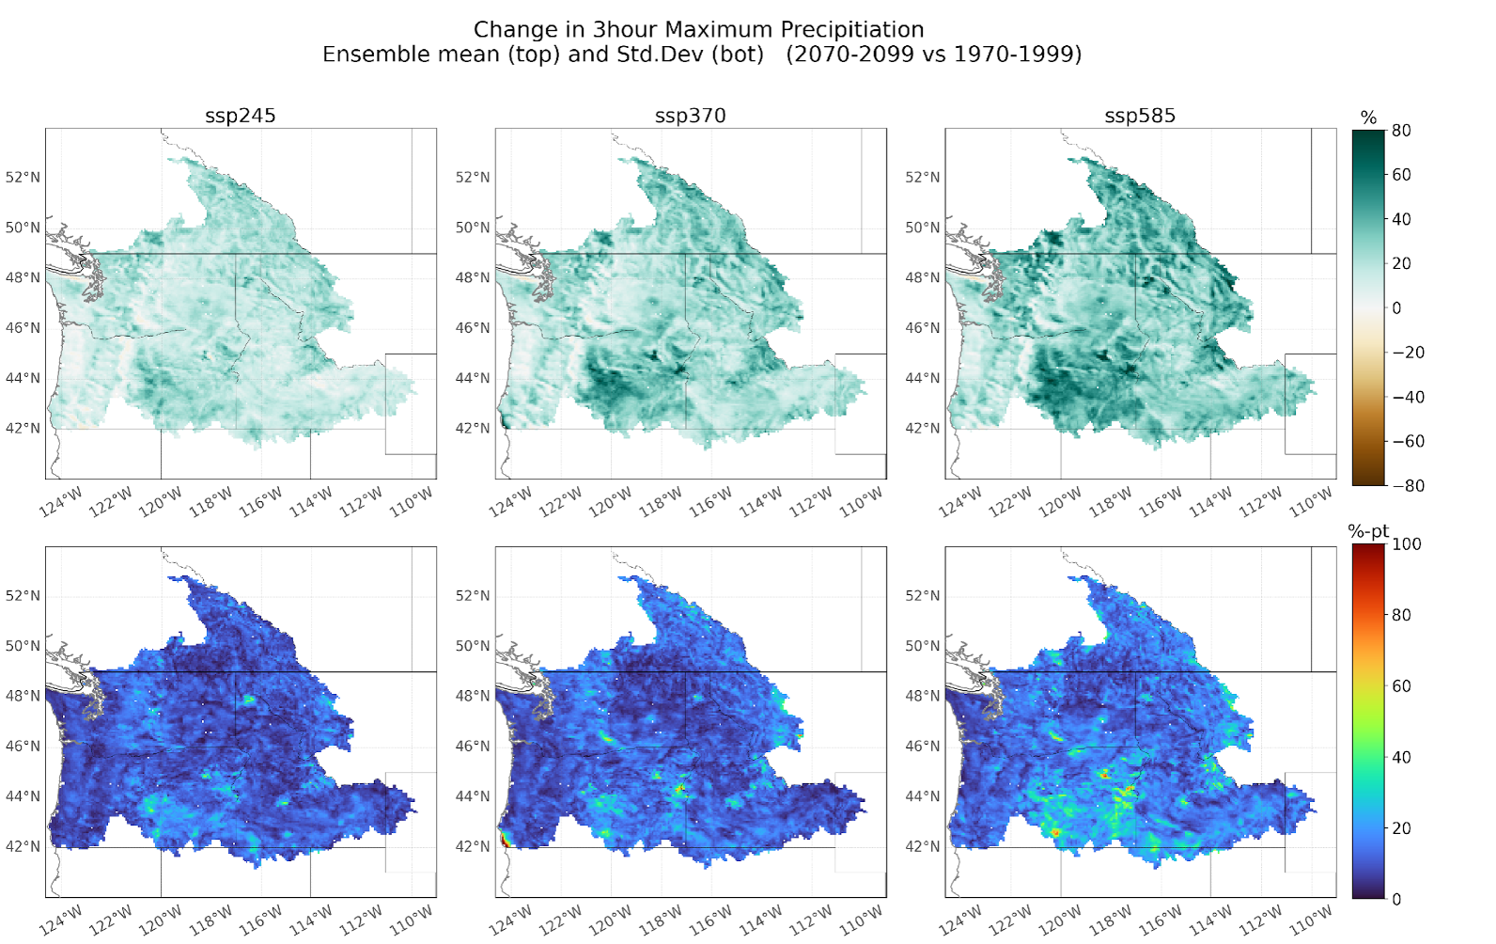
Figure 24. As in figure 23, subset over the Columbia River Basin.

Unlike precipitation, air temperature increases everywhere across the domain, with the greatest increase observed in the interior, and the least increase observed along the coast (Figure 25). In addition, there is a notable snow albedo feedback effect leading to elevation dependent warming (more warming at higher elevations), this is most evident in daily maximum temperatures. . There are significantly greater increases in air temperature in the SSP585 emissions scenario and particularly in the CanESM5 climate model (Figure 26). Note that CanESM5 is one of the hottest of the “Hot” models in CMIP6 (Rahimpour Asenjan et al., 2023) and should be used with caution; however, it is useful to evaluate as a possible extreme future change.
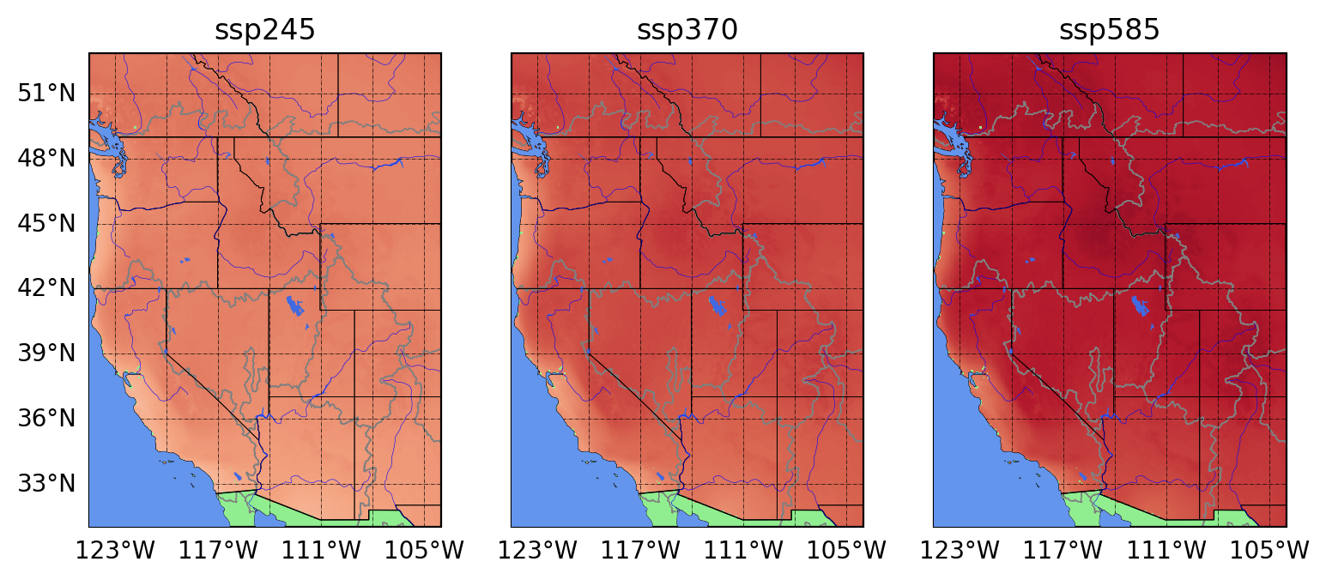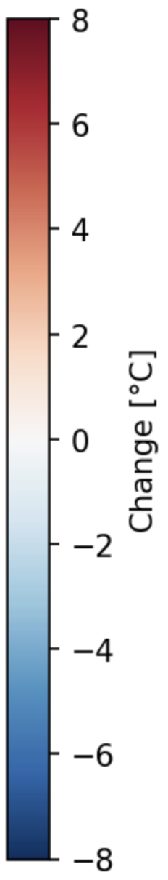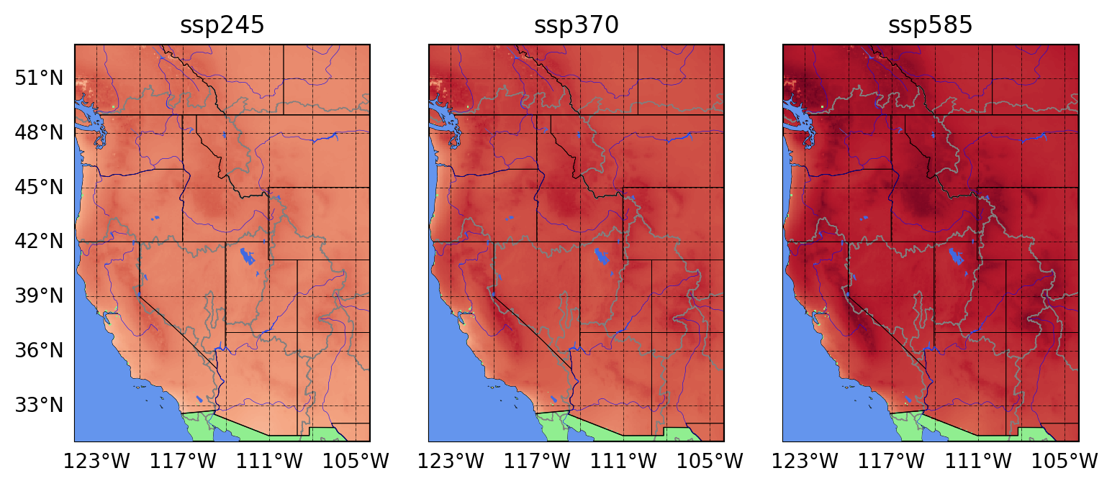
Figure 25. Change in daily minimum 2 m air temperature (top) and daily maximum 2 m air temperature (bottom) for each SSP (columns) averaged across GCMs.

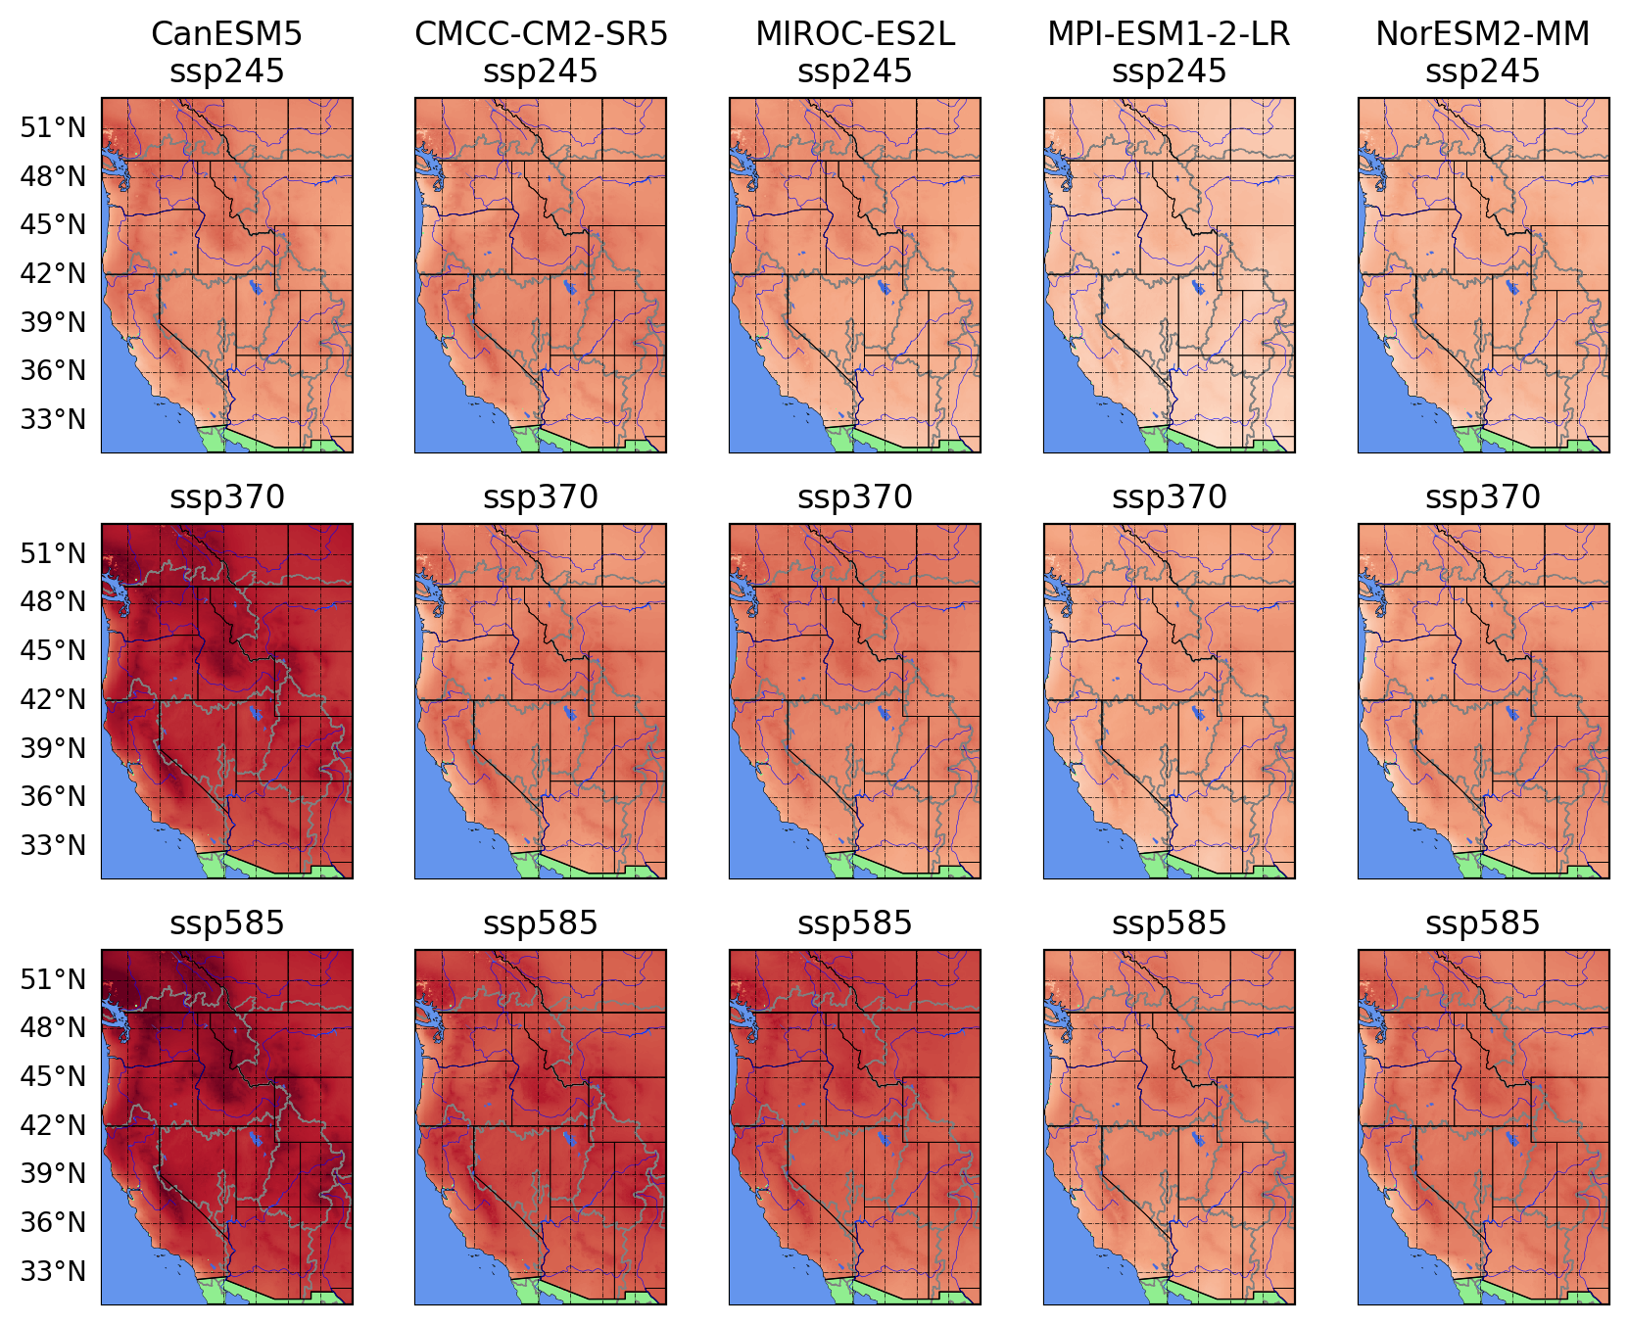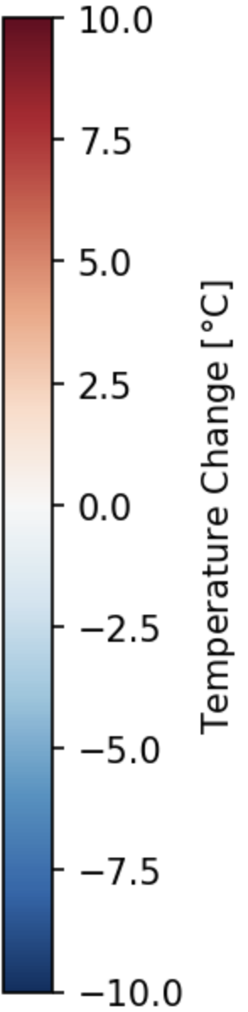
Figure 26. Changes in daily maximum air temperature across the western U.S. for five CMIP6 GCMs (columns) and three SSPs (rows).

5.1.2 CMIP6 Seasonal Change Signal
The patterns of changes in precipitation have a strong seasonality to them (Figure 27). The winter season (December, January, and February: DJF) has a decrease in precipitation on the leeward side of the mountains, and in the southern part of the western US, with increases in precipitation at lower elevations. Spring (March, April, and May: MAM) has a pronounced latitudinal gradient, with significant decreases in precipitation expected across the southern part of the western U.S, and increases projected north of 40° latitude. Summer (June, July and August: JJA) has the greatest increases in precipitation being projected across the majority of the western U.S. However, this effect is likely amplified because change is being reported as a percentage, and much of the region with large percent increases receives very little precipitation currently. Finally, fall (September, October, and November: SON) have a similar pattern of change as in winter (DJF), but with more increases in precipitation in the southern part of the western US. Most of the Columbia River basin is projected to have increases in precipitation, though the coast range in the Pacific Northwest have decreases in mean precipitation particularly in JJA and SON, and the largest percent increases in the Deschutes and Snake river basins in JJA (Figure 28).

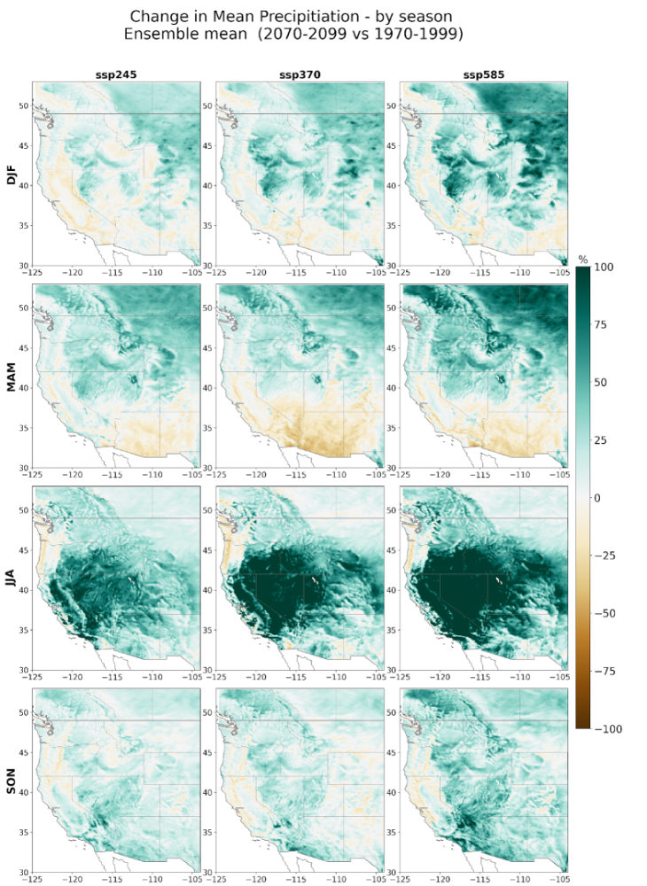
Figure 27. Percent change in precipitation for three SSPs (columns) by season (rows) as averaged across GCMs.
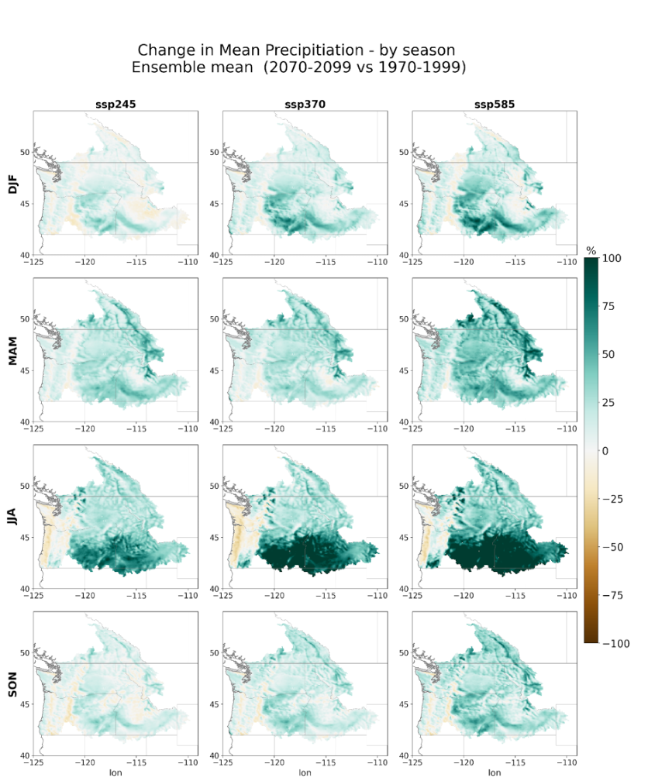
Figure 28. Percent changes in precipitation by SSP (columns) and season (rows) over the Columbia River Basin
Air temperature changes also exhibit a strong seasonality, with the largest changes typically in JJA followed by SON, then MAM, while DJF has the smallest changes (Figure 29). In the Columbia River basin, the greatest increases in air temperature are projected to occur in JJA and SON (Figure 30). This is a feature that is consistent across climate models. The snow albedo feedback warming is most prominent in JJA, with a little enhanced warming at mid elevations in MAM and the highest elevations projected to have less warming in MAM as persistent snow cover in the future reduces the potential temperature changes. The seasonality of the snow albedo feedback effect may be later in the year than it should be. In particular, while the shift from the Noah LSM to the Noah-MP LSM provided better representation of air temperatures in general, it also appears that the snow in Noah-MP takes too long to melt, and lasts later into the summer than it is observed to. Future work will need to improve the coupling between the Noah-MP LSM and the atmosphere in ICAR.
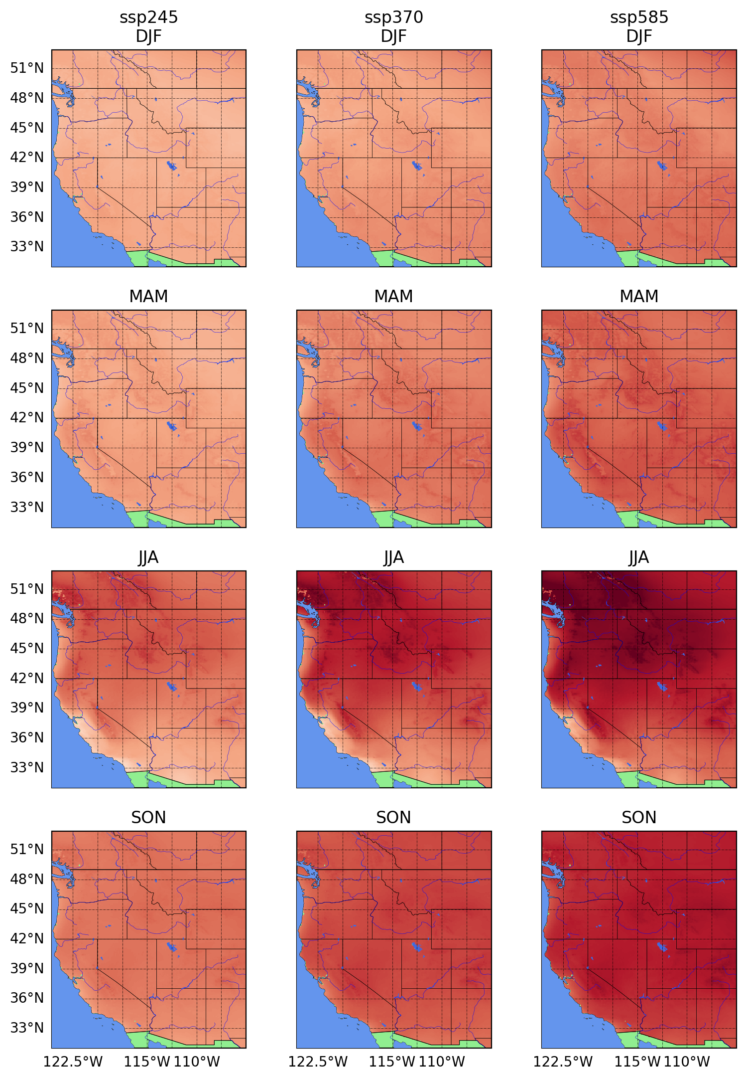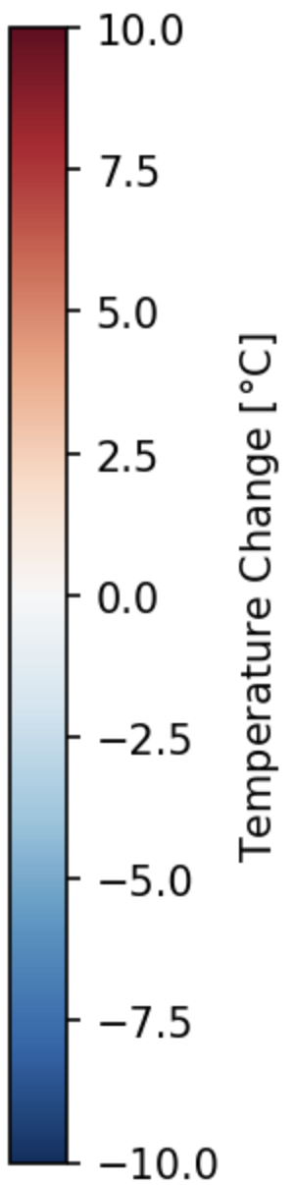
Figure 29. Change in daily maximum air temperature across the western U.S. by SSP (columns) and season (rows).
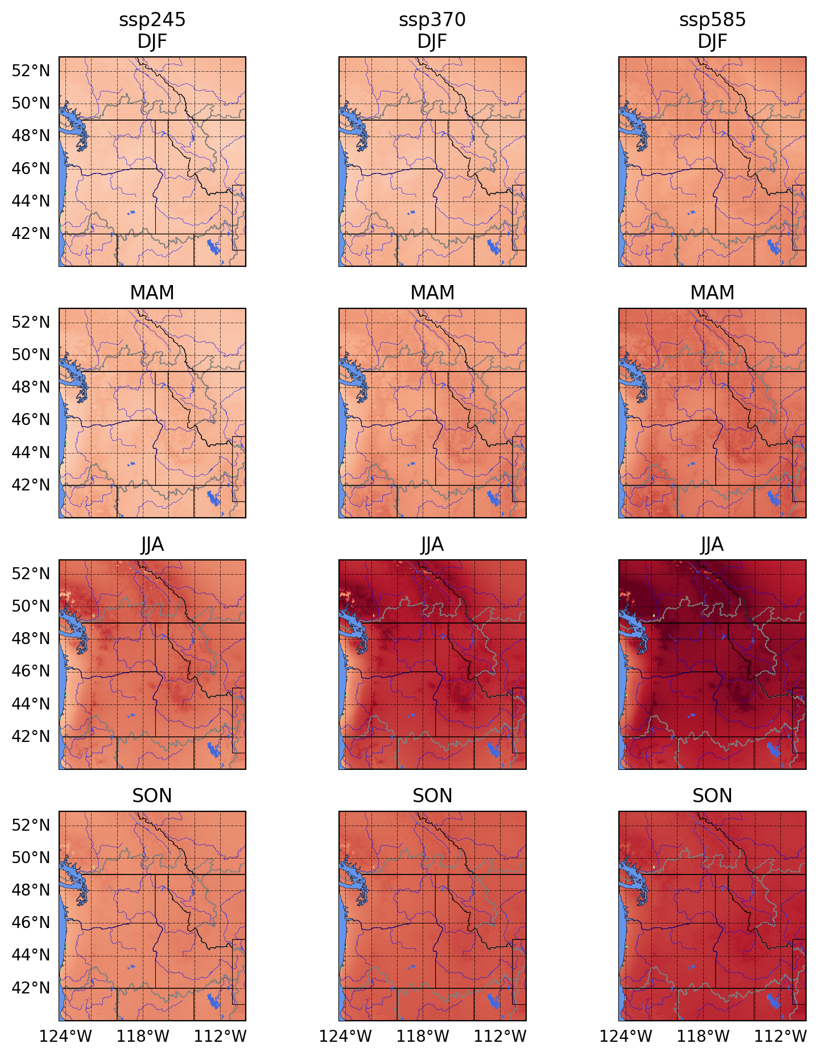
Figure 30. Change in daily maximum air temperature in the PNW region by SSP (columns) and season (rows).

5.1.3 CMIP6 Changes in extreme precipitation
Individual basins within the Columbia River basin are expected to see significant increases in extreme precipitation (mean annual daily maxima). Single day mean annual maximum precipitation totals were compared with the mean annual maximum for 3-day accumulated and a 7-day accumulated totals. Changes in annual maximum 1-day, 3-day and 7-day accumulated precipitation exhibit similar patterns (Figure 31). Statistics are computed from the rolling n-day accumulated precipitation, with the maximum value in each year selected, and the mean across years computed from those. These different accumulation time periods are useful for different applications and are controlled by different physical processes. 1-day extreme precipitation events, particularly East of the Cascades are often caused by more isolated convective precipitation, while 3-day and 7-day events are more likely to be caused by larger spatial scale frontal passages including atmospheric rivers (ARs). In all cases, maximum precipitation increases, with the largest increases in absolute changes occurring along the windward side and the crest of the Cascades, and the largest percentage increases occurring in the interior of the domain where the absolute magnitudes are low to begin with. For 7-day totals, there are some slight decreases predicted on the downwind side of the coast range. These decreases are small and only in very small regions; more work is needed to understand if these changes are robust.
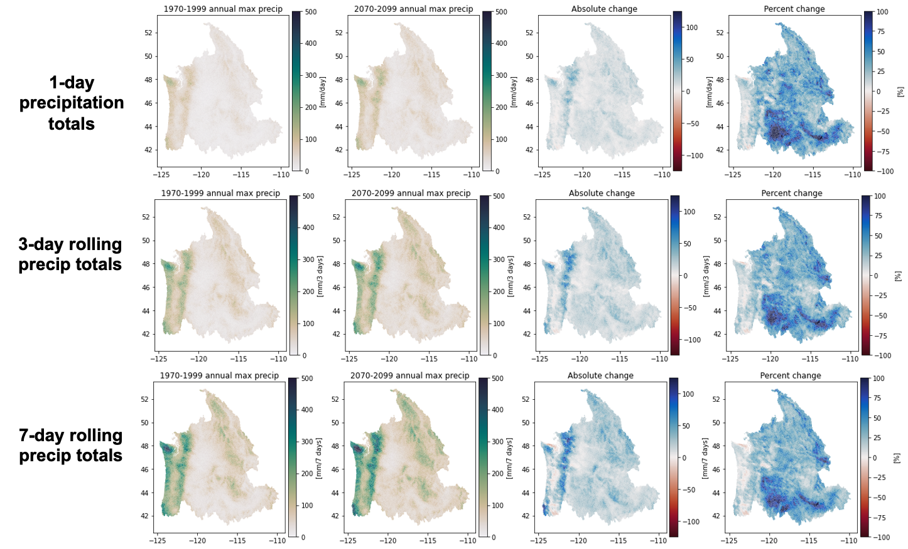
Figure 31. Precipitation extremes for 1, 3, and 7-day events for the historical (left) absolute change (middle) and percent change (right).
Because extreme precipitation can be a noisy statistic, we show the temporal evolution of the daily annual maxima (rolling average) for the time period 1960 to 2100 for a subset of the domain near Libby in the Kootenai River basin. This shows consistent increasing trends in annual daily maximum precipitation averaged across the Kootenai River basin for all climate models (Figure 32) evaluated.
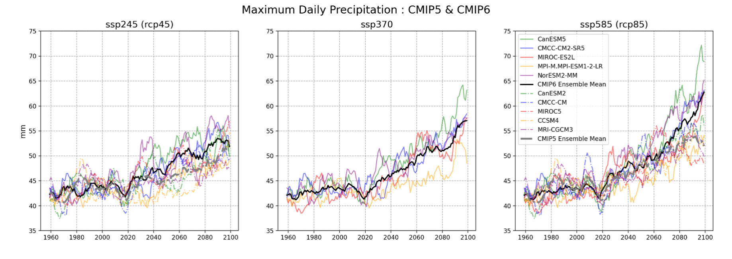
Figure 32. Rolling average annual daily maximum precipitation averaged over the Kootenai River basin for SSP245 and RCP45 (left), SSP370 (middle), SSP585 and RCP85 (right), with individual climate models in colors and larger ensemble mean values in black (CMIP6) and grey (CMIP5) lines.

5.1.4 Evaluation with Respect to other Downscaling Methods
It is currently impossible to validate future climate change projections from ICAR; however, it is useful to compare the changes predicted by ICAR to those derived using other downscaling methods (Figure 33). This helps reveal places that the new dataset may differ from other frequently used products and shows that the simplifications in ICAR still result in changes that are consistent with a full physics dynamical downscaling approach (WRF PGW), as compared to the more simplistic statistically downscaled products (LOCA and BCSD). For this analysis it was necessary to use only CMIP5 GCMs and average across the same GCMs for all downscaling methods. Note that the climate change imposed on WRF is derived from an idealized Pseudo-Global Warming (PGW) approach that averages a climate change signal across 19 global climate models; however, those 19 models have a similar change as the GCMs in downscaled by ICAR, LOCA, and BCSD. The precipitation changes in LOCA and BCSD are significantly smoother in space than the changes in the ICAR and WRF models. WRF has many of the same changes we have noted earlier in this report, with very little change on the lee side of major mountain ranges, but larger percent changes further downwind of those mountain ranges.
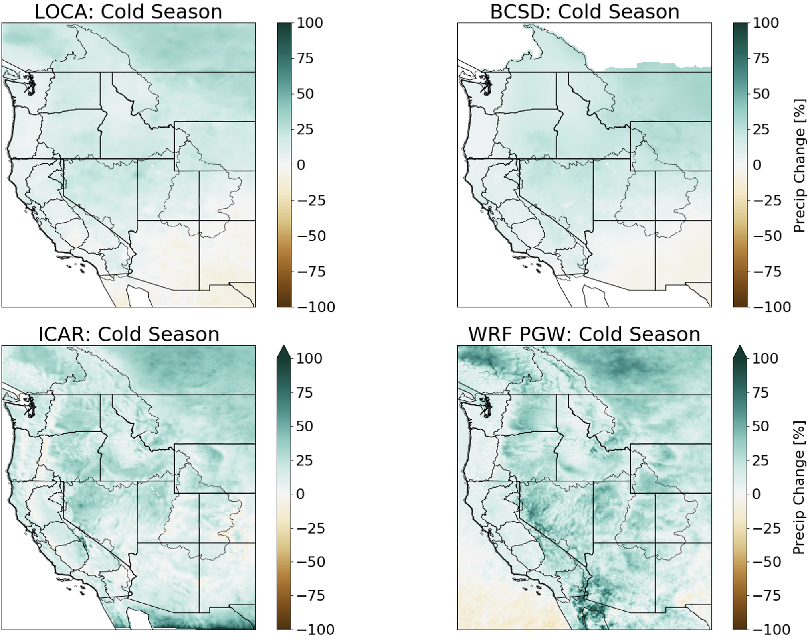
Figure 33. Changes in cool season (ONDJFMAM) mean precipitation for 4 different downscaling methods averaged across climate models from LOCA (top left), BCSD (top right), ICAR (bottom left) and WRF (bottom right).

5.2 Streamflow Projections
Flow duration curves (FDCs) and decadal mean seasonality plots are available for each site to compare historical flow and projected flows during the mid and late 21st century. Flow duration curves are constructed for three 30-year epochs–historic baseline (WY1980-2004), 2040s (WY2030-2060), and 2080s (WY2069-2099). Results are shown at four example reference sites located on large rivers in the Columbia River system– Snake (BRN; Brownlee), Pend Oreille (BDY; Boundary), and Columbia (ARD; Arrow Lakes and TDA; The Dalles) (Figure 34). Ensemble envelopes for each period are based on maximum and minimum values among all the ESMs (CMIP5 and CMIP6 combined). Future periods (2040s and 2080s) include only high emission scenarios (RCP8.5 for CMIP5 ESMs and SSP5-8.5 for CMIP6 ESMs).
FDCs at the flow sites on smaller, or tributary rivers to the mainstem, Snake, and Columbia are shown below (Figure 35) – LIB (Libby; Upper Columbia), CSC (NF Payette; Snake), SVN (T.W. Sullivan; Willamette), HAH (Howard Hanson; Western Cascade), KIOW (Yakima River at Kiona; Yakima). High flow events above 99 percentile are underestimated during the control period at ARD and KIOW sites. Such underestimation of the high flow events is seen at the sites on the eastern side of the Cascade range. For all other sites, the observed FDC falls within the range of modeled FDCs in the historical control period. In all cases there is an increase in discharge magnitude, particularly for the upper end of the FDC (>95 percentile). In the larger mainstem sites, there is less of an increase, and at TDA even a few models that project slight decreases.
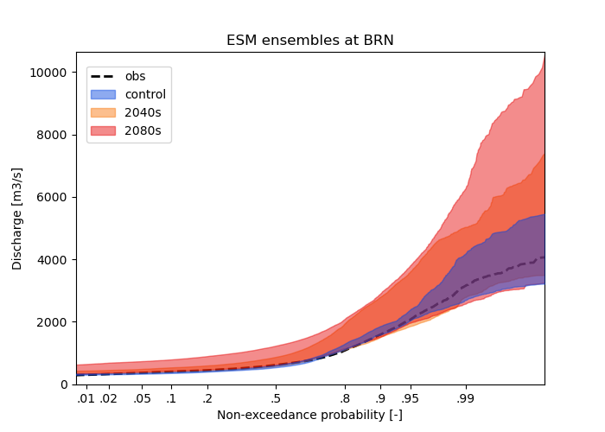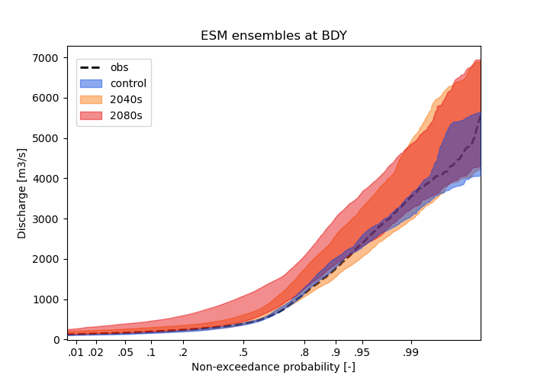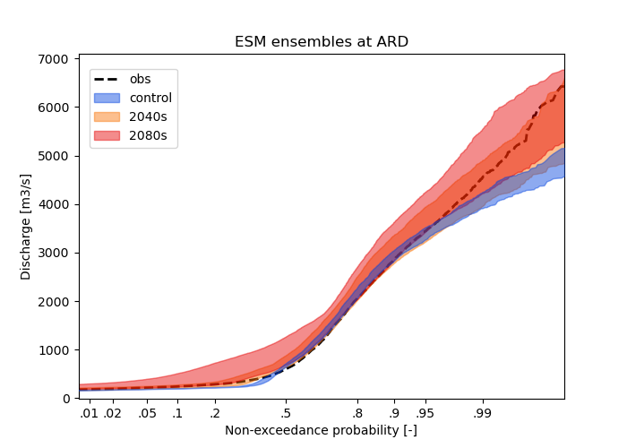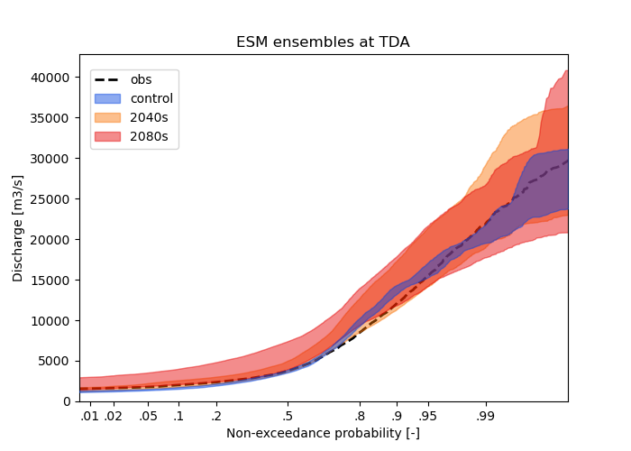
Figure 34. Flow duration curves during control, 2040s, and 2080s periods at 4 sites on key large river segments throughout the Columbia River basin.
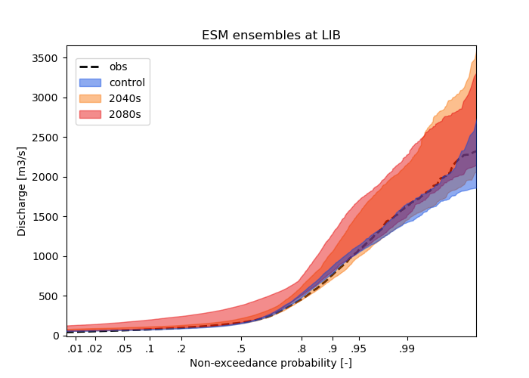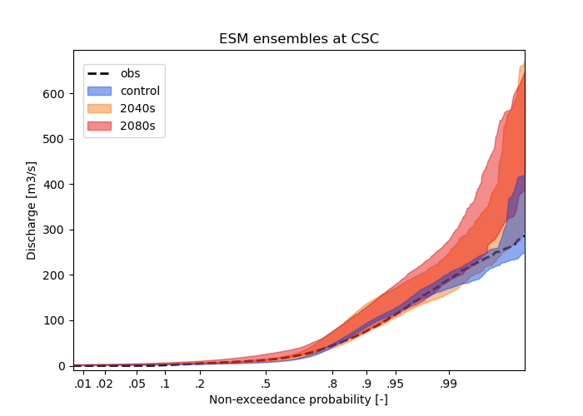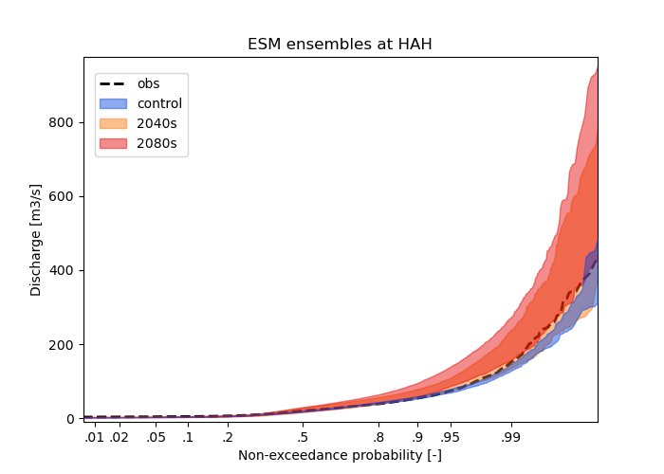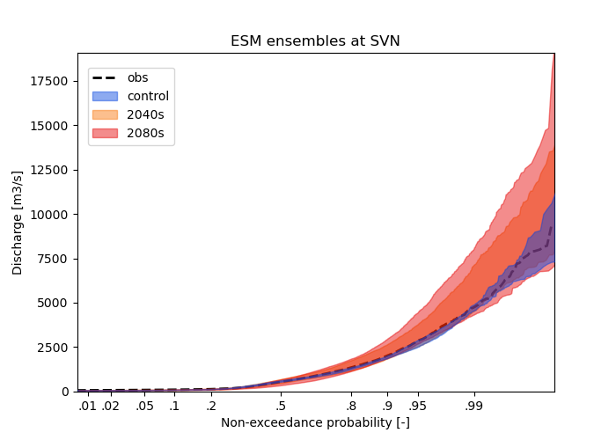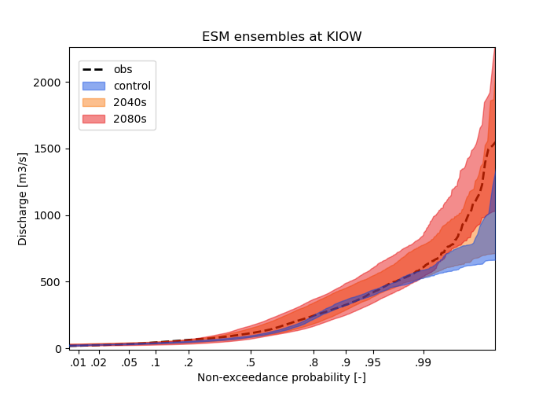
Figure 35. Flow duration curves during control, 2040s, and 2080s periods at 5 sites on the tributaries basin of the Columbia and Snake rivers. Observed FDC in black dashed line.

There is a clear shift in seasonality of mean flow (Figure 36, 37), with peak flows typically occurring approximately one month earlier in the season. In the far future, there are larger increases in mid-winter flows as well, suggesting a shift from entirely snow dominated streamflow regime to a mixed rain and snow regime even in the winter. This is most pronounced for mid-elevation smaller tributary sites such as HAH and KIOW (Figure 37).
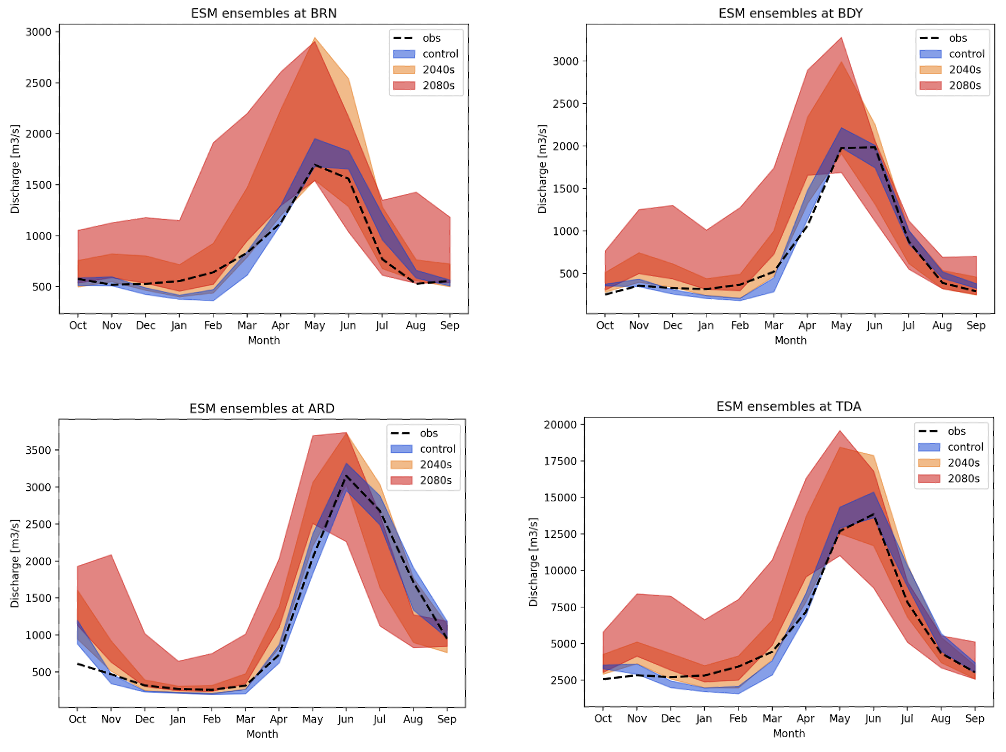
Figure 36. 20-year mean flow seasonality for the larger mainstem sites in the historical GCM control period (blue), near future 2040s (orange) and far future 2080s (red). Observed historical seasonality shown for reference (black dashed line)
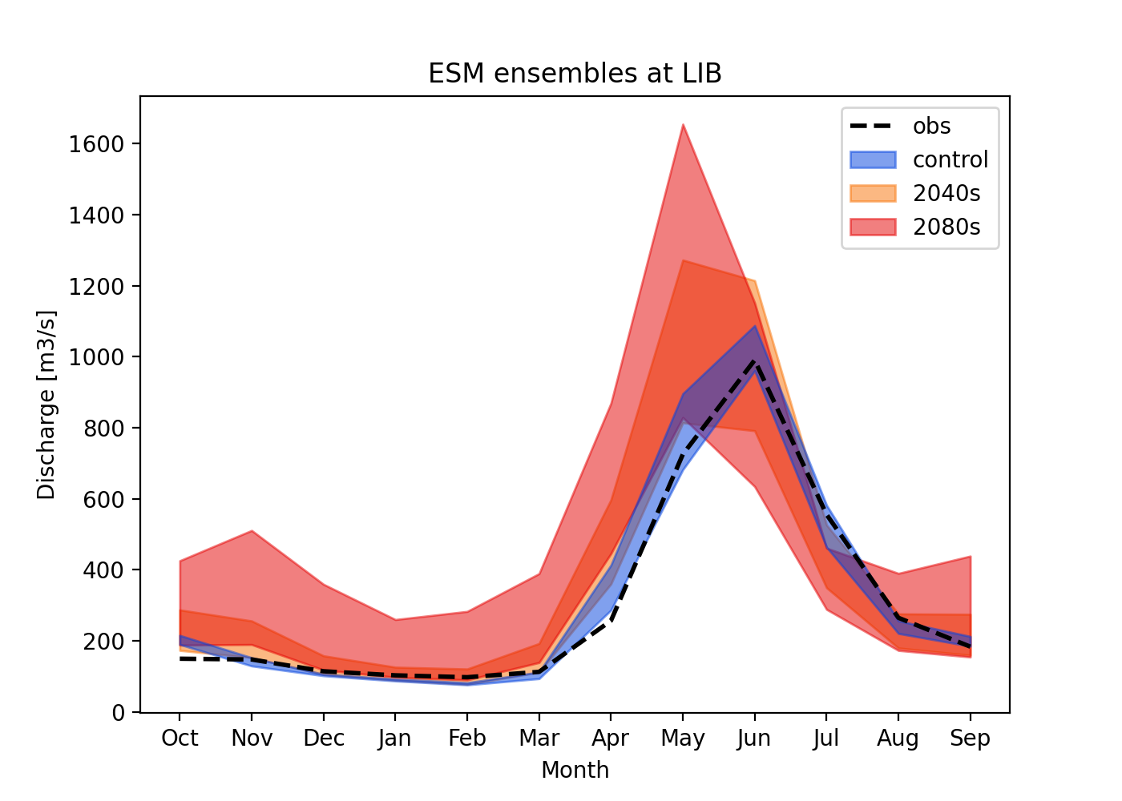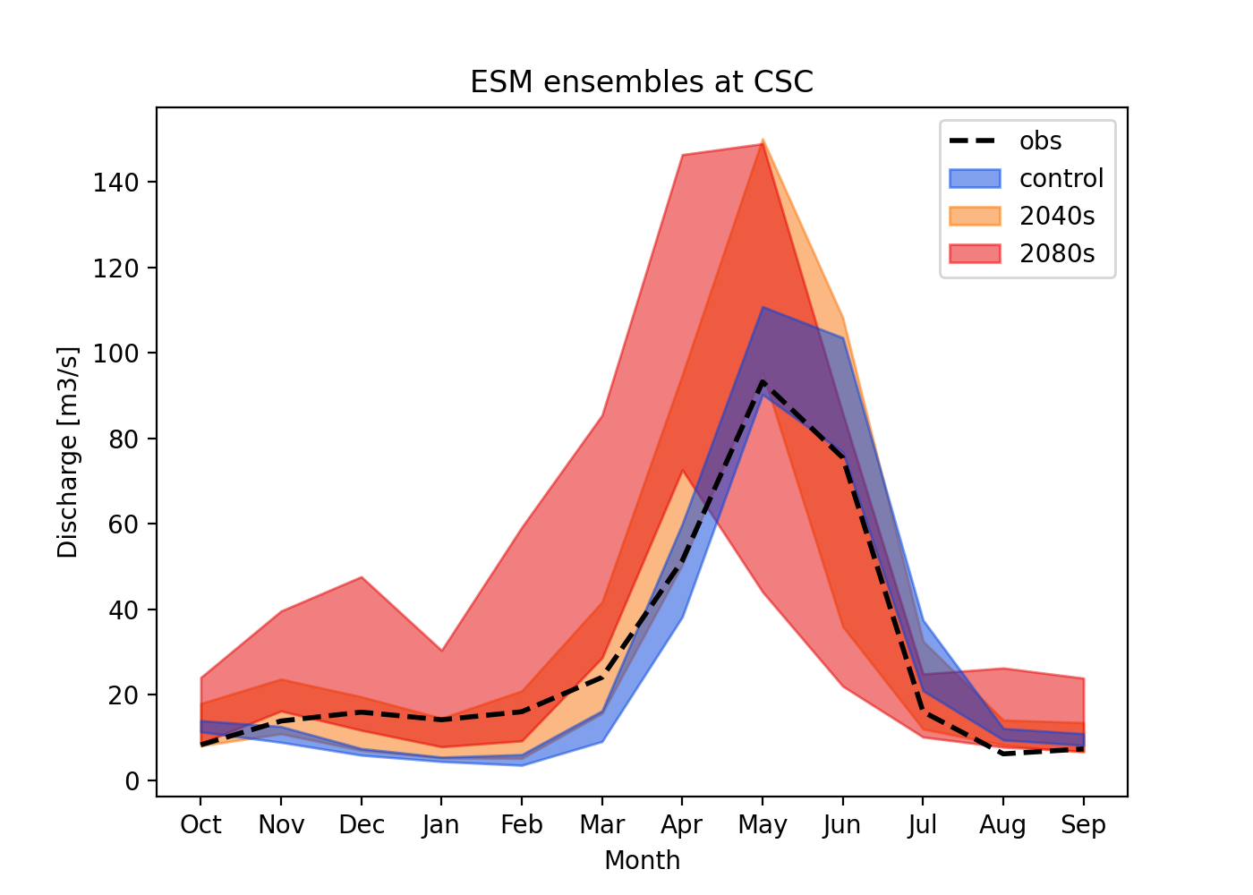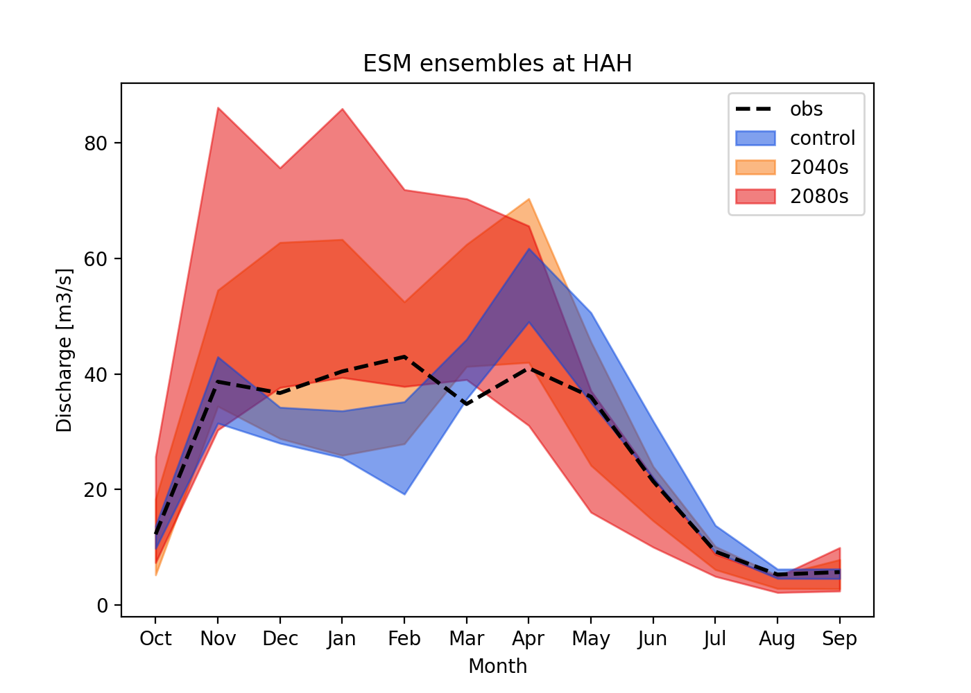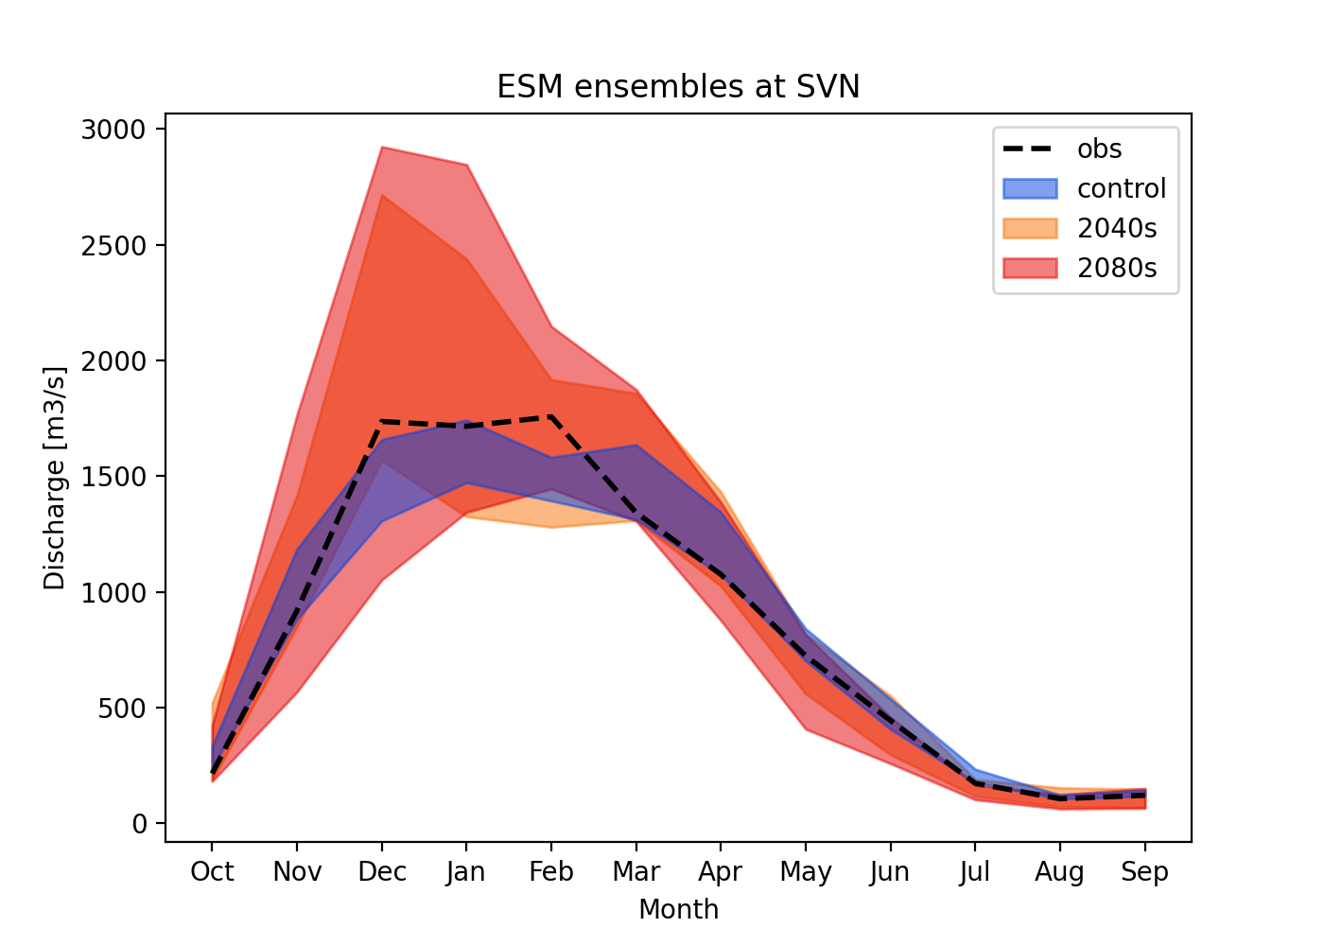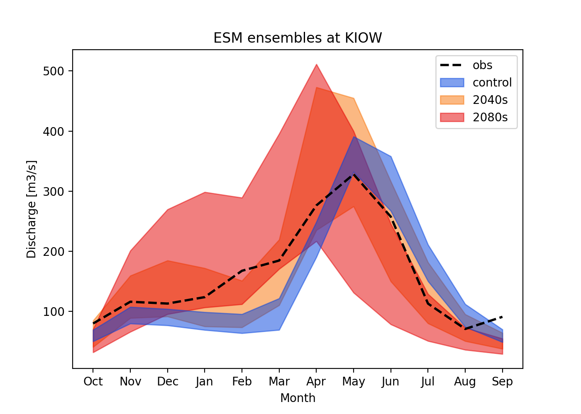
Figure 37. 20-year mean flow seasonality for the smaller tributary sites in the historical GCM control period (blue), near future 2040s (orange) and far future 2080s (red). Observed historical seasonality shown for reference (black dashed line)

6 Data Availability
The data for this project have been made available directly to the USACE, and are in the process of being posted to the NCAR Research Data Archive. https://rda.ucar.edu/
References
Ball, J. T., Woodrow, I. E., & Berry, J. A. (1987). A Model Predicting Stomatal Conductance and its Contribution to the Control of Photosynthesis under Different Environmental Conditions. In J. Biggins (Ed.), Progress in Photosynthesis Research (pp. 221–224). Dordrecht: Springer Netherlands. https://doi.org/10.1007/978-94-017-0519-6_48
Bennett, A., Hamman, J., & Nijssen, B. (2020). MetSim: A Python package for estimation and disaggregation of meteorological data. Journal of Open Source Software, 5(47), 2042. https://doi.org/10.21105/joss.02042
Bennett, A., Stein, A., Cheng, Y., Nijssen, B., & McGuire, M. (2022). A Process-Conditioned and Spatially Consistent Method for Reducing Systematic Biases in Modeled Streamflow. Journal of Hydrometeorology, 23(5), 769–783. https://doi.org/10.1175/JHM-D-21-0174.1
Betts, A. K., & Miller, M. J. (1993). The Betts-Miller Scheme. In K. A. Emanuel & D. J. Raymond (Eds.), The Representation of Cumulus Convection in Numerical Models (pp. 107–121). Boston, MA: American Meteorological Society. https://doi.org/10.1007/978-1-935704-13-3_9
BPA. (2020). 2020 Level Modified Streamflow 1928-2018 (No. DOE/BP-4985). Bonneville Power Administration. Retrieved from https://www.bpa.gov/-/media/Aep/power/historical-streamflow-reports/2020-level-modified-streamflow.pdf
Broman, D. P., & Wood, A. W. (2019). Better Representation of Low Elevation Snowpack to Improve Operational Forecasts (Final Report No. ST-2019-178-01). Denver, USA: Science and Technology Program, Research and Development Office, US Bureau of Reclamation. Retrieved from https://www.usbr.gov/research/projects/download_product.cfm?id=3099
Bruyère, C. L., Done, J. M., Holland, G. J., & Fredrick, S. (2014). Bias corrections of global models for regional climate simulations of high-impact weather. Climate Dynamics, 43(7–8), 1847–1856. https://doi.org/10.1007/s00382-013-2011-6
Bunn, P. T. W., Wood, A. W., Newman, A. J., Chang, H.-I., Castro, C. L., Clark, M. P., & Arnold, J. R. (2022). Improving station-based ensemble surface meteorological analyses using numerical weather prediction: A case study of the Oroville Dam crisis precipitation event. Journal of Hydrometeorology. https://doi.org/10.1175/JHM-D-21-0193.1
Celia, M. A., Russell, T. F., Herrera, I., & Ewing, R. E. (1990). An Eulerian-Lagrangian localized adjoint method for the advection-diffusion equation. Advances in Water Resources, 13(4), 187–206. https://doi.org/10.1016/0309-1708(90)90041-2
Chen, F., & Dudhia, J. (2001). Coupling an advanced land surface-hydrology model with the Penn State-NCAR MM5 modeling system. Part I: Model implementation and sensitivity. Monthly Weather Review, 129(4), 569–585. https://doi.org/10.1175/1520-0493(2001)129<0569:Caalsh>2.0.Co;2
Clark, M. P., & Slater, A. G. (2006). Probabilistic quantitative precipitation estimation in complex terrain. Journal of Hydrometeorology, 7(1), 3–22. https://doi.org/10.1175/Jhm474.1
Clark, M. P., Nijssen, B., Lundquist, J. D., Kavetski, D., Rupp, D. E., Woods, R. A., et al. (2015). A unified approach for process-based hydrologic modeling: 2. Model implementation and case studies. Water Resources Research, 51(4), 2515–2542. https://doi.org/10.1002/2015wr017200
Cosgrove, B. A., Lohmann, D., Mitchell, K. E., Houser, P. R., Wood, E. F., Schaake, J. C., et al. (2003). Real‐time and retrospective forcing in the North American Land Data Assimilation System (NLDAS) project. Journal of Geophysical Research: Atmospheres, 108(D22), 2896. https://doi.org/10.1029/2002jd003118
Daly, C., Halbleib, M., Smith, J. I., Gibson, W. P., Doggett, M. K., Taylor, G. H., et al. (2008). Physiographically sensitive mapping of climatological temperature and precipitation across the conterminous United States. International Journal of Climatology, 28(15), 2031–2064. https://doi.org/10.1002/joc.1688
Dee, D. P., Uppala, S. M., Simmons, A. J., Berrisford, P., Poli, P., Kobayashi, S., et al. (2011). The ERA-Interim reanalysis: configuration and performance of the data assimilation system. Quarterly Journal of the Royal Meteorological Society, 137(656), 553–597. https://doi.org/10.1002/qj.828
Gershunov, A., Shulgina, T., Clemesha, R. E. S., Guirguis, K., Pierce, D. W., Dettinger, M. D., et al. (2019). Precipitation regime change in Western North America: The role of Atmospheric Rivers. Scientific Reports, 9(1), 9944. https://doi.org/10.1038/s41598-019-46169-w
Glabau, B., Nielsen, E., Mylvahanan, A., Stephan, N., Frans, C., Duffy, K., et al. (2020). Climate and Hydrology Datasets for RMJOC Long-Term Planning Studies: Second Edition (RMJOC-II) Part II: Columbia River Reservoir Regulation and Operations—Modeling and Analyses (p. 235). River Management Joint Operating Committee (RMJOC). Retrieved from https://www.bpa.gov/-/media/Aep/power/hydropower-data-studies/rmjoc-ll-report-part-ll.PDF
Gutmann, E., Barstad, I., Clark, M., Arnold, J., & Rasmussen, R. (2016). The Intermediate Complexity Atmospheric Research Model (ICAR). https://doi.org/10.1175/JHM-D-15-0155.1
Hungerford, R. D., Nemani, R. R., Running, S. W., & Coughlan, J. C. (1989). MTCLIM: a mountain microclimate simulation model (No. INT-RP-414) (p. INT-RP-414). Ogden, UT: U.S. Department of Agriculture, Forest Service, Intermountain Forest and Range Experiment Station. https://doi.org/10.2737/INT-RP-414
Iacono, M. J., Delamere, J. S., Mlawer, E. J., Shephard, M. W., Clough, S. A., & Collins, W. D. (2008). Radiative forcing by long-lived greenhouse gases: Calculations with the AER radiative transfer models. Journal of Geophysical Research, 113(D13), D13103. https://doi.org/10.1029/2008jd009944
Jordan, R. (1991). A one dimensional temperature model for a snow cover (Tech. Doc. for SNTHERM.89) (p. 49). Hanover, New Hampshire, USA: U.S. Army Corps of Eng. Cold Reg. Res. and Eng. Lab.
Lin, P., Pan, M., Beck, H. E., Yang, Y., Yamazaki, D., Frasson, R., et al. (2019). Global Reconstruction of Naturalized River Flows at 2.94 Million Reaches. Water Resources Research, 55(8), 6499–6516. https://doi.org/10.1029/2019WR025287
Livneh, B., Rosenberg, E. A., Lin, C. Y., Nijssen, B., Mishra, V., Andreadis, K. M., et al. (2013). A Long-Term Hydrologically Based Dataset of Land Surface Fluxes and States for the Conterminous United States: Update and Extensions. Journal of Climate, 26(23), 9384–9392. https://doi.org/10.1175/Jcli-D-12-00508.1
Lohmann, D., Nolte-Holube, R., & Raschke, E. (1996). A large-scale horizontal routing model to be coupled to land surf ace parametrization schemes. Tellus A: Dynamic Meteorology and Oceanography, 48(5), 708. https://doi.org/10.3402/tellusa.v48i5.12200
Lybarger, N. D., Smith, A., Newman, A. J., Gutmann, E. D., Wood, A. W., Frans, C. D., et al. (2024). Improving Earth System Model Selection Methodologies for Projecting Hydroclimatic Change: Case Study in the Pacific Northwest. Journal of Geophysical Research: Atmospheres, 129(7), e2023JD039774. https://doi.org/10.1029/2023JD039774
Mahat, V., & Tarboton, D. G. (2012). Canopy radiation transmission for an energy balance snowmelt model. Water Resources Research, 48(1), 2011WR010438. https://doi.org/10.1029/2011WR010438
Mahat, V., Tarboton, D. G., & Molotch, N. P. (2013). Testing above‐ and below‐canopy representations of turbulent fluxes in an energy balance snowmelt model. Water Resources Research, 49(2), 1107–1122. https://doi.org/10.1002/wrcr.20073
Matott, L. (2017). OSTRICH: an Optimization Software Tool, Documentation and User’s Guide, Version 17.12.19. University at Buffalo Center for Computational Research. Retrieved from http://www.civil.uwaterloo.ca/envmodelling/Ostrich.html
Mizukami, N., Clark, M. P., Sampson, K., Nijssen, B., Mao, Y. X., McMillan, H., et al. (2016). mizuRoute version 1: a river network routing tool for a continental domain water resources applications. Geoscientific Model Development, 9(6), 2223–2238. https://doi.org/10.5194/gmd-9-2223-2016
Newman, A. J., Clark, M. P., Craig, J., Nijssen, B., Wood, A., Gutmann, E., et al. (2015). Gridded Ensemble Precipitation and Temperature Estimates for the Contiguous United States. Journal of Hydrometeorology, 16(6), 2481–2500. https://doi.org/10.1175/Jhm-D-15-0026.1
Niu, G. Y., Yang, Z. L., Mitchell, K. E., Chen, F., Ek, M. B., Barlage, M., et al. (2011). The community Noah land surface model with multiparameterization options (Noah-MP): 1. Model description and evaluation with local-scale measurements. Journal of Geophysical Research-Atmospheres, 116(D12), D12109. https://doi.org/10.1029/2010jd015139
Pytlak, E., Frans, C., Duffy, K., Johnson, J., Nijssen, B., Chegwidden, O., & Rupp, D. (2018). Climate and Hydrology Datasets for RMJOC Long-Term Planning Studies: Second Edition (RMJOC-II) Part I: Hydroclimate Pro (p. 112). River Management Joint Operating Committee (RMJOC): Bonneville Power Administration, United States Army Corps of Engineers, United States Bureau of Reclamation. Retrieved from https://www.bpa.gov/-/media/Aep/power/hydropower-data-studies/rmjoc-ll-report-part-l.pdf
Rahimpour Asenjan, M., Brissette, F., Martel, J.-L., & Arsenault, R. (2023). Understanding the influence of “hot” models in climate impact studies: a hydrological perspective. Hydrology and Earth System Sciences, 27(23), 4355–4367. https://doi.org/10.5194/hess-27-4355-2023
Ralph, F. M., Neiman, P. J., Kiladis, G. N., Weickmann, K., & Reynolds, D. W. (2011). A Multiscale Observational Case Study of a Pacific Atmospheric River Exhibiting Tropical–Extratropical Connections and a Mesoscale Frontal Wave. Monthly Weather Review, 139(4), 1169–1189. https://doi.org/10.1175/2010MWR3596.1
Rasmussen, R. M., Chen, F., Liu, C. H., Ikeda, K., Prein, A., Kim, J., et al. (2023). CONUS404: The NCAR–USGS 4-km Long-Term Regional Hydroclimate Reanalysis over the CONUS. Bulletin of the American Meteorological Society, 104(8), E1382–E1408. https://doi.org/10.1175/BAMS-D-21-0326.1
Raupach, M. R. (1994). Simplified expressions for vegetation roughness length and zero-plane displacement as functions of canopy height and area index. Boundary-Layer Meteorology, 71(1–2), 211–216. https://doi.org/10.1007/BF00709229
Rutz, J. J., Steenburgh, W. J., & Ralph, F. M. (2014). Climatological Characteristics of Atmospheric Rivers and Their Inland Penetration over the Western United States. Monthly Weather Review, 142(2), 905–921. https://doi.org/10.1175/MWR-D-13-00168.1
Shields, C. A., Payne, A. E., Shearer, E. J., Wehner, M. F., O’Brien, T. A., Rutz, J. J., et al. (2023). Future Atmospheric Rivers and Impacts on Precipitation: Overview of the ARTMIP Tier 2 High‐Resolution Global Warming Experiment. Geophysical Research Letters, 50(6), e2022GL102091. https://doi.org/10.1029/2022GL102091
Skamarock, W. C., & Klemp, J. B. (2008). A time-split nonhydrostatic atmospheric model for weather research and forecasting applications. Journal of Computational Physics, 227(7), 3465–3485. https://doi.org/10.1016/j.jcp.2007.01.037
Tolson, B. A., & Shoemaker, C. A. (2007). Dynamically dimensioned search algorithm for computationally efficient watershed model calibration. Water Resources Research, 43(1), 2005WR004723. https://doi.org/10.1029/2005WR004723
Warner, M. D., Mass, C. F., & Salathé, E. P. (2012). Wintertime Extreme Precipitation Events along the Pacific Northwest Coast: Climatology and Synoptic Evolution. Monthly Weather Review, 140(7), 2021–2043. https://doi.org/10.1175/MWR-D-11-00197.1
Wood, A. W., Sturtevant, J., Barrett, & Llwewellyn, D. (2021). Improving the robustness of southwestern US water supply forecasting (Final Report No. ST-2018-8117-01). Denver, USA: Science and Technology Program, Research and Development Office, US Bureau of Reclamation. Retrieved from https://www.usbr.gov/research/projects/detail.cfm?id=8117

https://github.com/NCAR/ESM_bias_correction

