ICAR-SUMMA PNW Modeling Application Technical Report
Ethan Gutmann, Naoki Mizukami, Andrew Wood, Bart Nijssen, Bert Kruyt, Abigail Smith

Downscaled Projections

Overview of the ICAR model/downscaling framework
A major component of this work was the downscaling of Global Climate Model (GCM) data using the Intermediate Complexity Atmospheric Research (ICAR) model. ICAR is a quasi-dynamical downscaling method designed to represent 90% of the physical processes in the atmosphere for one percent of the computational cost of a traditional atmospheric model. Many sensitivity tests were performed to configure ICAR with the best possible grid, vertical level structure, and internal physics parameterization. The domain used for the simulations was expanded to cover the entire western United States to better represent surrounding topographic barriers in simulations over the Columbia River Basin, and to enable the use of this data set for a larger range of applications. In the course of testing ICAR with GCM data, it was determined that raw climate model outputs had too many biases to realistically reproduce the regional hydroclimate of the Columbia River Basin. To correct this, a three dimensional bias correction method was developed and implemented as part of this project. The source code for this bias correction technique is now available on GitHub for other uses. It was also determined that the convective parameterization within ICAR was not sufficient to reproduce warm season precipitation, so multiple additional convective parameterizations were added to the model and tested. We ended up using the BMJ parameterization. Similarly, recent work has shown that the Noah-MP land surface model provides a better representation of land atmosphere feedbacks, and so we added Noah-MP to ICAR. To represent water vapor fluxes off of lakes in a changing climate, a multi-layer lake model was coupled within ICAR as well. Finally, because changes in future long wave radiation are important for climate projections due to the direct influence of greenhouse gases on long wave radiation, we added the RRTMG radiation parameterizations to ICAR. The addition of Noah-MP and RRTMG were found to improve ICAR temperature biases in the historical period.

CMIP models included and CMIP model performance
ICAR was used to downscale 14 GCMs for over 150 years each to a 6 km grid. This included eight GCMs from the Coupled Model Intercomparison Project phase 5 (CMIP5) for each of two Representative Concentration Pathways (RCP) scenarios, RCP 4.5 and RCP 8.5. This also included six models from CMIP phase 6 (CMIP6) for three Shared Socio-economic Pathways (SSP) scenarios, SSP2-4.5, SSP3-7.0, and SSP5-8.5. One of the CMIP6 models, CESM2, included 10 different ensemble members that each simulated the time period 1850 - 2100, though only with the SSP370 future scenario.

Performance

Global Earth System Models
To evaluate the viability of the use of global Earth System Models (ESMs) to understand variability in atmospheric rivers in the Columbia River basin we evaluated the representation of both the mean and extreme Integrated Vapor Transport (IVT) in ESMs the west coast. We found that while the mean IVT in various ESMs exhibited a realistic spatial pattern, individual ESMs could be biased high or low (Figure). Evaluating the frequency of extreme IVT events in the ESMs revealed a similarly consistent pattern when compared to observations, but with larger variations between ESMs. This suggests that the ESMs are realistically representative of the weather patterns that control extreme precipitation events across the Columbia river basin, but that persistent biases would limit their ability to use them in direct downscaling without correcting those biases. Because the biases identified were more pronounced in the extreme statistics we implemented a more complex bias correction algorithm than has been used previously.
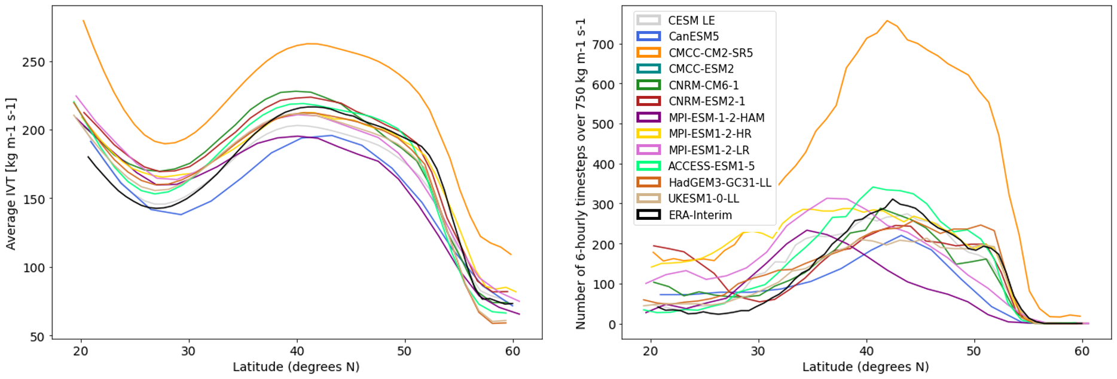
After bias correction of temperature, humidity, and winds independently, the models have minimal bias in the aggregate IVT mean spatial patterns, or frequency distributions (Figure), despite the fact that IVT itself is not corrected directly. This suggests that the models themselves have a realistic covariance between large scale fields such that this independent bias correction is sufficient.
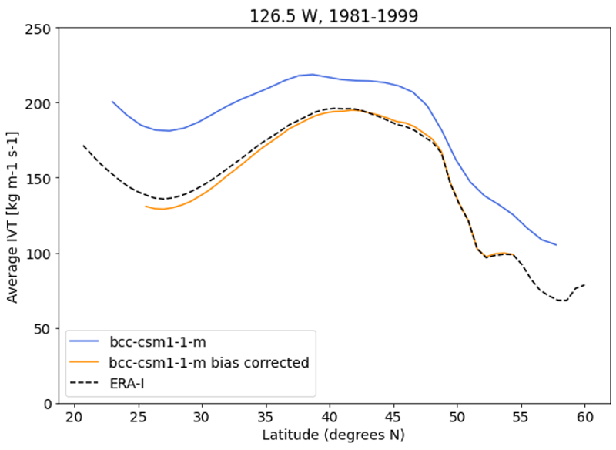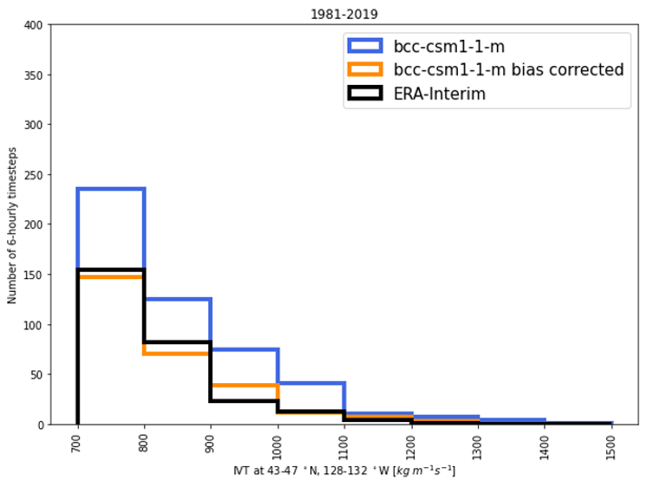

The climate models selected for the initial dataset production in this study all have a reasonable performance in the Pacific Northwest. They span a range of relative skill scores for the domain (Figure), this is partially due to the availability of 3D 6-hourly data needed to run ICAR, and partially due to complications that arose when processing some of the better models. In some cases these complications may be impossible to overcome as a result of errors in the CMIP6 data that were archived by the global modeling centers. More work is planned to add additional CMIP6 models to the ensemble or ICAR simulations.
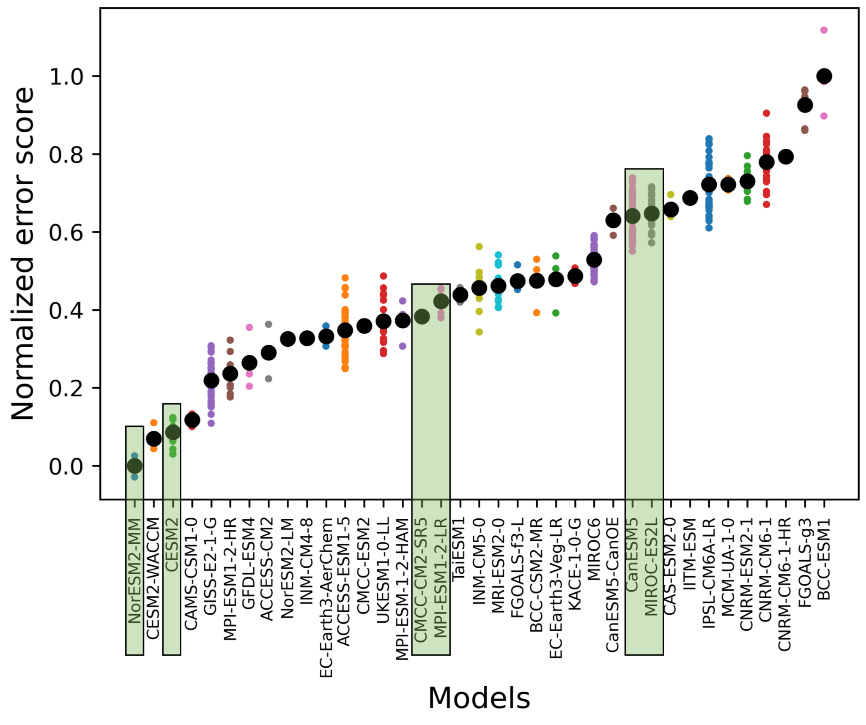

ICAR
When ICAR is used to simulate the historical period (1980-2019) using an atmospheric Reanalysis (ERA-interim; Dee et al) for boundary conditions, ICAR simulates realistica patterns of precipitation across the domain with a high correlation coefficient between monthly modeled and observed precipitation (Figure ). ICAR exhibits a dry bias across the domain that warrants future investigation to improve the internal representation of atmospheric processes. This is likely to be do to a tendency to underestimate turbulent variability in the atmosphere, resulting in a weaker enhancement of precipitation than is actually caused by embedded convective processes. New work is developing methods to increase that variability in the wind field; however, for the purposes of this effort, we have bias corrected the final output of ICAR to enable its use for forcing hydrologic models.
The high degree of month to month correlation between ICAR and the observational dataset (Figure) indicates that it can be used to project monthly variations in weather, and provides some confidence in the ability of ICAR to simulate the response of the atmosphere to future changes in weather and climate. The monthly correlation coefficient in ICAR varies around 0.5 to 1 across the domain, with a mean value of 0.74. For comparison, the Weather Research and Forecasting (WRF) model has similar, though slightly higher, correlation coefficients, with a mean value across the domain of 0.78.
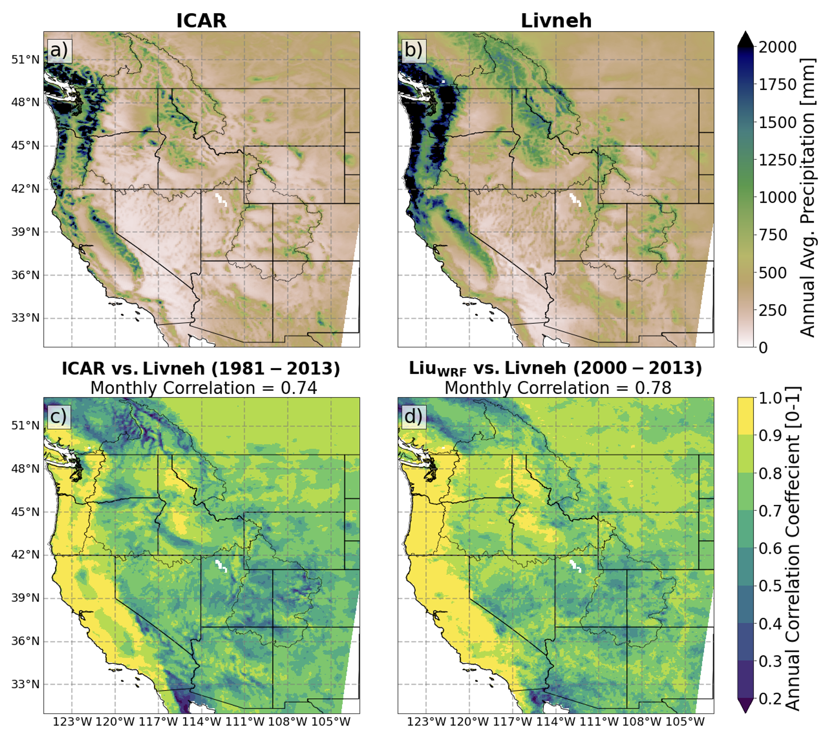
In addition to an evaluation of the mean patterns, the response of ICAR to IVT events was compared with the Weather Research and Forecasting (WRF) model. While ICAR was found to underestimate the magnitude of extreme precipitation events, the response of ICAR to IVT was similar to that of WRF. Multiple atmospheric river events were simulated with ICAR, and the correlation between IVT and precipitation in ICAR was between 0.76 and 0.83. For comparison, the correlation between IVT and precipitation in WRF for these events varied between 0.80 and 0.86. This shows that ICAR is able to respond to extreme IVT events in a similar fashion as a much more complex atmospheric model, although the simulation of the most extreme precipitation events needs more evaluation.
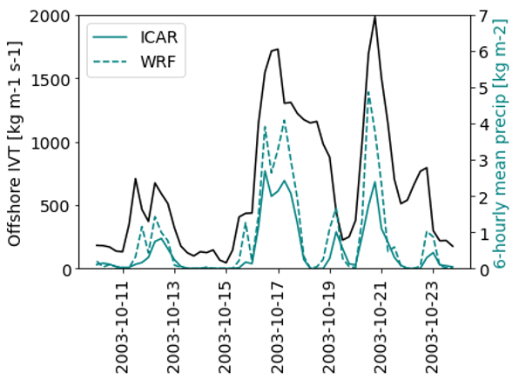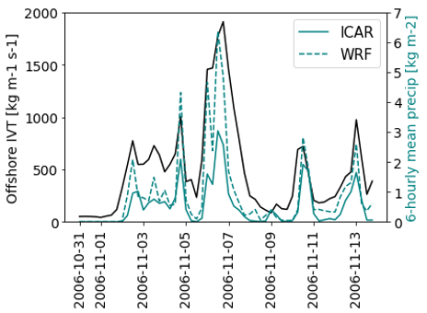
Spatial patterns of extreme precipitation events in ICAR also roughly match the patterns of extreme precipitation observed across the Western US (Figure). The 50-year period (1950-2000) maximum daily precipitation event modeled by ICAR from nine different ensemble members of the CESM2 Large Ensemble are shown below. The variability between these ensemble members is representative of the expected chaotic, natural variability in the real climate system. All members exhibit the same large scale features with similar magnitudes as observed; however, none of the members capture the more extreme events observed in the interior rocky mountains in Idaho and Montana.
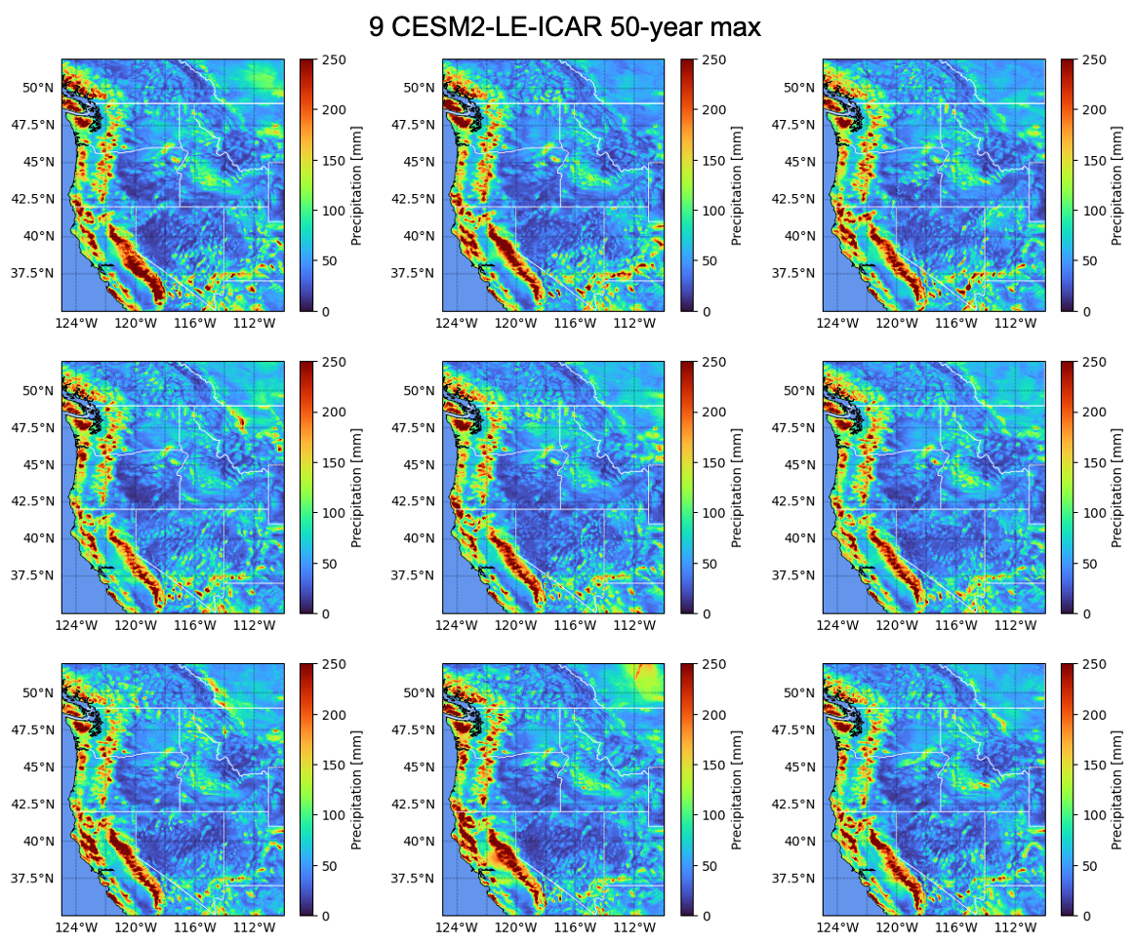
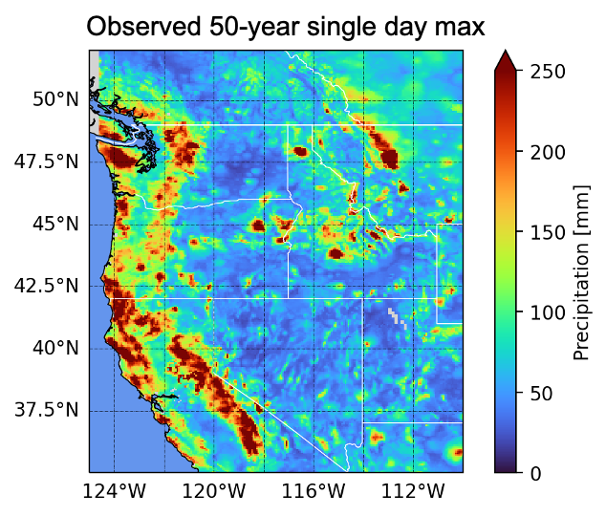
As with precipitation, ICAR is able to simulate a very similar spatial distribution of temperature when compared to a more sophisticated atmospheric model; however, while precipitation is biased too low in ICAR, temperature is typically biased too high (Figure). In particular, coastal and lower elevation northern regions are too warm in the simulations. This is believed to stem primarily from near surface representation of land atmosphere coupling, and more work is needed to improve the representation of the land surface in ICAR.

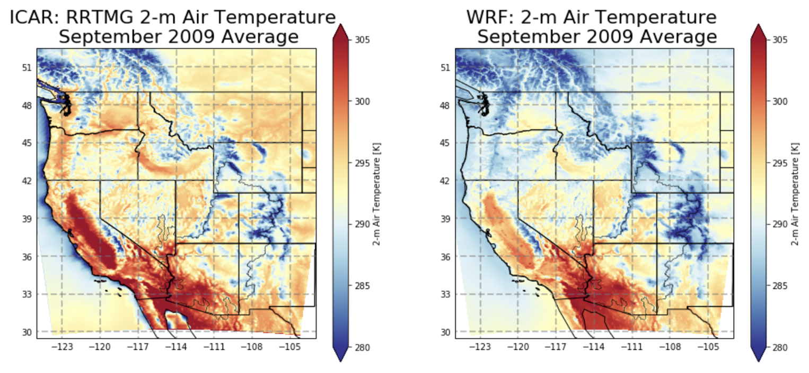

SUMMA-mizuroute

Overview of SUMMA+mizuroute model configuration
This project uses hydrology and river models that are run in sequence—SUMMA (Structure for Unifying Multiple Modeling Alternatives (Clark et al. 2015a,b) that simulates land-surface water and energy fluxes and mizuRoute (Mizukami et al. 2016) that simulates routed runoff in rivers. SUMMA is run first and its runoff outputs are then used as input to mizuRoute. Hereafter, the modeling framework is called SUMMA-mizuRoute.
The initial SUMMA-mizuRoute implementation for the project was developed in a series of prior projects (led by NCAR Co-PI Andy Wood) that were sponsored primarily by USACE, Reclamation and NASA. SUMMA was configured for the entire western US domain using a spatial resolution defined by catchments, rather than grids. For the western US, the catchment boundaries are from the USGS Hydrologic Unit Code Level 12 (HUC12) dataset, and these are extended to cover the remaining connected drainage areas (i.e., in Canada and Mexico) using similarly sized (slightly smaller) catchments defined in the MERIT-Hydro dataset (REF). SUMMA also adopted a single Hydrologic Response Unit (HRU) -- i.e., where water-energy states and fluxes are computed independently -- for each catchment (termed a Grouped Response Unit, or GRU, in SUMMA). The configuration used a 3-hour time step to resolve diurnal weather patterns, with unique meteorological forcings and physiographic characteristics including slope, elevation, soil layer thickness, vegetation and soil types defined for every catchment (GRU, HRU). More details of this SUMMA model setup are provided in several Reclamation project reports, available online at [ ]. For the current project, a PNW-subset of this western US SUMMA model was extracted, comprising approximately 10,000 catchments.
SUMMA offers several options for water and energy balance flux parameterizations (i.e., process algorithms). For this project, we used the flux parameterization choices that were selected in the pre-existing SUMMA modeling work. These include a Ball-Berry parameterization for simulating stomatal resistance, one of the main physiological factors controlling transpiration, similar to the Noah-MP land surface model (Niu et al., 2011). A logarithmic wind profile below the vegetation canopy is used, described in Mahat et al. (2013), and also the Raupach (1994) parameterization for vegetation roughness length and displacement height. The configuration uses Beer’s law (Mahat and Tarboton, 2012), similar to the Variable Infiltration Capacity (VIC) model (Liang et al. 1994) to represent the radiation transmission through vegetation. For the vertical moisture transmission along the soil column, and the mixed form of the Richards equation (Celia et al., 1990), a vertically constant hydraulic conductivity and a lumped aquifer model. For snow, a constant albedo decay rate is used, and the thermal conductivity was parameterized using the Jordan (1991) approach. Further, each HRU incorporates an unconfined aquifer at the bottom of the soil column, which contributes to baseflow generation, using an exponential baseflow curve that is a function of aquifer storage. No lateral water movement occurs between HRUs in SUMMA. However, SUMMA computes “delayed runoff” (often termed hillslope routing) by accounting for overland and subsurface travel time of runoff movement to the river channel through gamma distribution-based unit hydrograph. Daily mean water flux variables are output while overland routed runoff is output at a 3-hour time step. This 3-hour delayed runoff is input into mizuRoute for the river routing.
MizuRoute (Mizukami et al., 2016) uses the “vector-river network” defined based on the MERIT-basin (Lin et al. 2019). The PNW-subset of the western US modeling framework includes 17,957 river reaches (blue lines in Figure 1) and their associated contributing catchments within the Pacific Northwest. Since SUMMA’s HRUs and mizuRoute’s MERIT basin HRUs differ in the size, runoff remapping is performed within mizuRoute using the 1st order mass conserving averages. Then, the model performs a river reach routing to route the runoff for each river reach in the order defined by the river network topology. Among several reach routing schemes offered by mizuRoute, we use the quickest routing method, Impulse Response Function or Unit Hydrograph based routing. This scheme mimics Lohmann’s IRF routing, which was used in the hydrologic modeling for past climate change studies in the US. MizuRoute also uses a 3-hour simulation step.

Overview of forcings (GMET/metsim)
We use an observation based 6-km climate dataset generated using the Gridded Meteorological Ensemble Tool (GMET; Newman et al. 2015; Bunn et al, 2022) as the retrospective forcing dataset for SUMMA. The GMET data are available from 1970 through 2023. GMET is based on multiple logistic and linear regression using static geophysical attributes to predict precipitation and temperature across a grid (Clark and Slater, 2006; Newman, 2015). The core algorithm is a spatial regression approach for interpolating situ meteorological observations, using spatially distributed terrain variables as predictor fields in an ordinary least squares (OLS) linear regression to explain the spatial distribution of point in situ observations of weather. The spatial predictors are static geophysical attributes (south-north and east-west slopes, elevation, latitude, and longitude). The regression is applied to predict daily precipitation, mean temperature, and diurnal temperature range (DTR) for each target grid cell, on each day, based on the current observed values of those variables within a sample from the 30 nearest meteorological stations and given their relationship to the local terrain features at the station locations. This strategy generates dynamic (time-varying) mean and uncertainty estimates of the daily meteorological fields that are driven by daily observed meteorological conditions.
In the prior westwide modeling projects, GMET was applied for the period 1970 to present at both 1/8th and 1/16th degree resolutions, yielding daily precipitation and temperature minima and maxima. The resulting outputs were spatially remapped to SUMMA HUC12 modeling fabric and then disaggregated to 3-hourly time resolution and to a full set of meteorological fields (including radiation, pressure, humidity, wind variables) using MetSim (Bennett et al, 2020), a python-based wrapper for the MTCLIM program (Running et al, 1989). This approach was applied to the entire western US, and the model forcing inputs for the PNW domain were extracted from the larger domain forcing dataset.
This project undertook multiple refinements of the forcings dataset. Early analysis led to a revision of several predictor fields (related to slope in particular) that were optimized precipitation prediction, as well as intensive comparison of the GMET forcings with other sources of meteorological forcings (NLDAS, WRF, PRISM). A notable result of this analysis was that GMET precipitation appeared to be biased approximately 15-20% low in some areas compared to PRISM. We ultimately chose to scale GMET to match the PRISM precipitation and temperature climatology for forcings within the US, with a linearly damped scaling over 1 degree latitude to the north of the US border, where the PRISM dataset ends.

Calibration overview
The SUMMA calibration strategy adopted the core methods and workflows from the prior SUMMA-mizuRoute modeling work, as described in Wood et al. (2021), with some modification. The primary parameter optimization method from that work is the Dynamical Dimensional Search algorithm (DDS; Tolson and Shoemaker 2007), which had been tested and refined in a dozens of smaller western US basins (e.g., the Shoshone R, the Flathead R, the Clearwater R, among others). DDS is incorporated into the workflow through a software package called Ostrich [REF]. Prior work focused mostly on individual basins, with one larger implementation (for the upper Rio Grande R basin) having developed a strategy for using DDS in a nested, headwaters-to-outlet sequence in which upstream areas (and headwaters) are calibrated before downstream areas.
Due to the size of the PNW, one modification of this approach was to tackle the calibration in two stages: (1) an regional combined calibration, in which the PNW domain is split into 4 regions that are more hydroclimatically similar than the region as a whole — Cascade, Western Cascade, Snake, and Upper Columbia (Figure 2). This phase was not expected to obtain optimal parameters at each location, but to provide improved parameters that could serve as prior estimates for a second phase that focused on individual and nested basin calibration, using the core approach from the prior projects. For both individual and multi-basin calibration, parameter multipliers are calibrated to optimize the objective functions involving the simulated streamflow at the individual or multiple basins, depending on the phase. This strategy is relatively common, and was found in the earlier SUMMA work to achieve a mixture of spatially varying and spatially uniform parameters, depending on the prior/uncalibrated parameters being scaled. The parameters of mizuRoute were not calibrated. The SUMMA parameters that were calibrated are shown in Table 2. Most of the selected parameters were used in the prior studies (e.g., Wood et al., 2021), with a few calibration parameter additions to the list (critSoilTranspire, fieldCapacity, the van Genuchten parameters vgn_*, windReductionParam, and wettingFrontSuction). Calibrated regional parameter multipliers are applied to all the HUC12 HRUs to update the parameters inside each region.
After this regional calibration, we performed an individual-basin calibrations at the flow sites, using the nested basin strategy from Wood et al. (2021). For this step, we first calibrated the headwater upstream areas of 65 selected naturalized flow sites, denoted by red circles in Figure 1, then subsequently continued calibrating the areas between each immediate upstream site and the next downstream site with the parameters already calibrated in the upstream areas fixed. This downstream basin calibration continues till the most downstream sites in the river basins, which is near the mouth of Columbia River. There are 33 such downstream naturalized flow sites used for the calibrations, denoted by the orange triangle in Figure 1. Total 98 flow sites are used for individual basin calibration, resulting in the areas with adjusted parameters covering the majority of the PNW domain. Areas upstream of each flow site consists of multiple HUC12 HRUs, therefore parameters at each HUC12 HRU are adjusted via applying parameter multipliers determined using DDS with 300 iterations to all the HUC12 HRUs upstream of the flow site. We used normalized Kling-Gupta efficiency (Eq.1), nKGE’, as an objective function for the calibration. nKGE’ ranges from 0 to 1.
$nKGE'=\frac{1}{2-KGE'}$ $KGE'=1-\sqrt{{\left(1-\frac{μ_{obs}}{μ_{sim}}\right)}^{2}+{\left(1-\frac{{CV}_{obs}}{{CV}_{sim}}\right)}^{2}+{\left(1-r\right)}^{2}}$
(1)
where 𝜇_{obs} and 𝜇_{sim} are mean of reference and simulated flows, respectively; and CV_{obs} are CV_{sim} coefficient of variation of reference and simulated flows, respectively; and r is correlation coefficient of reference and simulated flows.
Model calibration uses the period between 1991 and 2001 which includes the driest and wettest years within 1980-2014 periods. In general, each calibration used 100 iterations across the parameter space, which is relatively limited given the dimensionality of the calibration parameters.

Table 2. List of the SUMMA parameters included in the calibration.
Parameter names | Process | Descriptions | min-max
Fcapil | snow | capillary retention as a fraction of the total pore volume (-) | 0.009-0.110
tempCritRain | climate | critical temperature where precipitation is rain (K) | 269-275
frozenPrecipMultip | climate | frozen precipitation multiplier (-) | 0.5-1.5
routingGammaScale | Hillslope routing | scale parameter in Gamma distribution used for sub-grid routing (s)
routingGammaShape | Hillslope routing | shape parameter in Gamma distribution used for sub-grid routing (-)
k_soil | soil | Saturated hydraulic conductivity (m s-1) | 10⁻⁷, 10⁻⁴
theta_sat | soil | Porosity (-) | 0.3, 0.6
critSoilTranspire | soil | critical vol. liq. water content when transpiration is limited (-) | 0.1, 1.0
fieldCapacity | soil | Field capacity (-) | 0, 1
k_macropore | soil | saturated hydraulic conductivity for macropores (m s-1) | 10⁻⁷, 10⁻¹
qSurfScale | soil | scaling factor in the surface runoff parameterization (-) | 1, 100
aquiferBaseflowExp | soil | Baseflow exponent (-) | 1, 10
aquiferBaseflowRate | soil | Baseflow rate when aquifer storage is equal to aquiferScaleFactor (m s-1) | 10⁻⁷, 0.1
vGn_alpha | soil | van Genuchten "alpha" parameter (m-1) | -1.0, -0.01
vGn_n | soil | van Genuchten "n" parameter (-) | 1.0, 3.0
wettingFrontSuction | soil | Green-Ampt wetting front suction (m) | 0.1, 1.5
summerLAI | vegetation | Maximum leaf area index at peak of growing season (m2 m-2) | 0.01, 10.0
heightCanopyTop | vegetation | height of top of the vegetation canopy above ground surface (m) | 0.05, 100
windReductionParam | vegetation | canopy wind reduction parameter (-) | 0.0, 1.0
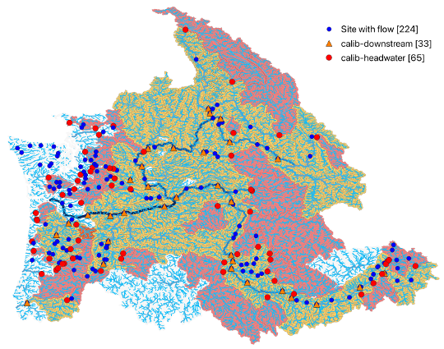
Figure x. Modeled river network in the Pacific Northwest with 221 naturalized flow sites. Red areas are headwater catchments calibrated using the flow data at the sites denoted by red circle first, and then their downstream areas in orange are subsequently calibrated using the flow data at orange triangle sites with calibrated parameters of their upstream areas fixed.

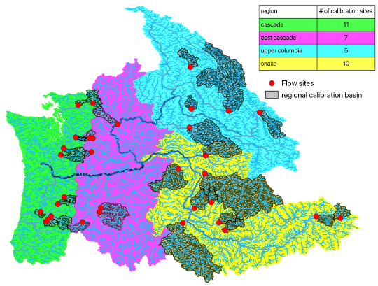
Figure 2. 4 subregions and basins used for regional multi-basin calibrations.

NRNI – Jane can contribute to documentation on NRNI

Performance

Post-calibration Results:
      - Map of daily KGE, other stats (e.g., q90, seasonal pBias)?
      - CDF calib examples, some good figures were shown at workshop
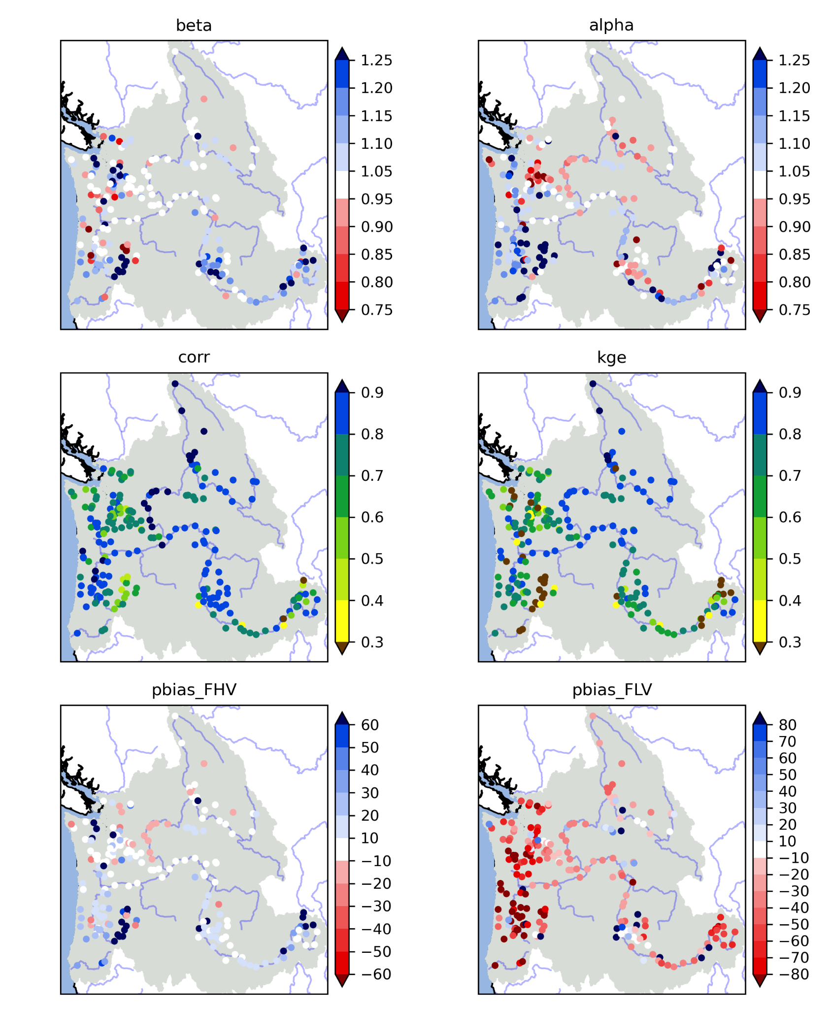
Figure 3. Maps of 219 flow sites with KGE and its three components (variability ratio, mean flow ratio, and correlation) and percent bias of high flow (>90% in FDC: FHV) and low flow (<10% in FDC: FLV). The error metrics are computed using 2001-2014 daily streamflow aggregated from 3hr simulations.

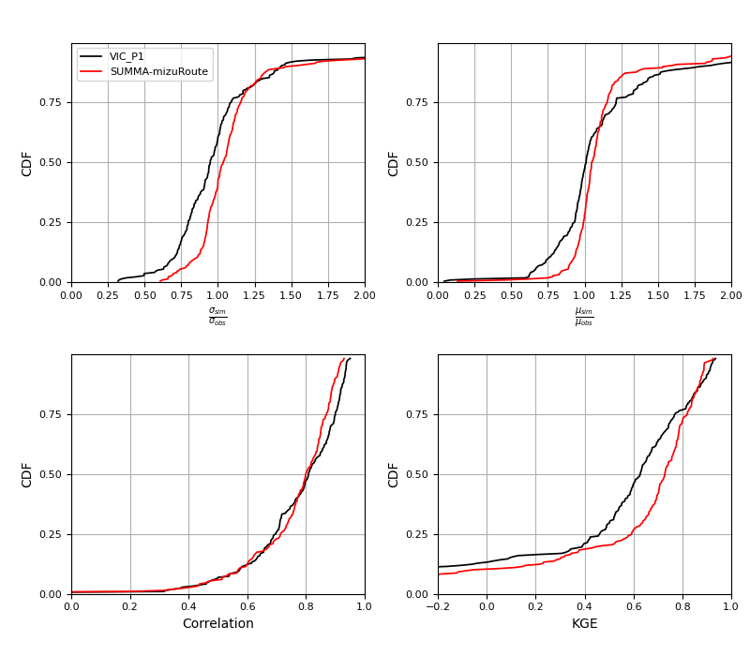
Figure x. Comparison of cumulative distributions of KGE and its components at 219 naturalized flow sites between SUMMA and VIC (Chegwidden et al.,2019). The error metrics are computed using 2001-2014 daily streamflow aggregated from 3hr simulations.

High flow simulations are evaluated based on >90 percentile (high flow) and >99 percentile (extreme high flow) of flow duration curves. Histograms below show that the extreme high flow tends to be underestimated.
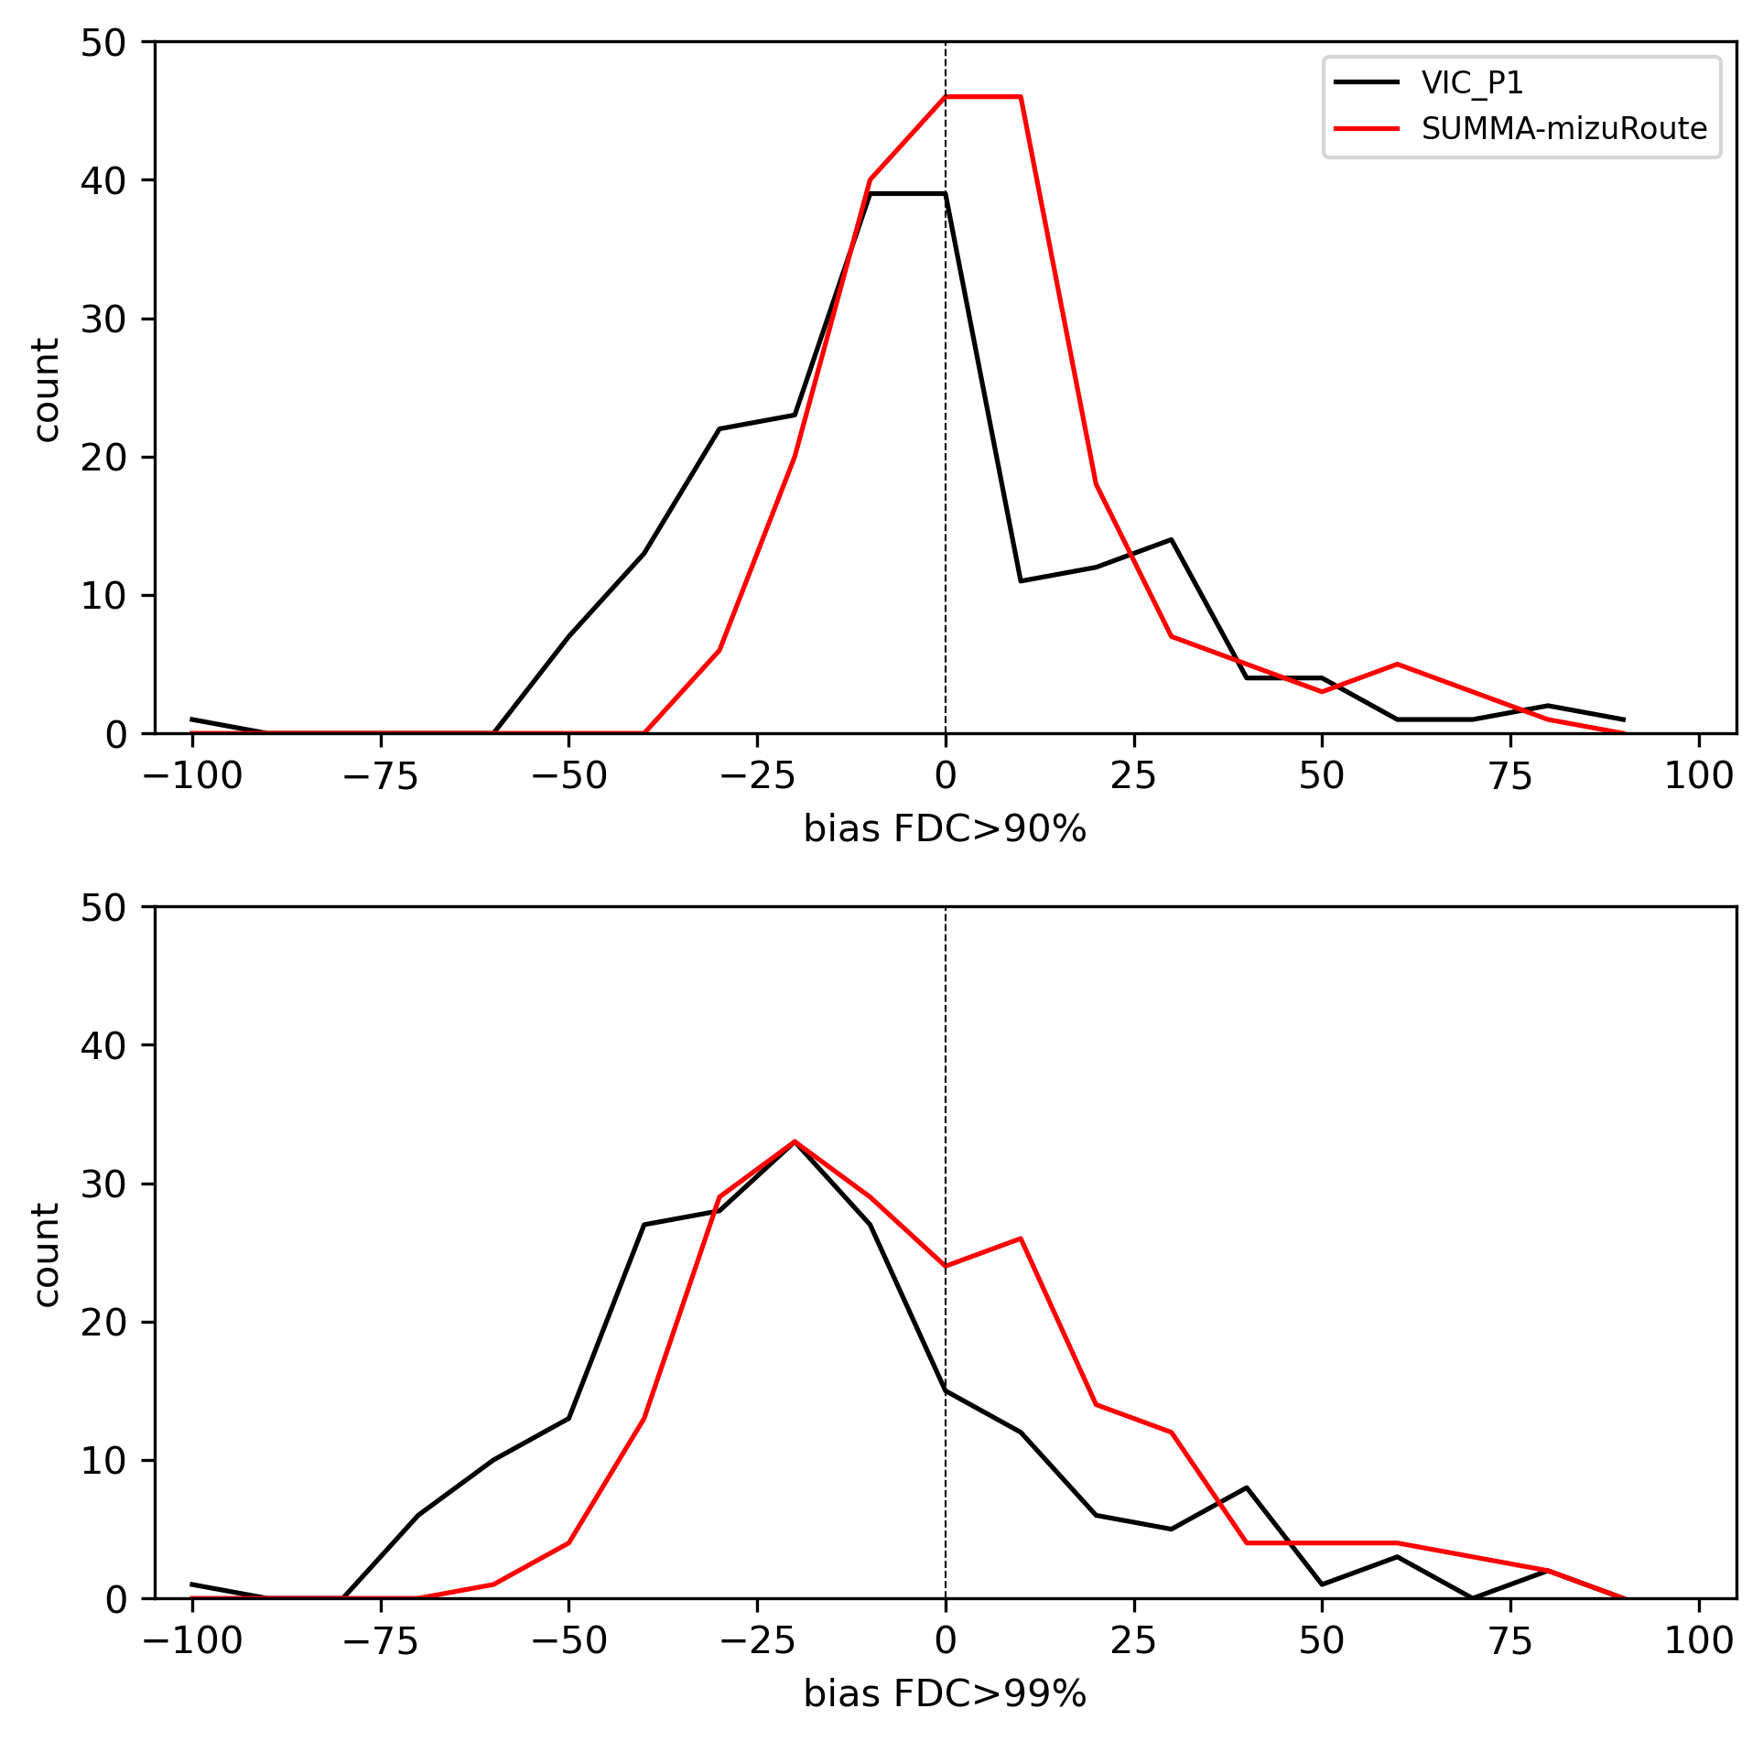

Bmorph

Overview bmorph and scbc
The calibration of SUMMA parameters intends to improve a bias in historical streamflow simulations over PNW. However, the bias is likely to be reintroduced in streamflow simulation from the calibrated SUMMA-mizuRoute if forced by the downscaled GCMs. This is because differences in the daily sequences of daily precipitation and temperature between GMET and downscaled GCMs may cause differences in longer time scale hydrologic state such as seasonal snow accumulation and soil moisture state. To reduce the streamflow bias in SUMMA-mizuRoute simulation forced by the downscaled GCMs, we use the software package called bmorph (Bennett et al. 2022). The bmorph package first constructs two cumulative distribution functions of long-term observed and simulated streamflow, which are used to correct the simulated flow so that its quantile of the corrected flow matches with the observed one given the same flow magnitude (reference). This is a traditional flow bias correction at individual sites. Bmorph further performs the flow adjustment at non-gauged reaches in the entire river network in the spatially consistent manner. For this bias correction—spatially consistent bias correction, lateral flow, instead of routed flow, is adjusted based on the interpolated cumulative distribution function of observed flow at reaches between flow sites. Then, adjusted lateral flow is re-routed with mizuRoute over the entire river network to generate adjusted or bias corrected routed flow at each reach. This spatially consistent bias correction avoids unrealistic routed flow discontinuity introduced by independent at-site bias correction.

Performance
    - Example of results – Jane pulled some monthly hydrographs that are good examples of pre-post bias-correction, can include.

Bias corrected streamflow is evaluated based on KGE components —bias, variability error, and correction, against non-bias corrected or raw streamflow simulation. For this evaluation, we use a validation period of 2001-2020, which is not used for SUMMA calibration nor bmorph training. Figure x shows comparison of cumulative distributions for each KGE component as well as KGE across the 200 flow sites, between raw streamflow simulations and SCBC streamflows. Figure x shows spatial maps of the error metrics for raw and SCBC streamflows. SCBC improves long term bias, mostly around Northern Cascade Mountain areas. Variability error improvements are seen in the Willamette River basin area, and Snake River but some deterioration is seen in the east side of the northern Cascade area. KGE improvement is derived from bias improvements.
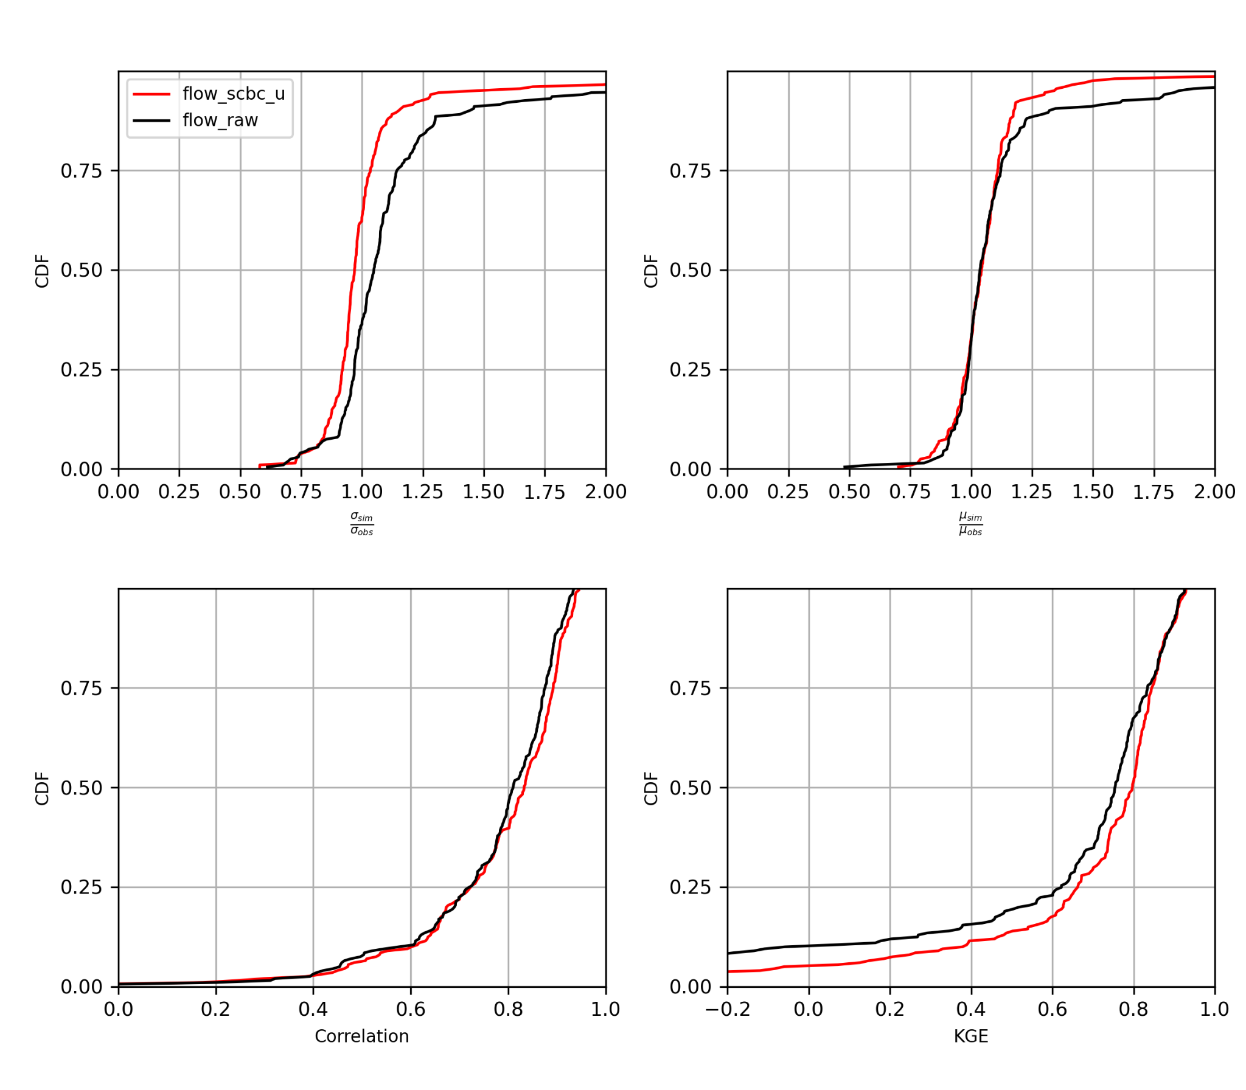
Figure x. Comparison of cumulative distributions of KGE and its components between raw streamflow simulations and SCBC bias corrected streamflows. The error metrics are computed using 2001-2020.

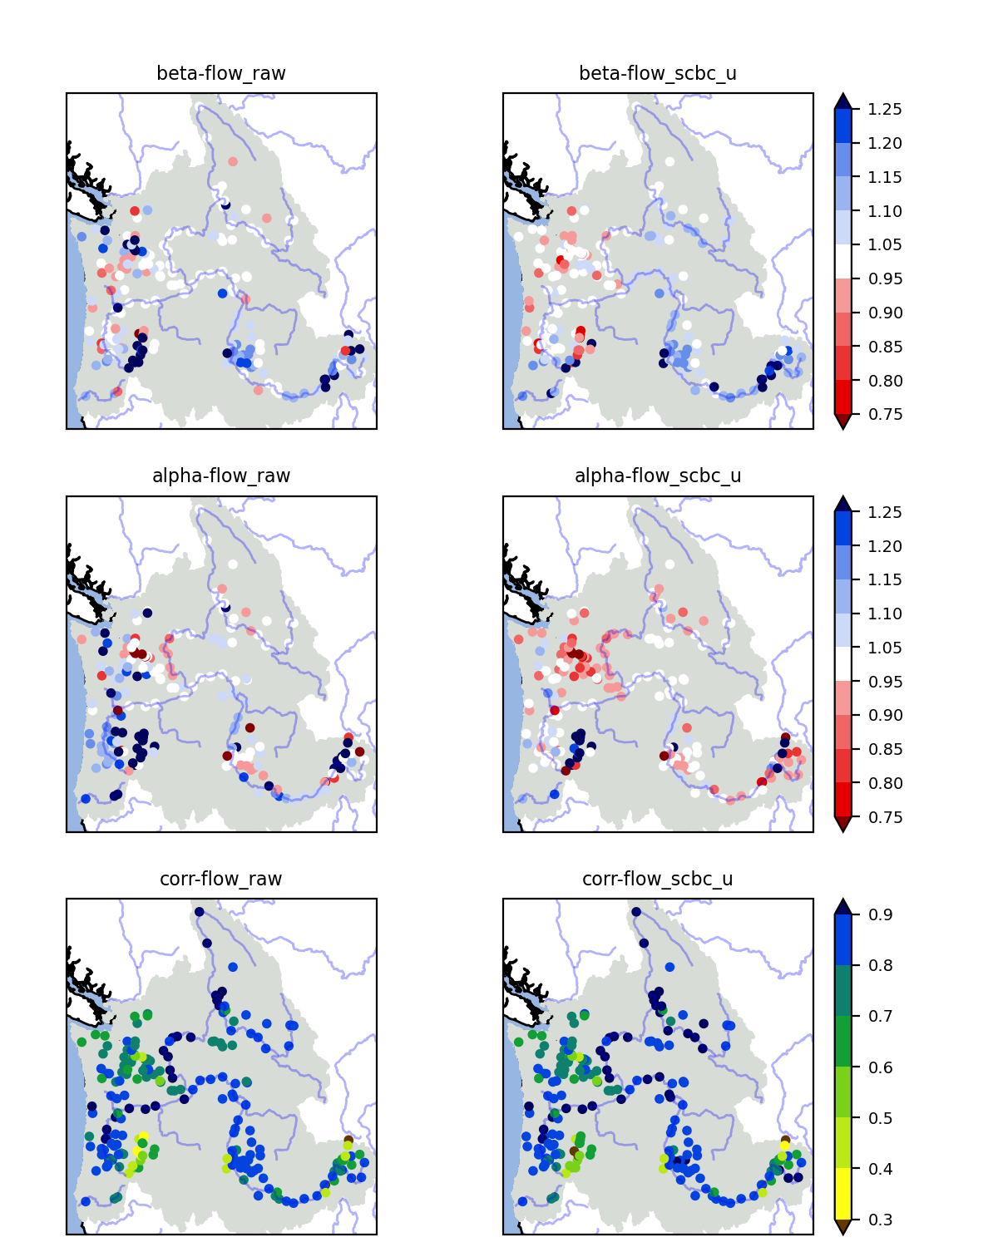
Figure x. Spatial distributions of KGE components for raw streamflow simulations (left column) and SCBC bias corrected streamflows (right column). The error metrics are computed using 2001-2020.
Flow summary plots include comparisons of the magnitude of annual maximum and minimum flow based on 7-day flow (top left 4 panels), timing (top right 3 panels), long-term mean seasonal cycle (bottom left), 30-day flow probability density (bottom middle), and daily flow Flow Duration Curve (bottom right). Here, flow summary plots are constructed to compare bomorph bias corrected GMET flow and raw GMET flow during each 20-year period–control (WY1980-2004) at all the sites. Below are two example sites on the Columbia river–ARD and TDA. The ARD site, located on upper Columbia exhibits underestimation of extreme high flow events indicated by flow magnitudes at above 95 percentile in FDC, though the simulated 20-year mean seasonality (seasonal peak) captures observations well. Such underestimations of high flow events are seen at other sites in the upper Columbia River. As moving toward the downstream (e.g., TDA), the degree of high flow event underestimation becomes less.
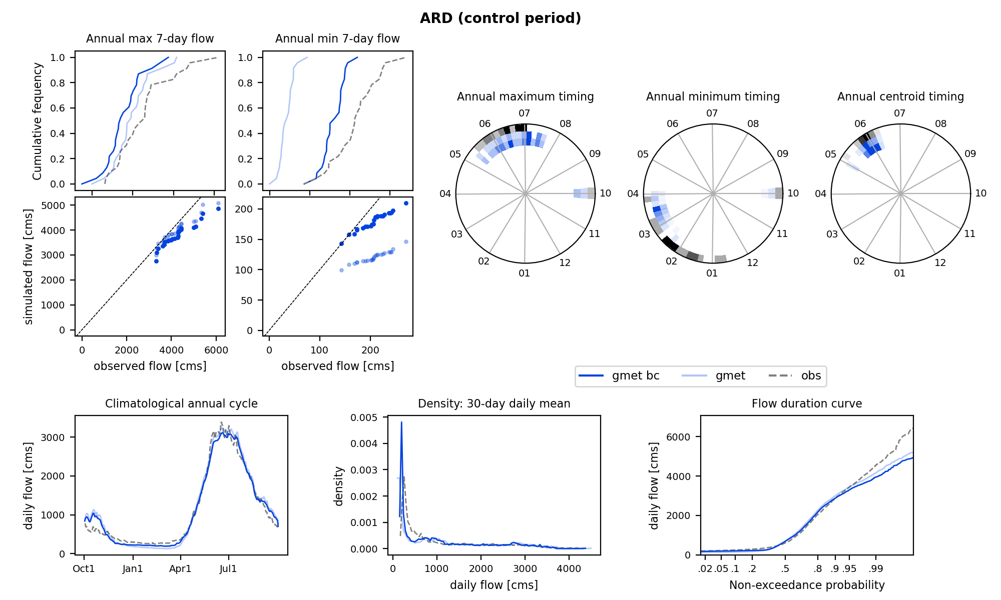
Figure xx. Flow summary plots at ARD (upstream Columbia River) during the control period (WY1980-2004). Light blue line: raw simulation using GMET forcing. Blue line: bmorph bias corrected flow.

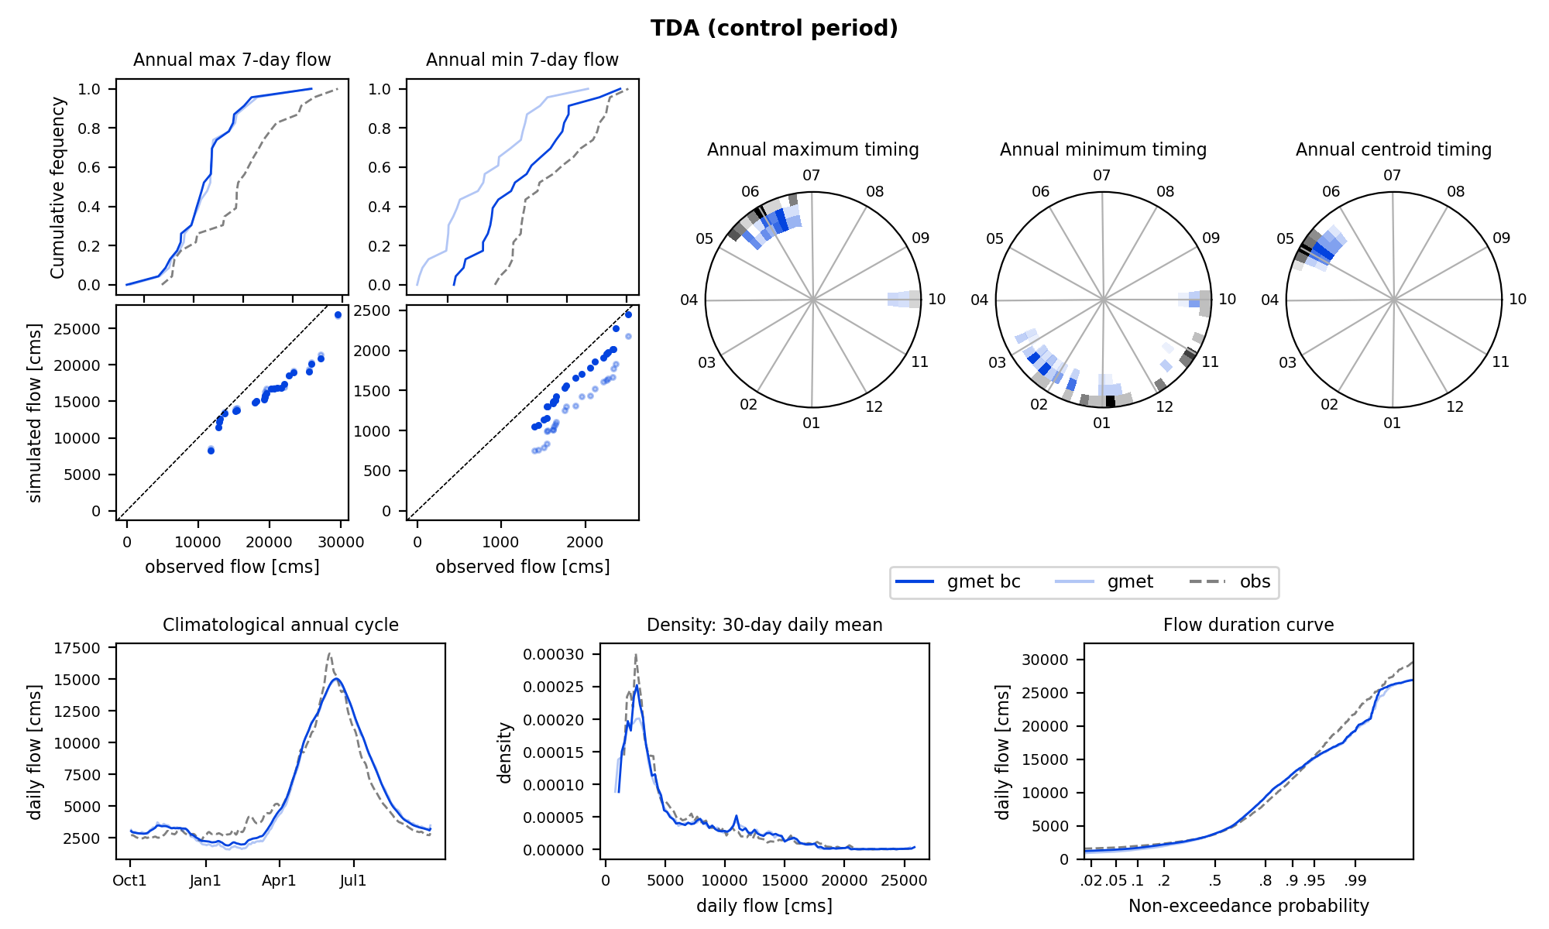
Figure xx. Flow summary plots at TDA (downstream Columbia River) during the control period (WY1980-2004). Light blue line: raw simulation using GMET forcing. Blue line: bmorph bias corrected flow.

Temporal disaggregation from daily to sub-daily
The bias corrected flow from the bomorph spatially consistent bias correction is given at daily step. Temporal disaggregation from daily to 3hr is performed for several sites by using sub-daily patterns in raw simulation. On each day, fractions of 3hr flow to daily flow (8 fraction value per day) is computed using the raw 3hr simulation, then multiply each 3hr fraction to the daily bias corrected flow to obtain 3 hr bias corrected flow. With this method, daily flow volumes based on the 3hr disaggregated bias corrected flow should be equal to daily BC flow volume (or mean 3hr disaggregated flow match up with daily flow). The figure below illustrates this.
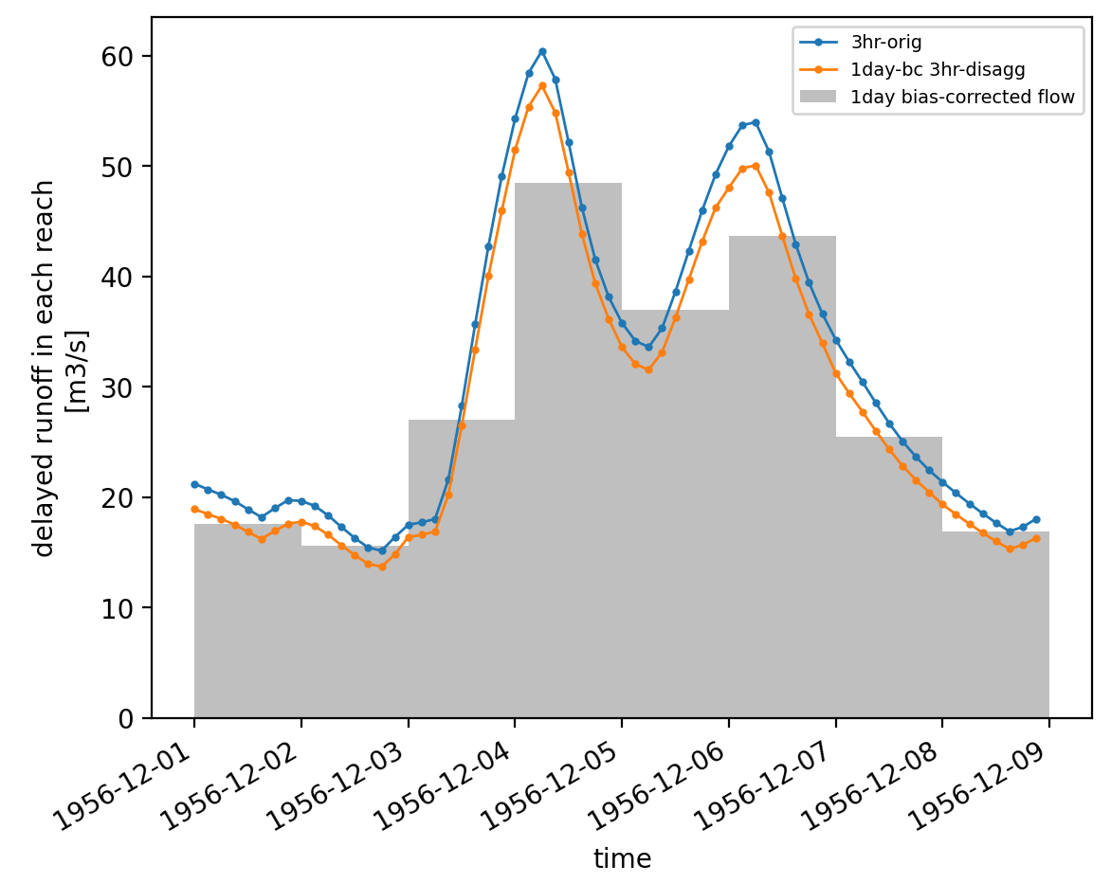
Figure xx.

Results
  - Summary of trends in ICAR max/mean
    - Annual change signal
When averaged across global climate models, ICAR projects increases in mean annual precipitation across most of the western United States, with small decreases along the mountains of the west coast, particularly on the lee (East) side of those mountain ranges. The increases are larger in SSP585 than in SSP370 or SSP245. The variation in changes between climate models is greatest in the central latitudes of the US (37° to 45° N) and inland from the first major mountain ranges. This implies greater uncertainty in the changes in the Snake river, but more confidence in the upper Columbia and along the coast ranges and windward (West) side of the Cascade range.
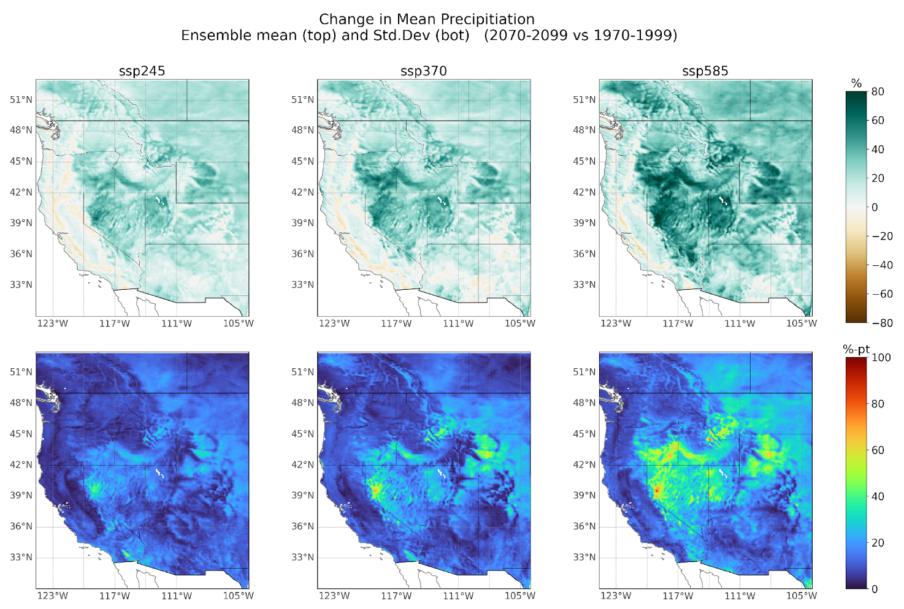
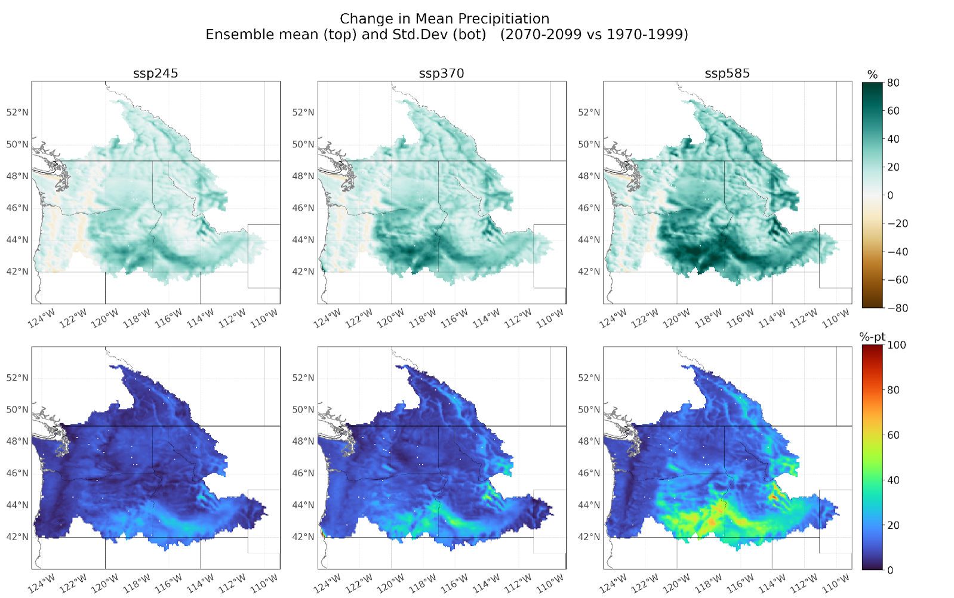

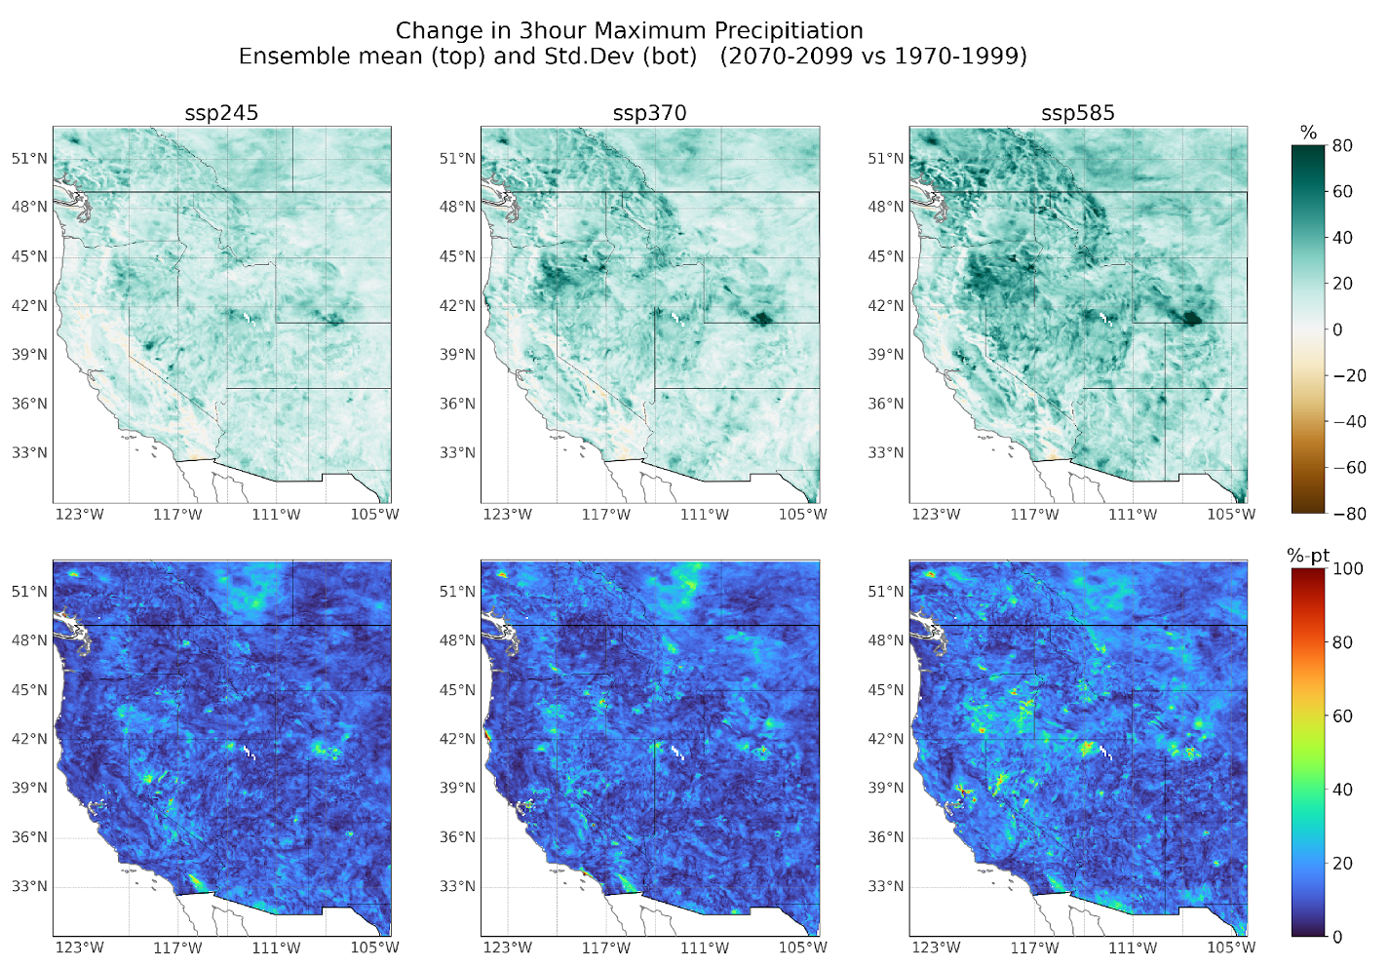
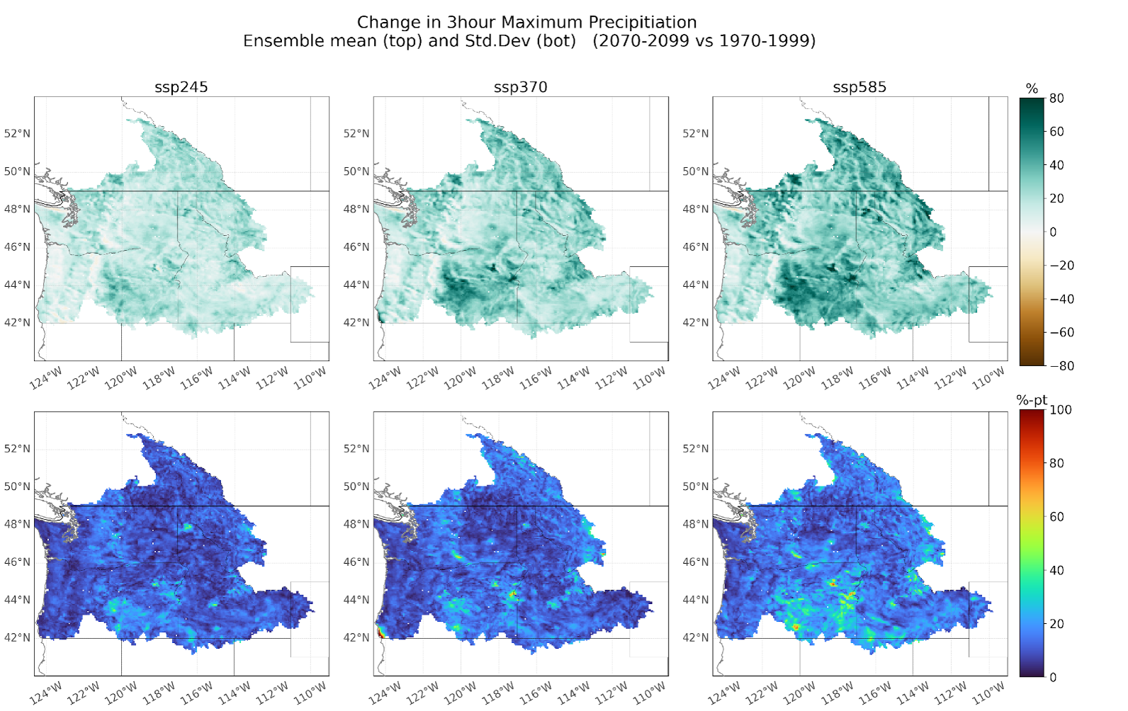

Air temperature increases across the domain, with the greatest increase observed in the interior, and the least increase observed along the coast. There are significantly greater increases in air temperature in the SSP585 emissions scenario and particularly in the CanESM5 climate model (Figure).
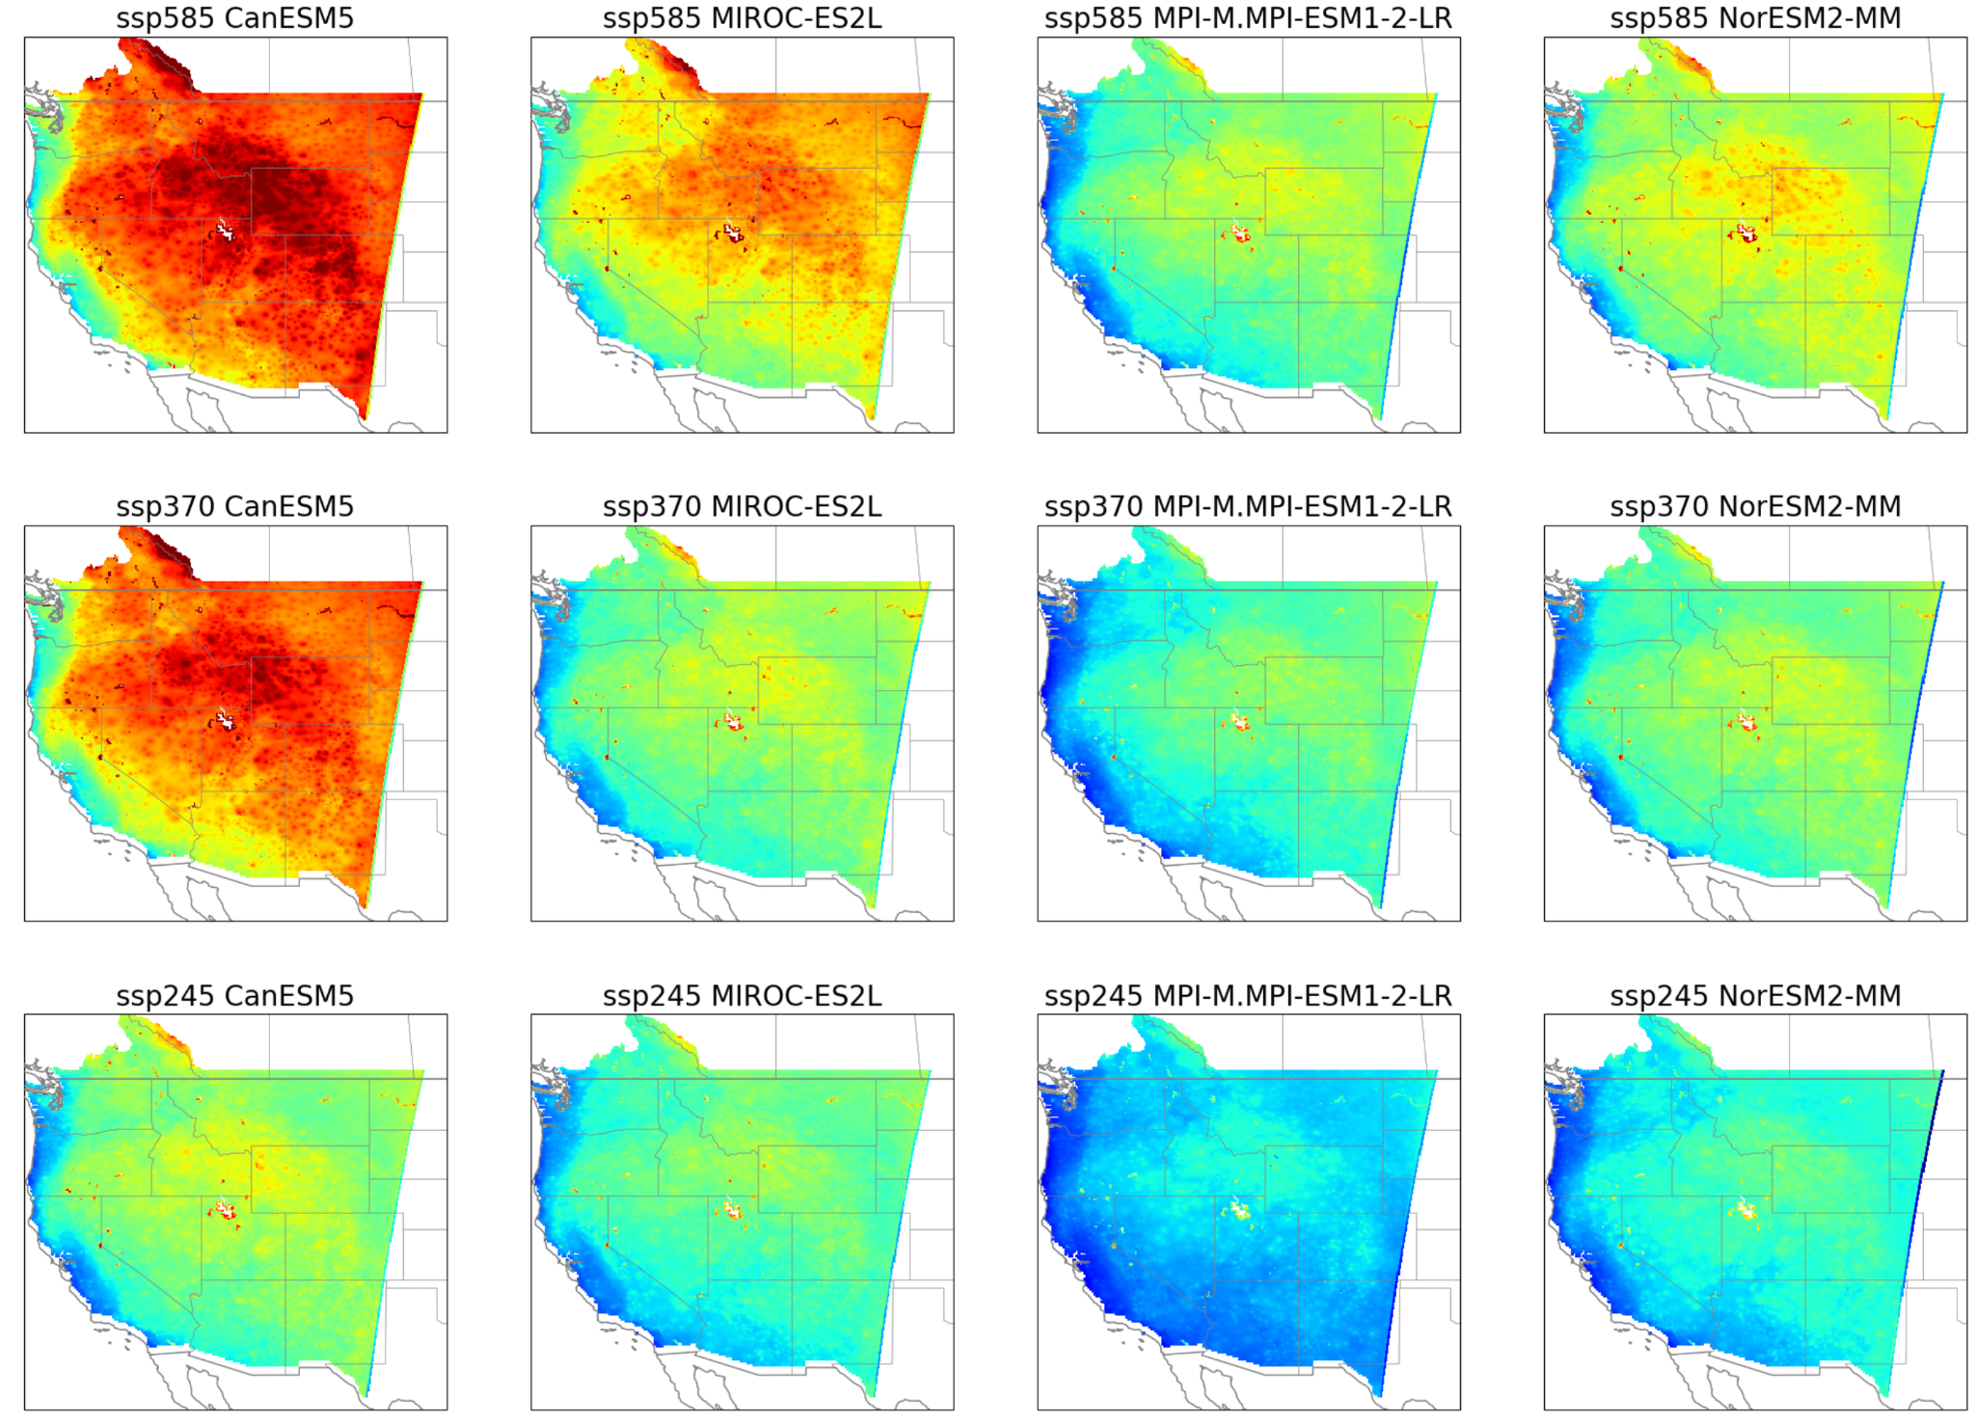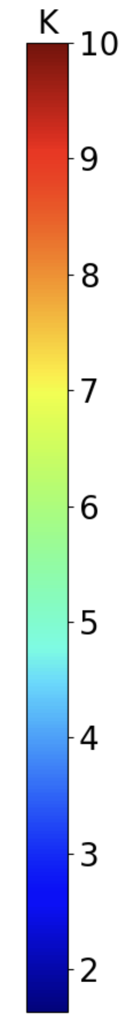

    - Seasonal change signal
The patterns of changes in precipitation have a strong seasonality to them (Figure). The winter season (December, January, and February: DJF) has a decrease in precipitation on the lee side of the mountains, and in the southern part of the western US, with increases in precipitation in lower elevations. Spring (March, April, and May: MAM) has a pronounced latitudinal gradient, with significant decreases in precipitation expected across the southern part of the domain, and increases dominant north of 40° latitude. Summer (June, July and August: JJA) has the greatest increases in precipitation across the domain; however, this is as a percentage, and much of the region with large percent increases receives very little precipitation currently. Most of the Columbia river basin is projected to have increases in precipitation, though the coast range in the Pacific Northwest have decreases in mean precipitation. Finally, Autumn (September, October, and November: SON) have a similar pattern of change as in DJF, but with more increases in precipitation in the southern part of the western US.
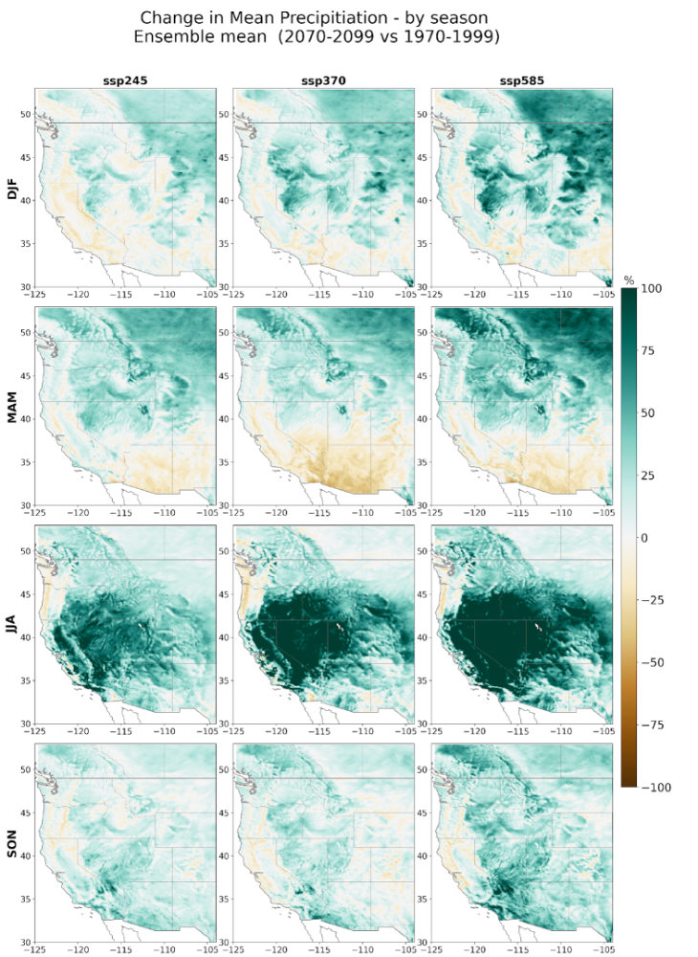
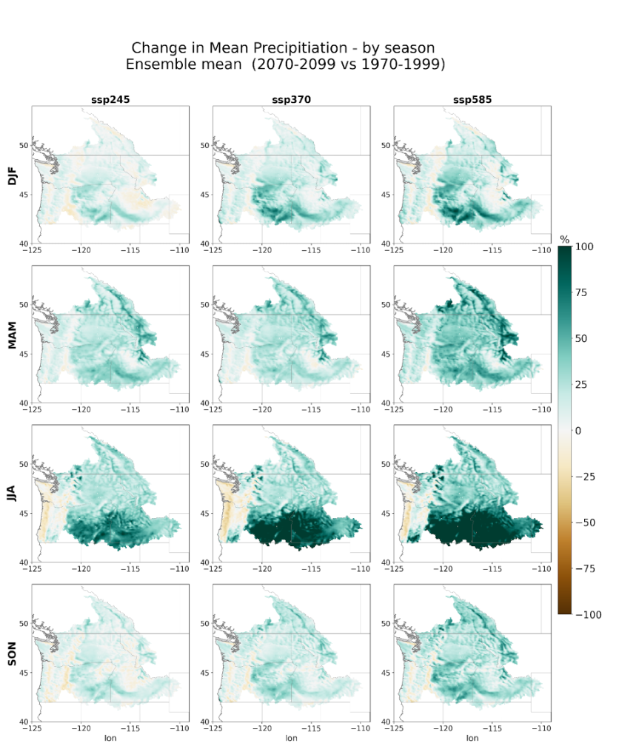

The greatest increases in air temperature are projected to occur in JJA and SON (Figure). This is a feature that is consistent across climate models.
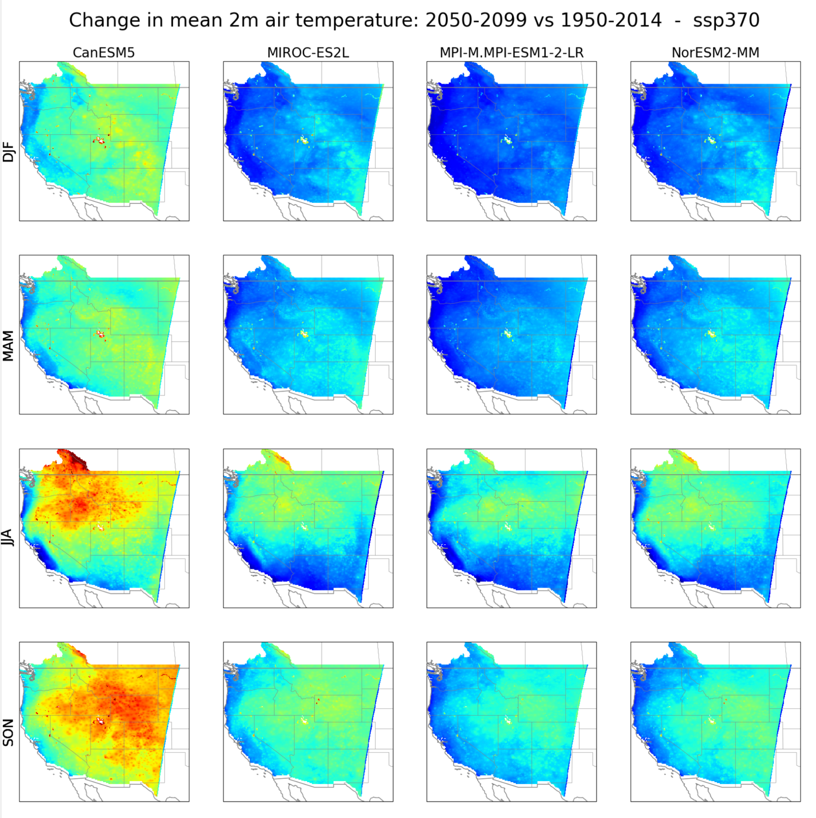

As shown west wide, individual basins within the Columbia river basin are expected to see significant increases in extreme precipitation. A subset of the domain near Libby Basin show consistent trends in daily maximum precipitation averaged across the region in all climate models (Figure)
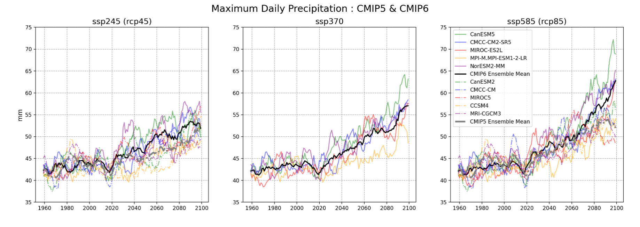

Changes in extreme precipitation for multiple time scales exhibit similar patterns (Figure). Single day mean annual maximum precipitation totals were compared with the mean annual maximum for 3-day accumulated and a 7-day accumulated totals. In all cases, maximum precipitation increases, with the largest increases in absolute changes occurring along the upwind side and the crest of the Cascades, and the largest percentage increases occurring in the interior of the domain where the absolute magnitudes are low to begin with. There are some suggestions of decreases in extreme precipitation on the Northeast side of the Olympic Peninsula. For 7-day totals, there are some slight decreases predicted on the downwind side of the coast range. More work is needed to understand if these changes are robust.
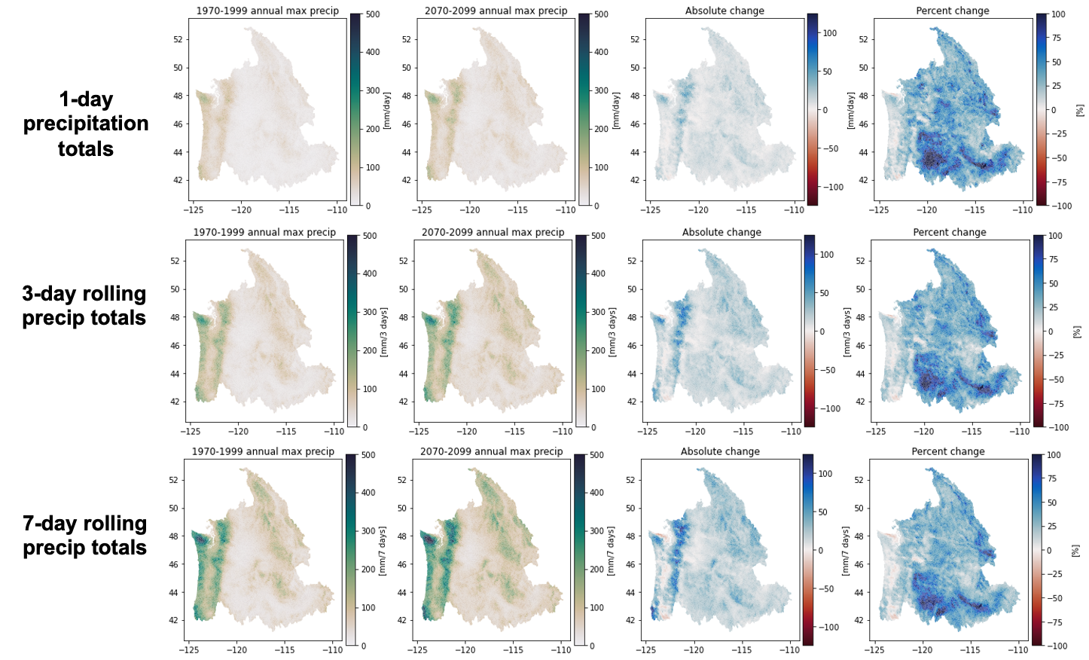

    - Evaluation with respect to other downscaling methods
It is currently impossible to validate future climate change projections from ICAR; however, it is useful to compare the changes predicted by ICAR to those from other methods. This helps reveal places that the new dataset may differ from guidance previously used by USACE, and shows that the simplifications in ICAR still result in changes that are consistent with a full physics dynamical downscaling approach.
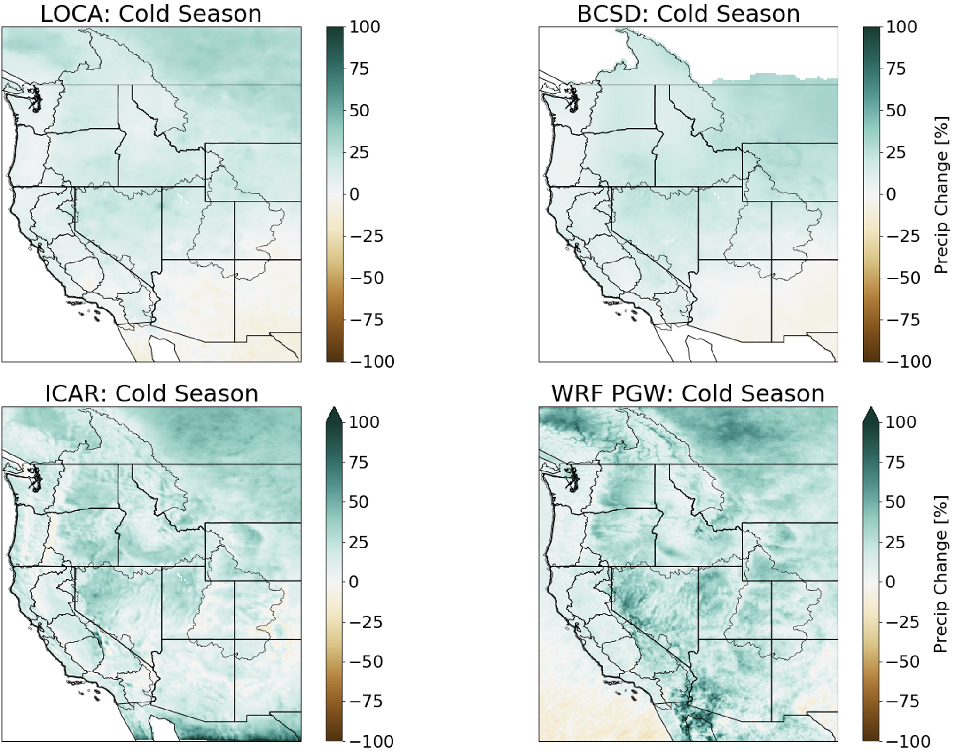

  - Summary of streamflow trends
Two types of plots are available for each site to compare historical flow and projected flows during the mid and late 21st century. These are flow duration curves and decadal mean seasonality. Here the plots at selected sites are provided.
Flow duration curves are constructed each 20-year period–control (WY1980-2004), 2040s (WY2029-2060), and 2080s (WY2069-2099), shown at 4 example sites on large rivers in the Columbia River system– Snake (BRN), Pend Oreille (BDY), and Columbia (ARD and TDA). [May need a map showing the sites and river reaches?]. Ensemble envelopes for each period are based on maximum and minimum values among all the ESMs (CMIP5 and CMIP6 combined). Future periods (2040s and 2080s) include only high emission scenarios (RCP8.5 for CMIP5 ESMs and SSP5-8.5 for CMIP6 ESMs).
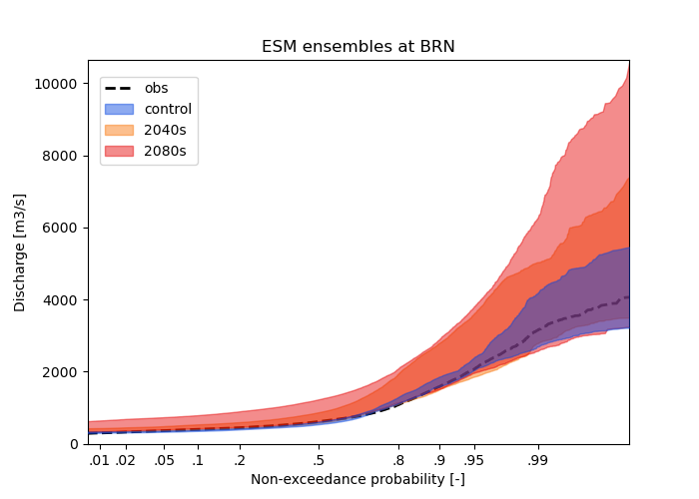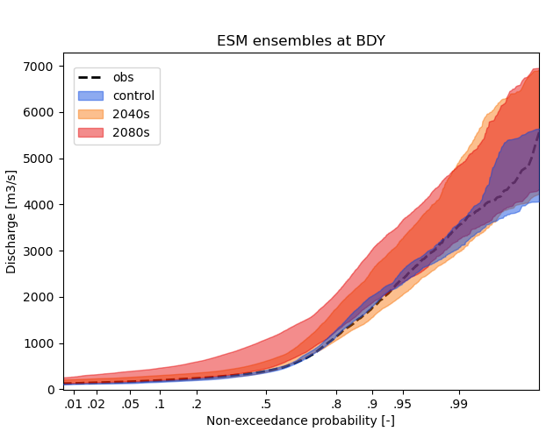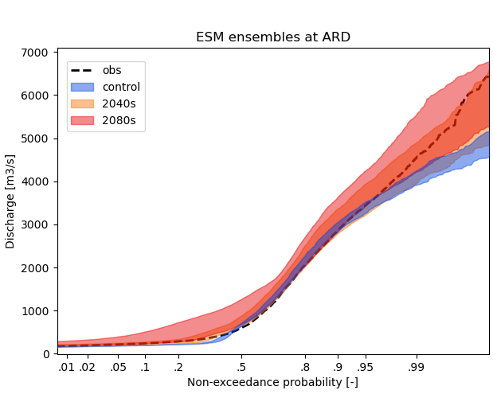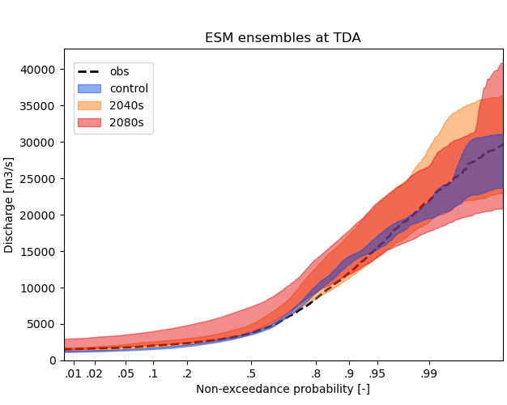
Figure xx. Flow duration curves during control, 2040s, and 2080s periods at 4 sites on the large rivers.
FDCs at the flow sites on smaller, or tributary rivers to the mainstem Snake, and Columbia are shown below– LIB (Upper Columbia), CSC (Snake), SVN (Willamette), HAH (Western Cascade), KIOW (Yakima). High flow events above 99 percentile are underestimated during the control period at KIOW site. Such underestimation of the high flow events are seen at the sites on the eastern side of Cascade
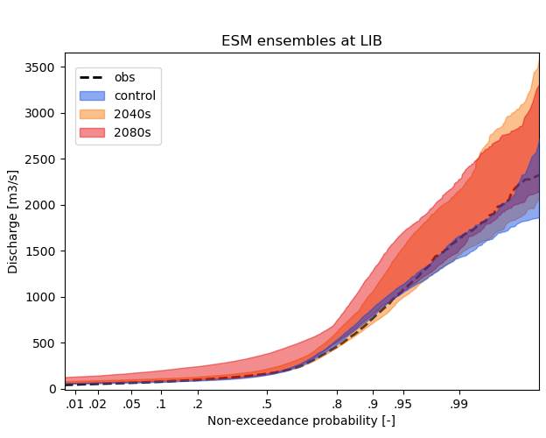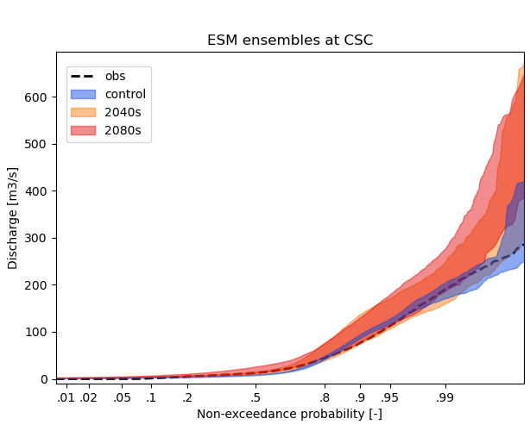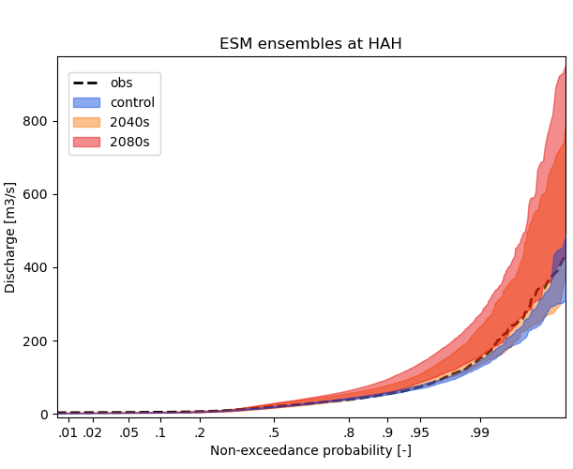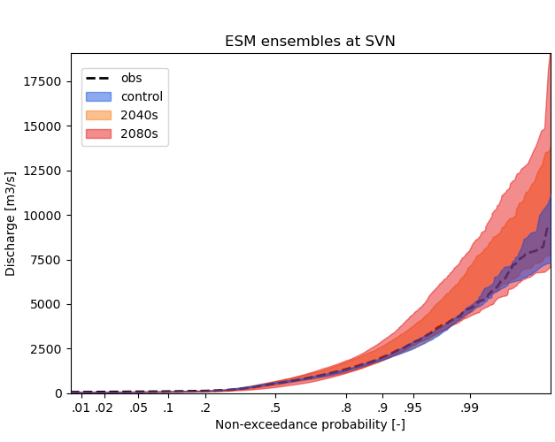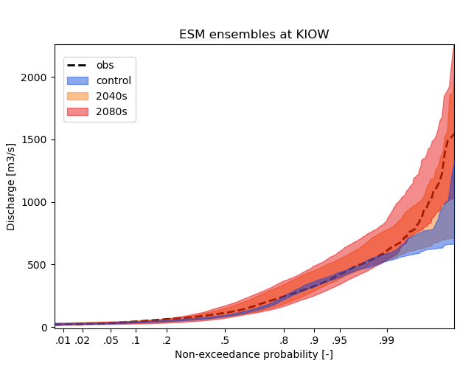
Figure xx. Flow duration curves during control, 2040s, and 2080s periods at 5 sites on the tributaries basin of the Columbia and Snake rivers.
20-year mean seasonality are shown at the same sites below. Mainstem sites: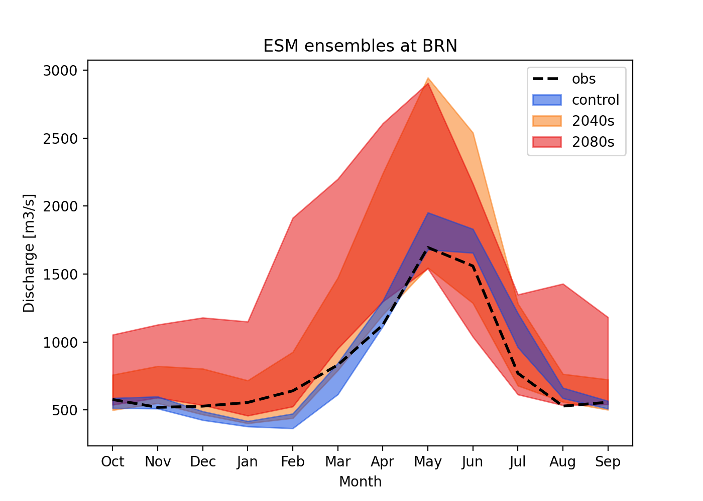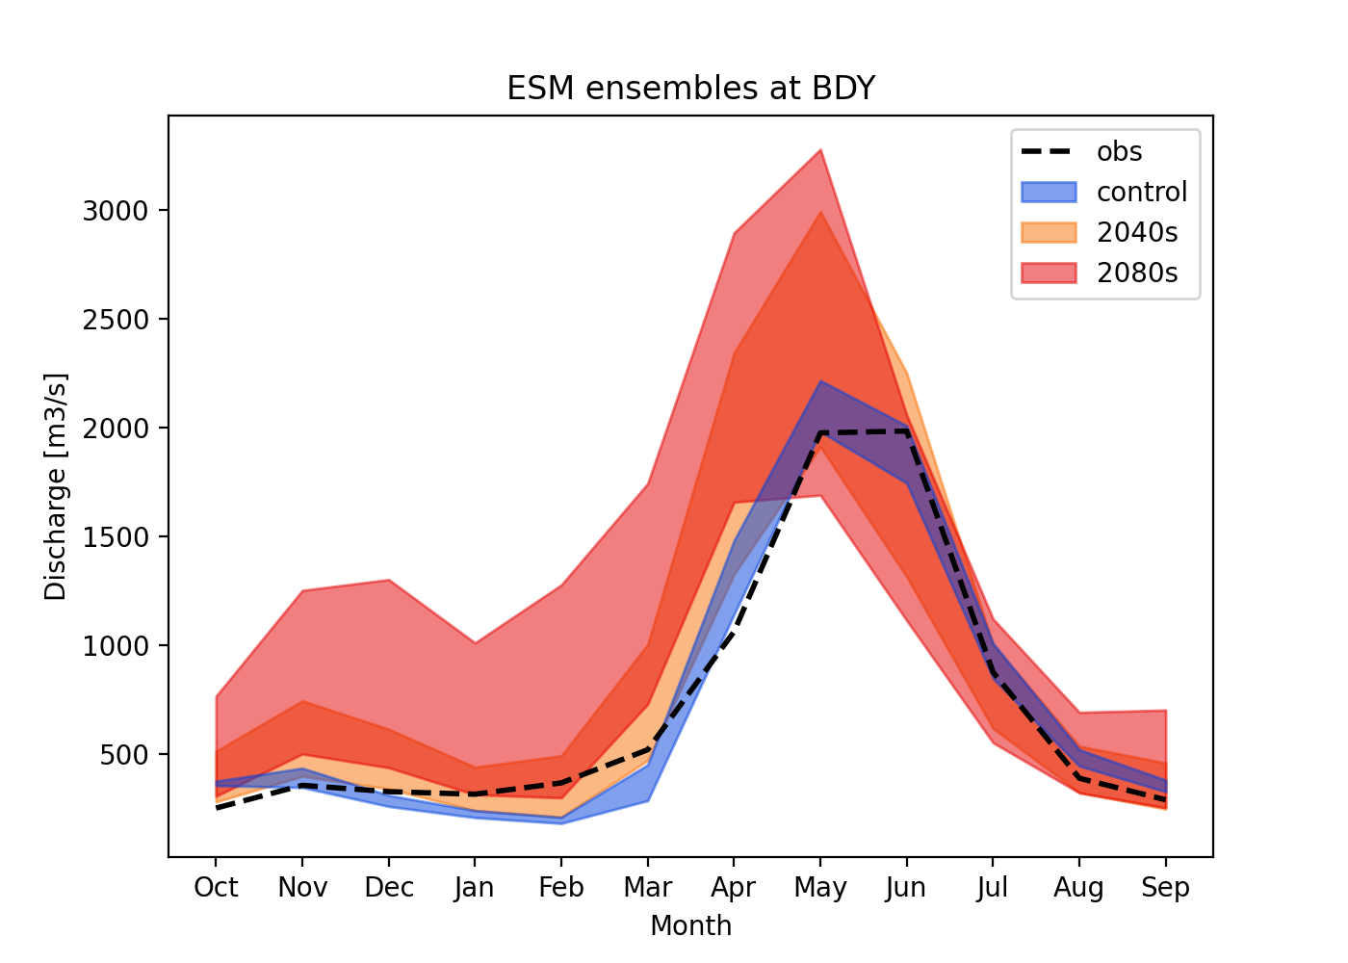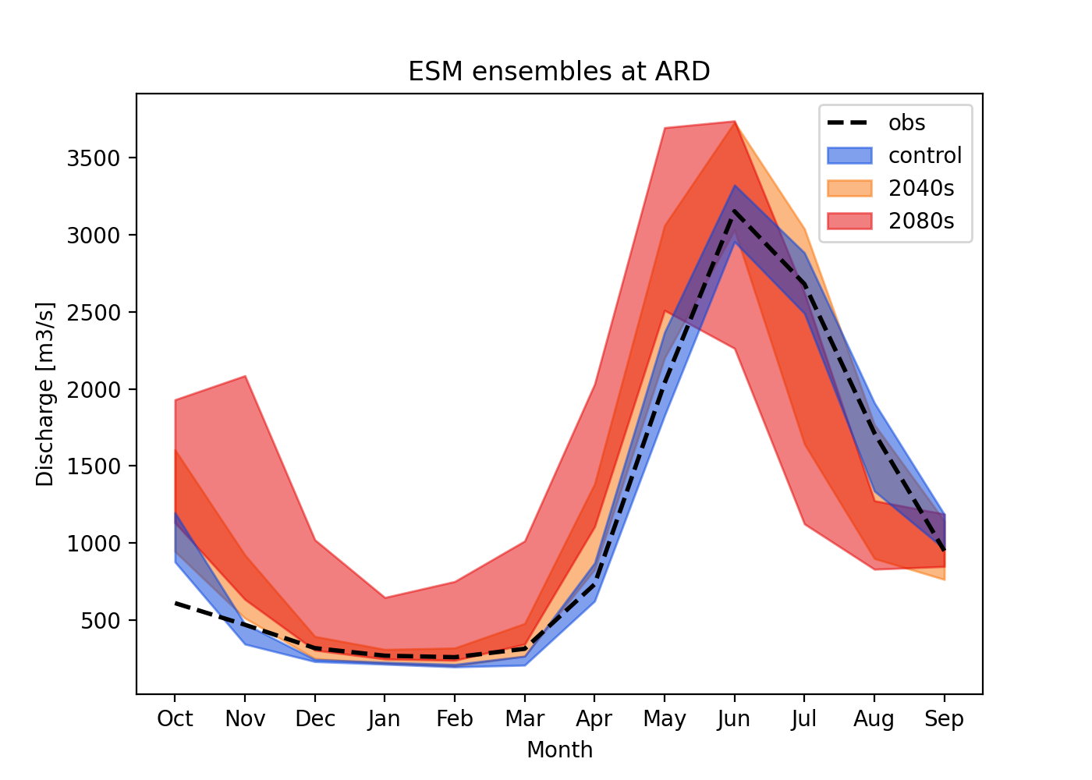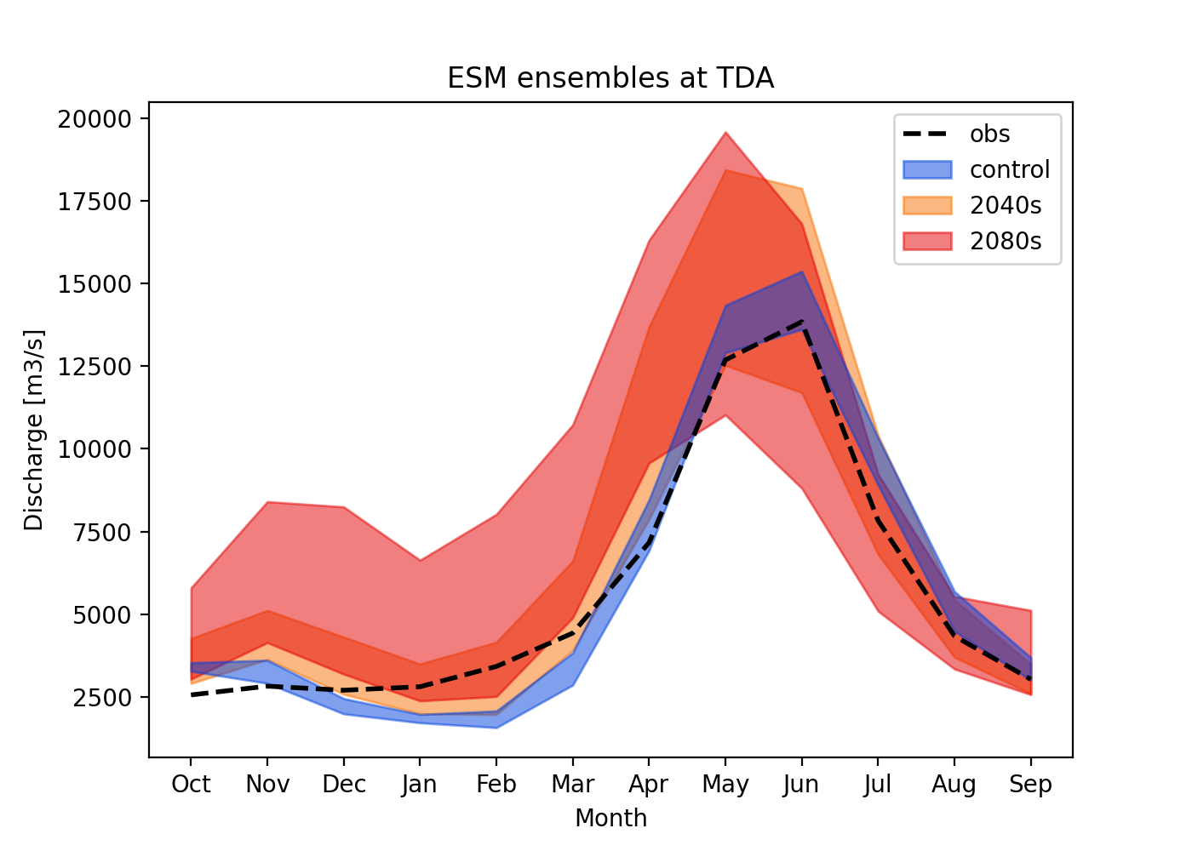
Tributary sites:
